Final Report of the Seminar on Indigenous Fisheries in Amazonas, Brazil and the Voluntary Guidelines for Securing Sustainable Small-Scale Fisheries in the Context of Food Security and Poverty Eradication

Operation Native Amazonia (OPAN) | International Collective in Support of Fishworkers (ICSF)
Partners
Social and Environmental Institute (ISA) | International Institute of Education in Brazil (IEB)
Support
Food and Agriculture Organization of the United Nations (FAO) | National Indian Institute (FUNAI)

Ana Paula Rainho, Santa Catarina Federal University
(UFSC), Brazil | Member, ICSF
Lorena França, Santa Catarina Federal University (UFSC), Brazil

Manaus, Brazil
May, 2019
Contents

Abbreviations……………………………………………………………………………………...4
Introduction………………………………………………………………………………………..6
Objectives………………………………………………………………………………………....7
Methodology………………………………………………………………………………………8
Part I - Characterisation of regions
Solimões River Basin…………………………………………………………………………….14
1. Fishing Context…………………………………………………………………………..15
2. Conflicts involved………………………………………………………………………..16
3. Opportunities……………………………………………………………………………..17
Juruá River……………………………………………………………………………………….17
1. Fishing Context…………………………………………………………………………..18
2. Conflicts involved………………………………………………………………………..18
3. Challenges stipulated at this moment…………………………………………………....19
Purus River…………………………………………………………………………………….. .20
1. Fishing context…………………………………………………………………………..20
2. Conflicts and Challenges involved……………………………………………………....20

Negro River Basin……………………………………………………………………………….22
1. Fishing context and challenges involved from Upper Negro……………………………22
2. Fishing context and challenges involved from Middle Negro…………………………...25

Madeira River Basin……………………………………………………………………………..26
1. Fishing context of Middle Madeira River and Marmelos River………………………... 27
2. Conflicts and challenges involved……………………………………………………….29
3. Fishing context of Lower Madeira………………………………………………………29
4. Conflicts and challenges…………………………………………………………………30

Part II: The Seminar on Indigenous Fisheries and the Guidelines……………………………….30
Sustainable management of fishery resources…………………………………………………...30
Social development, decent work and employment……………………………………………..33
Gender relations in Amazonian fisheries………………………………………………………...38

Reflections and recommendations…………………………………………………………….....41
Organisers’ reflections…………………………………………………………………………...43

References…………………………………………………………………………………….. ...44
Annexures…………………………………………………………………………………….. ...46
Annexure 1…………………………………………………………………………………….. ..46
Annexure 2……………………………………………………………………………………….47

List of Figures

Figure 1: Opening of the Seminar…………………………………………………………………8
Figure 2: Presentation of SSF Guidelines…………………………………………………………9
Figure 3: Negro River working Group…………………………………………………………...10
Figure 4: Solimões River working Group………………………………………………………..10
Figure 5: Purus and Juruá Rivers working Group……………………………………………….11
Figure 6: Madeira and Marmelos Rivers working Group………………………………………..11
Figure 7: Presentation of the results of the Purus and Juruá Rivers Working Group……………12
Figure 8: Presentation of the results of the Madeira and Marmelos Rivers Working Group…... 13
Figure 9: Map showing the territorial range of qualitative data recorded during the Seminar…..14

Abbreviations

ACIBRN Association of Communities of the Lower Negro River
ACIMRN Association of the Middle Black River Indigenous Communities
ACJ Association of Communities working with the Sustainable Development of the Municipality of Jutaí
AIMA Indigenous Agents of Environmental Management
APIATI Apurinã Indigenous People from Itixi Mitari
APITEM Tenharim Morogitá Indigenous People Association
ASPROC Association of Rural Producers of Carauari
CITES Convention on International Trade of Endangered Species of Wild Fauna and Flora
COIAB Coordination of Indigenous Organizations of the Brazilian Amazon
COIPAM Coordination of Organizations and Indigenous Peoples of Amazonas
CONFREM National Commission for Strengthening Coastal and Marine Extractive Reserves
CONSEA National Council of Food and Nutritional Security
CTI Indigenous Labour Center
CU Conservation Units
FAO Food and Agriculture Organization of the United Nations
FEI State Indian Foundation
FOIRN Federation of Indigenous Organizations of the Negro River
FUNAI National Indian Foundation
IBAMA Brazilian Institute of Environment and Renewable Natural Resources
IBGE Brazilian Institute of Geography and Statistics
ICMBio Chico Mendes Institute for Biodiversity Conservation
IDAM Agricultural and Forestry Development Institute
IEB International Institute of Education in Brazil
IFAM Federal Institute of Education, Science and Technology of Amazonas
ICSF International Collective of Support of Fishworkers
ISA Social and Environmental Institute
ILO International Labour Organization
MPF Federal Public Prosecutor's Office
MPP Movement of Fishermen and Fisherwomen
OPAN Operation Native Amazonia
PA Protected Area
PNGATI National Policy of Territorial and Ambiental Management of Land Indigenous
PRODERAM Regional Development Project of the State of Amazonas for the Green Free Zone
RDS Sustainable Development Reserve
RESEX Extractive Reserve
SAP Special Secretary for Fisheries and Aquaculture
SEPA Executive Secretariat of Fisheries and Aquaculture
TeiaPesca Brazilian Web of Artisanal Fishing Networks
WCS Wildlife Conservation Society

Introduction

A “Seminar on Indigenous Fisheries in Amazonas, Brazil and the Voluntary Guidelines for Securing Sustainable Small-Scale Fisheries” was held on March 27 and 28, 2019, in Manaus, capital of Amazonas state in Brazil. Supported by the Food and Agriculture Organization of the United Nations (FAO), the Seminar was organised by Operation Native Amazonia (OPAN) and International Collective of Support of Fishworkers (ICSF). Along with many grassroots associations of the indigenous peoples’ movement, the programme was attended by FUNAI (National Indian Foundation) from Lábrea, São Gabriel da Cachoeira, Tabatinga and Manaus; FEI (State Indian Foundation); SAP (Special Secretary for Fisheries and Aquaculture) of the federal government of Brazil; the SEPA (Executive Secretariat of Fisheries and Aquaculture) of the state of Amazonas; the ICMBio (Chico Mendes Institute for Biodiversity Conservation) of the state of Amazonas; ISA (Social and Environmental Institute); Wildlife Conservation Society (WCS) Amazonas; CTI (Indigenous Labor Center); IFAM (Federal Institute of Education, Science and Technology of Amazonas); and the Memorial Chico Mendes/ASPROC.
The Seminar was planned with the aim of understanding the reality of indigenous fisheries in the state of Amazonas and extend issues related to artisanal fishing to indigenous peoples. Far from the debates around the Voluntary Guidelines for Securing Sustainable Small-Scale Fisheries in the Context of Food Security and Poverty Eradication (the SSF Guidelines) of FAO, indigenous peoples in the Amazon are unaware of these Guidelines, or even the human rights of small-scale fishing communities. Coastal and riverine artisanal fishermen, on the other hand, have always been present in the discussions of the Guidelines. In 2011, coastal and riverine fishermen from various parts of Brazil gathered in Prainha do Campo Verde, Ceará, to contribute to the construction of the SSF Guidelines at the international level. This process was followed up by debates on the draft document, which were then spearheaded by the fishers’ movements, so that the guiding principles of the SSF Guidelines also became the fight flags of the main social movements related to fishing.
In June 2016, the ICSF and partner organizations produced in Brasília the "National Seminar on Training for the Implementation of the Voluntary Guidelines for Securing Sustainable Small-scale Fisheries". The main objective was to provide support and guidance for their implementation in Brazil, resulting in a document that summarised the demands of fisher organizations and in the creation of a working group for the implementation of the SSF Guidelines. The group, known as the "Brazilian Web of Artisanal Fishing Networks" (TeiaPesca), recognised the need to include indigenous peoples in the discussion on small-scale fisheries in the country, as well as understood the needs and challenges related to indigenous fisheries.
This separation between artisanal fisheries and indigenous fisheries is evident in national legislation, in which there are almost no fishery policies turned to help indigenous (marine or inland) artisanal fisheries. The few existing policies, such as the fishing permission and the closed season for certain species, do not always take into account the needs of indigenous fishers.
The laws that ensure indigenous rights in Brazil are the Indian Statute (Law 6,001, from December 19, 1973), the 1988 Constitution (articles 231 and 232), and the Decree nº 5,051, which fulfills Brazil’s ratification of Indigenous and Tribal Peoples Convention, 1989 (C169) of the International Labour Organization (ILO). This has been widely used to ensure the rights of indigenous peoples, including coastal and riverine fishermen One of the goals of the Manaus Seminar was to raise awareness about the SSF Guidelines, to inform participating indigenous people’s organisations about their rights as small-scale fishers. The need to include fishers in this debate also arises because of the relevance of inland fisheries for food security and their social, economic and cultural importance for several groups who are not yet represented in the debates about the SS Guidelines in Brazil.

Objectives
As an exploratory meeting to present the SSF Guidelines, to establish bridges between the small-scale fisheries movement at the national level and at the local level in indigenous territories, and to exchange experiences of indigenous fishing communities in Amazonas, the Seminar had the following objectives:
1. Survey information on indigenous fisheries in Amazonas state, including its contribution to food security and conflicts involving the diverse indigenous peoples’ groups represented in the seminar;
2. Raise awareness about the SSF Guidelines among indigenous peoples’ movements and leaders, civil society organizations and government agencies; and
3. Consult indigenous peoples’ groups of the state of Amazonas, as well as relevant agencies and institutions, on developing a small-scale fishers’ platform at the national and sub-national levels

Methodology
The report follows the programme of the Seminar and the results of working group discussions. The first part is divided by river basins, showing the main fishing modalities that exist in each region, as well as the current conflicts and opportunities. The second part is divided by thematic groups and topics contained within the SSF Guidelines, drawing a parallel between the discussions, the actions already implemented in the state of Amazonas, and the points brought by the Guidelines that allow a dialogue between what is already done in the region and what indigenous communities want to be done. Finally, we will present the recommendations and demands from each Working group and the recommendation set by the final plenary of the seminar. The recommendations of the organizing team, which arose after the meeting for evaluation of the seminar on March 29, will also be mentioned in this report.
The Seminar began at 9:00 am on 27 March 2019 with a presentation by the organizing organizatons, ICSF and OPAN. This was followed by a presentation of the SSF Guidelines by Ana Paula Rainho, ICSF member, Josana Pinto da Costa, representing the Movement of Fishermen and Fisherwomen (MPP), and Flávio Diniz, representing the National Commission for Strengthening Coastal and Marine Extractive Reserves (CONFREM). The aim of bringing up the social movements of coastal and riverine fishers was to bring them closer to indigenous fishermen, as well as to bring the approach of artisanal fishers, who face all the problems, complexities and opportunities related to artisanal fishing on a daily basis.
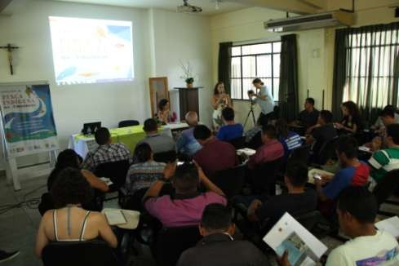

Figure 1: Opening of the Seminar

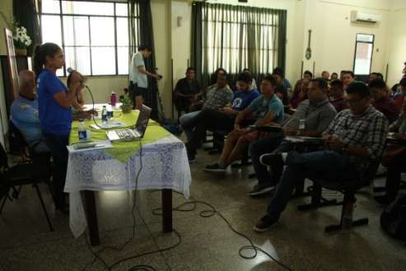
Figure 2: Presentation of the SSF Guidelines

After the presentation of the Guidelines, a space was opened for the prosecutor of the Federal Public Ministry of Amazonas, Fernando Merloto Soave, to present the actions undertaken by the 5th notification under the title “Indigenous peoples and traditional communities” talking about territorial conflicts and mainly about indigenous school meals. The intergovernmental effort, led by the Federal Public Ministry and the traditional food committee of the Amazonian Peoples, is aimed at Securing that food from indigenous/family agriculture (where technically fish are included) is purchased by municipalities for the provision of school meals, thus Securing income generation for producers and fishermen and food sovereignty. The theme was welcomed with great interest by those present at the seminar and was quickly connected to the axis of the Guidelines pertaining to food security and sustainability of artisanal fishermen.
In the afternoon, the participants were divided into four working groups based on their occupation within the main hydrographic basins of the state of Amazonas:
1) Solimões River
2) Negro River
3) Purus and Juruá Rivers
4) Madeira and Marmelos Rivers

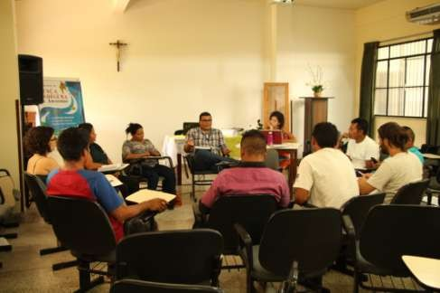

Figure 3: Negro River working group

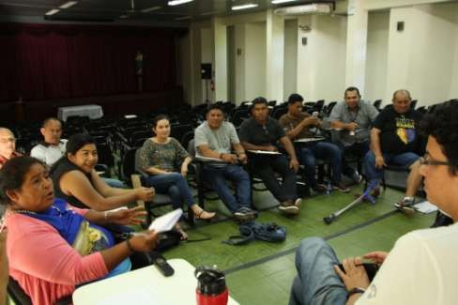

Figure 4: Solimões River working group
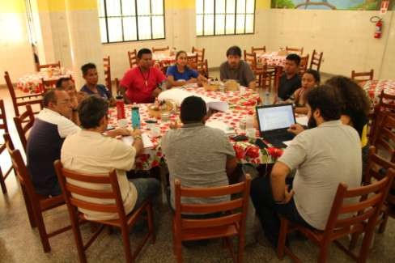

Figure 5: Purus and Juruá Rivers working group

The groups had as objective to know the reality of indigenous fishing in the main basins and rivers of the state of Amazonas through debates by territorialities. The working groups lasted 4 hours, with a coffee break between debates.
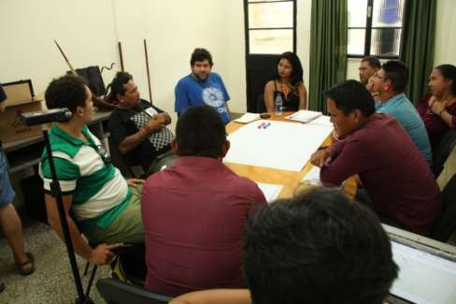

Figure 6: Madeira and Marmelos Rivers working group
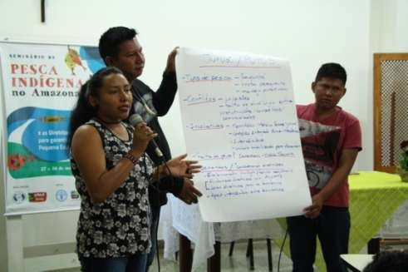
On March 28, the activities began at 9:00 am in the main auditorium with the presentation of the results of each working group. The presentations lasted about an hour and a half and then the plenary was divided again according thematic working groups. The team brought some suggestions from the thematic groups, based on the themes and opportunities that were most mentioned in the work groups separated by river basins.

Figure 7: Presentation of the results of the Purus and Juruá Rivers Working group
The suggestions presented to the plenary for the organization of the thematic groups were: fishery management, fish value chain and commercialisation, fishing tourism, aquaculture, and women. The participants suggested merging fishery management and fish value chain and commercialisation into one single group and expanding the fishing tourism group to community-based tourism to cover the many indigenous communities that are interested in tourism for sport fishing, like any other forms of tourism. The women decided to hold their specific group at another time so as not to miss the debate in the other groups, and the group was thus held during the lunch break. At the end, the groups were divided into fishery management, value chain and commercialisation; community-based tourism, and aquaculture.

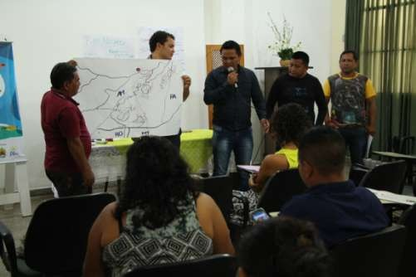
Figure 8: Presentation of the results of the Madeira and Marmelos Rivers Working group
The seminar went on to the final plenary session. At that moment, the Executive Secretary of Fisheries and Aquaculture of the state of Amazonas requested some minutes for a personal introduction to the participants. In the presence of the Secretary, the plenary was held. It included a debate on the SEPA, and then advanced to the referral and evaluation of the seminar.

Part I: Characterisation of regions
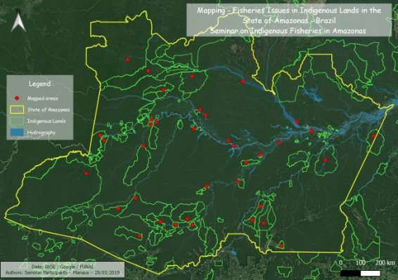
Map showing the territorial range of qualitative data recorded during the Seminar. The yellow line remarks the state territory of Amazonas. The green lines mark the indigenous lands recognised by Brazil. Each red point represents groups who have presented in the seminar.

Solimões River Basin
The Solimões River is the main tributary of the Amazon River, composing the upper portion, from its confluence with the Negro River. The Solimões River basin has areas outside the Brazilian territory and covers significant fractions of Colombia, Ecuador and Peru. In Brazil, the states of Amazonas and Acre are part of the Solimões River basin. Many of the tributaries of the Solimões River come from the Andes, and the main tributaries in the Brazilian territory are the Iça and Japurá Rivers, on the left bank, and the Jutaí, Juruá and Purus Rivers on the right bank (Paiva, 2009).
Several protected areas occur close to the banks of the Solimões River, such as the Jutaí-Solimões Ecological Station, the Jutaí River Extractive Reserve, the Mamiráua Sustainable Development Reserve, the Amanã Sustainable Development Reserve, the Auatí-Paraná Extractive Reserve, the Cujubim Sustainable Development Reserve, the Médio Juruá Extractive Reserve, and the Uacari Sustainable Development Reserve. In upper Solimões, there are an estimated 76,000 indigenous people distributed into 350 communities/villages, belonging to 18 ethnic groups: Tikuna, Kokama, Kambeba, Caixana, Kanamari, Witota, Katukina, Madja-Kulina, Mura, Maku, Makuna, Kaku- yuhup, Ava-Canoeiro, Miranha, Mayuruna, Desana, Tukano and Tuyuka. In the region that includes the Solimões river and the Jutaí river, there are the following regularised indigenous territories: Evare I, Evare II, Tukuna Porto Espiritual, Lauro Sodré, São Leopoldo, Tikuna de feijoal, Nova esperança do Rio Jandiatuba, Vui-Uata-In, São Francisco do Canimari, Maraitá, Betânia, Uati-Paraná, Prosperidade, São Sebastião, São Domingos do Jacapari, Espirito Santo, Estrela da Paz, Macarrão, Porto Praia, Miratu, Tupá-Supé, Ig. Grande, Méria, Marajaí, Jaquiri, Ilha do Camaleão, Lago do Beruri, Bía, Curuena. The Solimões river also crosses the country's second largest indigenous territory, the Vale do Javari, which has the largest population of isolated indigenous peoples in the world.

Fishing Context
The Solimões River presents a great diversity of fisheries and numerous conflicts and disputes over fishery resources. In its waters, large-scale commercial fishing takes place annually, yielding US$100-200 million from the direct sale of fish alone (Santos et al., 2006). The Solimões River supplies the capital of the state of Amazonas, Manaus, and is increasingly important as a producer of fish protein, especially after the reduction in stocks in other rivers near the capital. The creation of the Manaus Free Zone is also another factor that contributes to the uncontrolled fishing exploitation in the Solimões River, because it encouraged a large population migration to the state capital, drastically increasing the demand for fish (Batista et al., 2004 apud Ferreira et al., 2015). All these factors led large-scale boats to go up the Solimões River in search for areas rich in fish resources, entering into lakes that were previously restricted to indigenous and riverine communities (Ferreira et al., 2015). These fishing vessels have a much higher storage and extraction capacity than artisanal fishing, while the indigenous communities living close to the Solimões River practice subsistence fishing for the most part.
The main species fished for the subsistence of several indigenous villages are the pirarucu (Arapaima gigas), tambaqui (Colossoma macropomum), dourado (Salminus maxillosus), filhote (Brachyplatystoma filamentosum), surubim (Pseudoplatystoma corruscans), mapará (Hypophthalmus edentates), caparari (Pseudoplatystoma tigrinum), aruanã (Osteoglossum bicirhossum) and puroquê (Electrophorus electricus). Kanamari villages on the Jutaí River use archery, hook and line, longline, net, and hand-fishing. Kanamari villages also fish using a plant cultivated by them called oaka. Oaka is placed around a pulp of buruti and used as bait; it has an effect on the behavior of fish, leaving them disoriented and facilitating the catch.
The Kokama villages of the municipality of Jutaí manage their pirarucu fisheries and sell their catch to several cities, but they face several difficulties, including low prices and challenges in transporting their catch. The Tikuna ethnic group from the São José da Fortaleza community markets tambaqui, and their first share of cultivated pirarucu was successfully marketed in 2019. Women fish with reeds and men with fishing nets.
Conflicts
Municipalities in the state of Amazonas such as Tefé and Alvarães are facing problems related to the scarcity of fish resources, which has generated a series of conflicts and invasions of protected areas. Indigenous territories near the two municipalities do not have lakes, and for this reason the conflicts involving invasion of fishermen are more pronounced in the Sustainable Development Reserves, which also have indigenous and riverine communities living in their territories. On the other hand, lakes in the border cities between Colombia, Peru and Brazil have shown declines in fish stocks, according to the participants' reports, which further accentuate conflicts and invasions in protected areas and indigenous territories.
Diverse indigenous group participants in the Solimões working group expressed displeasure about encroachments into their territories. Most of these territories near the Solimões River are demarcated and regularised, and this should grant them exclusive use of the waters in these territories. However, there are several reports of incursions by commercial fishermen from municipalities such as Manaus and Tefé, and also by fishermen from Colombia and Peru, who harvest large numbers of pirarucus and turtles. According to the reports, fishermen invade the indigenous territories at night, making it difficult to supervise the region.
The vast majority of indigenous territories near the Jutaí River are not demarcated, as is the case with villages of the Kulina and Kanamari ethnicities. This further increases the fragility of these villages in the face of encroachments. The participants also reported incursions by loggers, hunters, gold prospectors, and drug dealers. Mining occurs within the Cujubim Sustainable Development Reserve, in Curuena and in the Mutum River, boundary of the territory of Bía. For over 20 years, more than 60 ferries have traveled the Jutaí River for the purpose of mining. Fisheries are also affected by the mining activity, since the fish caught in the mining region do not get the municipal inspection seal, affecting both commercialisation and subsistence consumption. The presence of loggers and drug dealers occurs mainly in indigenous territories located near the border between Colombia and Peru, as in the case of the Vale do Javari. In the case of illegal logging, the rivers to the north of the Vale do Javari have always been the main gateway to the activity. In recent years, the south of the territory has also been subject to deforestation for cattle farming and logging. Police surveillance and enforcement in this region is non-existent, aggravating the situation.
Mining activities in indigenous territories also bring other problems. Contact with miners, often allowed by the natives themselves, results in an easy entry of alcohol into the villages. Because of this, there is a high incidence of alcoholism in the indigenous communities of the region, especially among the Kanamari group. Monthly meetings are being held to reverse such situation. AIDS and Hepatitis B infections are also an alarming problem in Vale do Javari, and have caused high mortality in the villages, especially among children and youth. Recent studies confirm the high prevalence of Hepatitis B in blood samples of various indigenous peoples of Vale do Javari, and recommend urgent control and prevention strategies to combat the spread of the virus (Costa and Kimura, 2012). According to participant Kora Kanamari, cases of AIDS and Hepatitis B are so serious that they will kill an entire generation within 24 years if nothing is done to reverse the situation.

Opportunities
Despite the worrying data presented in the working group, the participants believe that fisheries management can help address the territorial problems, especially in non‐demarcated lands and in regions that do not yet have management. There are many fisheries management initiatives in indigenous and riverine communities in the vicinity of the Solimões River. The management of pirarucu was started with riverine fishers in the Solimões basin, specifically in the Mamirauá Sustainable Development Reserve, through the technical support of the Mamirauá Institute.
However, management has not been easy. Some participants brought up the difficulties in monitoring their own territories due to the high number of encroachments. These have reduced the fish stock, and set back management efforts. The Association of Communities working with the Sustainable Development of the Municipality of Jutaí (ACJ) is also working in the region on strengthening the surveillance in management areas.
In 2008, the government of Amazonas created the Regional Development Project of the State of Amazonas for the Green Free Zone (PRODERAM) with the objective of improving the quality of life in the municipalities of high Solimões, through access to healthcare, basic sanitation, and generation of jobs and income, along with environmental sustainability. According to the participants, the project did not go forward in some regions due to the lack of resources, while in other places it brought some benefits to communities, such as the training of youth in fisheries management.

Juruá River
The Juruá River lies in the western portion of Amazonas state. It is born in Peru and enters Brazil through Acre. It is a tributary of the right bank of the Solimões. Its basin is occupied in its middle course by the Kanamari, Majiha Kulina and Deni ethnicities, which are in the Juruá-purus interflow, as well as by several of fisher and extractive communities in or around Conservation Units (CUs). In this approach, populations residing between the municipalities of Carauari and Itamarati will be considered.
There are two CUs – Médio Juruá Extractive Reserve (RESEX) and Uacari Sustainable Development Reserve (RDS) – and two indigenous territories, Deni (1,530 million ha) and Kanamari (596,000 ha) along the middle Juruá River. There are also two other territories not yet demarcated by the State, but claimed by the indigenous population: Majiha Kulina from the Ueré canal, and Kanamari from the Taquara canal, located in the vicinity of the urban area of Carauari. In addition to these, there are approximately 30 Kanamari people from the Bauana canal who live within the limits of the Uacari Sustainable Development Reserve.

Fishing context
Fishing and hunting are the main sources of protein for the populations of the middle Juruá. They are carried out by indigenous peoples mostly with artisanal gear – arrows, spears, fishing lines, reeds and, to a lesser extent, small seines. Along the course of the Juruá River, where most of the extractive communities of the CUs are located, the use of small seines for subsistence fishing is more common. In these communities commercial fishing occurs on a small scale, alongside the main activities of income generation, such as the production of cassava flour and the extraction of seeds. According to the researcher João Campos-Silva, commercial fishing is more significant around protected areas (PA), in upstream Xeruã River and downstream Médio Juruá RESEX, since this is one of the few relatively structured production chains outside the limits of the PAs. With the exception of the Majiha-Kulina people from the Ueré canal and the Deni people from the Xeruã River, there are no significant records of fishing activities for income generation among the indigenous peoples of the region. Due to the proximity of the first people to the city, they make an effort at certain times of the year to fish species with relative commercial value in the local market, such as matrinxã species.
The pirarucu fishery is one of the main sources of income in the Médio Juruá. The pirarucu population has been monitored since 2005 in the CU’s and since 2009 in the Deni indigenous territory. The first experience of commercialisation of the species occurred in 2011 in the riverside communities of São Raimundo and Xibauazinho, located in the Médio Juruá RESEX and Uacari RDS. In the following years, the activity spread to several communities.
In 2017, the feasibility of a fishing agreement in the downstream area of the municipality of Carauari allowed communities located beyond the limits of the CU to participate in managing the fishery. In the same year, the Deni indigenous people of the Xeruã river also joined this value chain. In 2017, 1041 pirarucu fish were captured in the Médio Juruá, adding over 68 ton of fish that directly yielded approximately R$ 300,000 to the communities.

Conflicts
The area below this CU, located near the headquarters of the municipality of Carauari, faces significant pressure from fishermen of the colony. Petrobrás attracted many people from the countryside but when it left the municipality, fishing was the only means of livelihood available. This has put a lot of pressure on natural resources.
When the rivers flood, the encroachments become more frequent. Between December and February, pirarucu, matrinxã, catfish and to a lesser extent, turtles are targeted. In June and July, the focus is mainly on tambaqui and turtles. This pressure directly affects the food security of three communities in the RESEX – Novo Horizonte, Pupuaí and Roque – who face a worrying scarcity of fish resources in the dry season. In a similar situation are the Kanamari from the Taquara canal, located in the immediate surroundings of the urban area of Carauari. According to Wanen Kanamari, the indigenous teacher, "There is practically no fish to eat. When you are able to fish something, you have to go very far and even then, you only find small fish, which only serves for lunch. They are buying fish in town to eat in the village."
Pressure from local fishers directly affects the Majiha-Kulina people from the Ueré canal. According to Zé Pio Kulina, one of the Matatibem village leaders, encroachments into their territory is frequent, but surveillance has begun to be carried out. In the case of this indigenous area, the encroachments are mainly by former non-indigenous residents of Ueré who left the region during the rural exodus discussed earlier. Despite the threats, the Ueré canal is still an abundant area of fish resources and turtles. However, the indigenous people already complain that the concentration of fish, essential for food, is moving further away from the village. Manoel Cunha, in his comment on the situation of the Majiha from Ueré, pointed out the urgency of guaranteeing exclusive rights over the area to natives as a strategy to conserve resources. In his opinion, the Ueré canal is an important source of several species, such as matrinxã and tambaqui, and their conservation is fundamental to the food security of the natives and the urban population.
The Kanamari people from Bauana canal, the Kanamari and the Deni people from Xeruã are in a more comfortable situation in relation to pressure on their territories and access to fishing resources. The Bauana canal is located in a privileged area of the Uacari RDS, where access by potential invaders becomes practically infeasible, but there are conflicts between indigenous and riverside peoples for the use of lakes and other important environments for food. In this case, it would be important to initiate the process of territorial agreements between communities.
The Xeruã River is known in the region for its abundance of natural resources. Since the demarcation of the Deni indigenous territory in 2003, indigenous people have been engaged throughout the year in protecting the mouth of this river, and there are no recent records of high impact fishing activities. Extractive communities upstream of the Xeruã River are again suffering from the pressure caused by the demand for fish from the urban area of Itamarati and the city of Cruzeiro do Sul/AC.

Challenges
Although some training initiatives on indigenous people and territorial rights have been carried out, one big challenge is in disseminating knowledge about legislation and management to indigenous areas.

Purus River
At a total length of 3300 km, Purus River is known for its immense sinuosity. The river is born in Peruvian territory and enters Brazil by the state of Acre; its upper course was not discussed in this analysis. In the middle Purus are the ethnic groups Apurinã (of the linguistic family Aruak) and Paumari, Jamamadi, Suruwaha, Banawa and Jarawara (all of Arawa family).
Throughout the region of the middle Purus River, there are about 22 demarcated indigenous territories, the Médio Purus RESEX and the Piagaçu-Purus RDS, covering an immense area occupied by Indigenous Peoples. In this analysis, we present information only from the seminar participants. The Paumari are distributed in five indigenous territories: Cuniuá (42,800 ha), Lago Manissuã (22,970 ha), Lago Paricá (15,792 ha) – the three upstream from the mouth of the Tapauá river and downstream from Lábrea; and Paumari from the Ituxi river (8,000 ha), and Paumari Marahã, also inhabited by the Apurinã (119,000 ha). Besides these, the Apurinã are in the following territories: Aciman (41,000 ha), Itixi Mitari (182,000 ha), Caititu (308,000 ha), Apurinã from São João canal (18,000 ha), and Apurinã from Tauámirim canal (96,000 ha).

Fishing context
Most natives fish for their own consumption, and they have plenty of fish in the many lakes of the region. The general characterisation of the fishing situation is very similar to that of the Juruá River, with invasion of fishing boats that press for agreements disadvantageous to the indigenous communities.
The Paumari people have developed an initiative aimed at structuring their lucrative pirarucu fishery. Paumari participants Eugênio and Raimundo affirmed that before the management proposal, their leaders used to lease out the lakes in their territory and also practiced ornamental fishing. When thinking of solutions, the Paumari leaders wanted to acquire their own boats, but were then convinced that a boat would be of no use if there were no stocks left to fish. After many internal debates, stimulated by the OPAN, they chose to introduce a type of management system based on a model already developed by the Mamirauá Institute in the Tefé region. In 2011, they undertook a count of the pirarucu in the river and two years later, they started managing the fishery for commercialisation. It took them three to four years to get results but they were able to work together. Before that, fishermen would catch the small-, large- and medium-sized fish, according to Eugenio.
The Paumari have historically experienced socio-political pressures, mainly from commercial interests who have encroached into their territories since the 19th Century in search of animal skins, manatees and pirarucu. Trade relations were in the scheme of aviamento - a situation akin to forced labour in which the employer provides goods in exchange for labour, so that the worker has no control over the prices of the goods and is forced to work under exploitative conditions to repay the debt. It is in this context of historically power relations that the activity of pirarucu management among the Paumari started, in order to make possible greater financial autonomy and empowerment of the indigenous groups. In the words of Eugênio, "The management has helped us stay united; I think that is the main role of management.”
Like the Paumari, the Apurinã also practice management today in two indigenous territories: Itixi Mitari territories and Lago Ayapoá territories. In the first, the management began about six years ago and covers 11 communities, from Terra Vermelha to Itaboca. The Apurinã have a management focus on pirarucu, but also on migratory fish (also known as “big fish”). In 2010, a territorial management plan was drawn up and the emergence of the Association of Apurinã Indigenous People from Itixi Mitari (APIATI) followed in 2012. Decisions taken in their assemblies were participatory and transparent. Following this, the Association of the Indigenous Women Working in Terra Grande was created, and this greatly strengthened the engagement of women in all the processes. Initially, there were 180 pirarucu fish in six lakes. In the last year, they were counted to be 5,000.

Conflicts and challenges
In the Paumari area, the surveillance scheme was established with six radio communication bases and contributed greatly to reducing encroachments into their territory, but did not eliminate them completely. Therefore, one of the recommendations in the Workshop is for a greater presence of inspection agencies such as FUNAI and Brazilian Institute of Environment and Renewable Natural Resources (IBAMA) in the lands. They point out that because of the fragile land control and encroachments by fishing boats, the stock of fish has fallen in the lakes. One of the major challenges for the management project is to make the activity self-sustaining, since the fishery caters to the local market. The price of fish alone doesn’t justify the cost of managing the fishery, but, as Luiz Fernandes, a regional coordinator with FUNAI, said, the real gains are the strengthening of community organization, land management, and the participation of women, youth and children.
The best way to raise the price of fish is to reduce the number of intermediaries as it moves from the indigenous territories to the capital, but the Paumari people alone cannot meet all the conditions of handling, storage and transport. Currently, they sell in partnership with the Association of Rural Producers of Carauari (ASPROC), formed mainly by riverside people. The Paumari have had a fruitful partnership with the riverside people for several commercial activities, such as the extraction of chestnut and açaí.

Negro Basin
The Negro River basin is formed by tributaries that are born in Colombia, and the Negro course is born in Venezuela, occupying the northwest portion of the Brazilian Amazon. It is one of the largest rivers in the world and the longest black-water river. Its waters are dark due to the high acid content, which produce intense decomposition of organic matter. In contrast to the Solimões basin, the acidic pH levels of the water do not favour great biological diversity, including fish.
The Negro River basin is also known for its strong social and environmental preservation. It has 23 indigenous peoples from three linguistic families. The region, considered one of the great centers of social and linguistic diversity of the Latin American lowlands, has 16 territorial demarcations at the federal and state levels. In the upper and middle portion of the river, upstream of Santa Isabel do Rio Negro, there are 8 homologated indigenous territories and one in the process of demarcation in the middle-to-lower course of the river, around the municipality of Barcelos, Acará-Padauiri. The indigenous territory of the upper Negro river (8 million ha) adjacent to Cué-Cué-Marabitanas (809,000 ha) is one of the largest continuous territories in the country. Of the CUs, Pico da Neblina National Park is in the high part of the limits of São Gabriel da Cachoeira and in the lower portion, in the limits of the municipality of Novo Airão, are the Jaú and Anavilhanas National Parks, Rio Negro RDS, Unini RESEX and Rio Negro State Parks (northern and southern sectors).

Fishing context and challenges in Upper Negro River
The Uaupés, Tiquié, Içana and Xié Rivers and the course of the Negro River itself make up the upper Negro river region where two unfavorable characteristics to fishing prevail: low availability of fish and a rocky course, which make them, in many portions, difficult for navigation and for fishing activity. The city of São Gabriel da Cachoeira takes its name precisely because it is situated in one of the areas with waterfalls of small height, but with an immense volume of water, where fish are unable to continue swimming for the piracema (spawning). Fishing in the region is thus mainly for subsistence and a small portion is sold by boat to communities along the river. The demand for fish in the city is greater than what the local fishery can supply, so 60 per cent of the fish sold in São Gabriel comes from the municipalities of the middle Negro river – Santa Isabel and Barcelos.
In the city, there is the Association of Fishermen of São Gabriel da Cachoeira with 684 members, but this includes fish farmers. With the support of the Agricultural and Forestry Development Institute of the state of Amazonas (IDAM), tanks were built in urban and rural lots, fed by watercourses and streams. IFAM provided the fingerlings and IDAM supplied the feed. However, according to the current president of the association, most of the fry produced with governmental subsidies were destined for big companies, while the indigenous fishermen and the association received an insufficient amount. In 2012, the municipal health department forced the closure of tanks to avoid risk of epidemics spreading from stagnant water, causing great discontent among fishermen. The Association demanded that the health department regularise the fish tanks and make the project feasible, instead of simply prohibiting them. Health is also food, the president said at the time.
São Gabriel da Cachoeira is the most indigenous municipality in Brazil, with 76 percent of the population declared indigenous by Brazilian Institute of Geography and Statistics (IBGE). The food base is fish with cassava flour and other cassava derivatives. However, the price of fish is unaffordable for most people, because of low supply and high demand. Those who choose to live in the urban area, usually to be close to health and education services, raise their children with little access to fish, consuming canned sausage and beef, and frozen chicken, the cheapest protein sources, instead. This situation impedes the food cultures of the Indigenous Peoples in the city, severely hampering their food sovereignty and nutritional security.
The ISA has initiated several programmes to promote fishing activities among the communities of the Uaupés, Tiquié (tributary of Uaupés) and Içana. In the Tiquié and Uaupés rivers, a majority of people are from the oriental Tukano family (Tukano, Tuyuka, Piratapuia, Dessano, among others) and Hupd'äh (of Maku linguistic family).
In the upper Tiquié River, fish has always been in short supply. Its inhabitants developed an accurate technique of placing fishing traps in the waterfalls of the region. From 2005 to 2008, ISA assisted in mediations with the communities, one of which was to stop the practice of tinguijamento, whereby a macerated wine (timbó) is introduced in the water, which depletes the oxygen in the water and kills all the fish. However, it is difficult to ensure compliance, because tinguijamento is the most efficient way to catch a good number of fish. In the middle Tiquié River, fish are not so scarce, because there are lakes favorable to their reproduction. Here too, the stocks have declined as a result of overfishing, carried out by residents of the upper Tiquié River. Between 2009 and 2013, they developed a project to make a fishery management plan and stipulated some lakes closed for fish reproduction, using signs. But these, too, were encroached upon by external fishers. The community concluded that in order to make management work out, they needed to expand the debate and raise awareness.
In the upper Uaupés River, near the border with Colombia, the fishing situation is quite difficult due to the presence of many waterfalls. In Iauaretê, located between the middle and upper Uaupés, one of the largest districts of São Gabriel da Cachoeira, the pressure for fish is great as food is in short supply in this area. Thus, the aquaculture project was also applied in Iauaretê, a small indigenous town with more than 3,000 people. According to Radson Alves, a SEPA technician, the food shortage is so great that the locals consumed the small fish in the tanks before they could even grow. Moreover, the project introduced alien species, such as tambaqui (colossoma macropomum) and the long growing period didn’t allow fair returns on the price of feed.
The lower portion of this river has one of the best conditions for subsistence fishing in the region. However, a few years ago, residents of this region suffered with the invasion of fishing boats that supply the fish trade in the urban part of the municipality and with the invasion of the Baniwa kin group who came from the Içana River. The "invasion" in the lower Uaupés area is done mainly by the local kin groups who have already moved to the city, as well as by travelers (also indigenous) in transit to Tiquié, Iauaretê and upper Uaupés. Here, then, there is an internal problem, among the natives themselves (although illegal fishing of non-Indians occurs, but on a very small scale). In view of this fact, eleven communities in the lower Uaupés have been trying to formulate a fishery management plan, with the assistance of FUNAI, ISA, and FOIRN. In this project a group of 23 AIMA (Indigenous Agents of Environmental Management) was trained in the use of GPS, interpretation of satellite images and more. The emphasis of this work is the ecological mapping and monitoring (alteration of rain cycles and species according to the indigenous calendar), but they also take on the role of territorial surveillance, in the attempt of dissuade the presence of "invaders". Three major leadership meetings of the 11 communities involved took place in 2013, 2014 and 2017, along with representatives of Federation of Indigenous Organizations of the Negro River (FOIRN), FUNAI and ISA, to diagnose the problem and develop a management plan. Some objectives of the plan have been consolidated, but not completely. During the seminar, José Ivanildo Desano, a resident of that region, said that FUNAI should give more support for them to practice surveillance.
In the Içana River, the situation of fish scarcity is worrying, affecting the nutritional situation of the residents. Between 2006 and 2008, the Indigenous Organization of the Içana Basin (Oibi) with the support of FOIRN, ISA and Leônidas and Maria Deane (ILMD)/Fiocruz Amazônia Institute held a series of meetings to try to develop fishery management, but it was not implemented in the practice. Ronaldo Baniwa, present at the seminar, said that "there used to be a lot of fish in the past, but with the illegal practice of seine fishing, selling, the fish started to disappear". According to his evaluation, the management project did not work because "it was thought for the indigenous people and not by the indigenous people. These are two different things. They only did the first stage of establishing the agreements, but at the implementation, the project was suspended". Nowadays, when people go to the city to buy manufactured goods, they also buy frozen chicken to take to the communities.

Fishing context and challenges in the Middle Negro River
After receiving the waters of all its tributaries from above and below the waterfalls of São Gabriel, the Negro River forms a mighty navigable waterway. Its middle portion begins downstream of São Gabriel and goes to the municipality of Barcelos, receiving the waters of the Marié, Tea, Uneiuxi, Jurubaxi, Preto, Padauiri Rivers and others. Many of these rivers suffer from the pressure of tourism related to sport fishing in which tourism companies organise groups to fish especially tucunaré (genus Cichla), on the fee-fishing model.
In search for more preserved and productive areas, these companies advanced in the enticement of indigenous leaders, establishing precarious contracts that disregarded the collective rights and the typical forms of organization of indigenous communities. Most of the indigenous communities were unaware of this type of fishing and did not know much about the activities that took place within the river, generally following only the negative impacts, such as: garbage, fish mortality, noise and banzeiro (waves caused by vessels). The activity constituted another pressure or conflict for access to resources of the river, along with commercial fishing vessels coming from the municipal headquarters.
The first successful experience with fishery management, started in 2014, took place in the Marié River. This river is considered by the sport fishermen as the last frontier of Tucunaré Açu (Chicla temensis) and therefore has been much sought, but so far in an exploratory way. The structuring initiative was carried out by the Association of Communities of the Lower Negro River (ACIBRN) and FOIRN, which represents all grassroots associations. "The unprecedented nature of this initiative is, first of all, due to the participatory form in which it was built. Based on the interests of the communities, partners and official bodies were involved in the development of a sustainable and community-based sport fishing tourism model," said Camila Barra, an anthropologist of the ISA's Negro River Program.
Similarly, the Jurubaxi-Téa indigenous territory (housing the indigenous Arapaso, Baniwa, Baré, Desana, Kuripaco, Nadöb, Pira-Tapuya, Tikuna, Tukano and Tariana tribes) suffered with invasions by tourist companies and commercial fishermen for a long time. Since 2010, there has been a civil inquiry in the Federal Public Prosecutor’s Office (MPF) with the aim of accompanying this issue. But in 2017, the indigenous territory was in the process of study for identification and demarcation, and the limits of the territory were not clear, and this hindered the determination of criteria for development of sport fishing in this region. Then, the Association of the Middle Black River Indigenous Communities (ACIMRN) developed, with the partners FOIRN and ISA, the necessary technical studies and participatory workshops to elaborate the regional fisheries management plan.
In the context of the National Policy for Territorial and Environmental Management of Indigenous Territories (PNGATI), in 2015, leaders from all communities were present at the workshop held by FOIRN, FUNAI and ISA in Santa Isabel do Rio Negro, taking note of recent tourism legislation on indigenous territories and especially on the model experience developed by ACIBRN in the Marié river. When the Jurubaxi-Tea indigenous territory was declared, in 2017, the entire regularisation procedure of the activity could therefore be consolidated.

Madeira River Basin
The Madeira River is an important tributary of the right bank of the Amazon, occupying the southern part of the state. Its complete basin covers 1,400,000 km² of area, beginning in the state of Rondônia (being the main river of the capital city Porto Velho), and in the state of Amazonas, crosses Humaitá and Manicoré in the middle portion, and Borba, Autazes and Nova Olinda do Norte in the lower portion. Madeira is a white-water river like those of Solimões, carrying a large content of organic sediments. The Marmelos River, its tributary most mentioned here, is on the right bank of the Madeira River, covering its middle portion, in the region of the municipalities of Manicoré and Humaitá. Tenharim, Parintintin, Torá, Pirahã, Mura, Jiahui and Munduruku Indians are found throughout the Madeira basin. In middle Madeira river (including the Marmelos river), where most of these peoples are, there are 12 demarcated indigenous territories.
On the border of the state of Amazonas with Rondônia, there are the Mapinguari National Park (Madeira-Purus interfluvial region), the Humaitá National Forest, and the Tenharim-Marmelos indigenous territory, on the right side. Despite these demarcations, the boundary between federal states suffers strong territorial pressure with deforestation, land - both of the Parintintins, Lago Capanã with 6,000 ha of the Mura, Terra Torá, where they live beyond the Torá, the Apurinã with 55,000 ha, and the Sepoti lands, with 251,000 ha, Tenharim do Igarapé Preto with 87,000 ha, Tenharim Marmelos, with 498,000 ha, Tenharim Marmelos gleba B with 475,000 ha – the four territories of the Tenharim Indians. And, finally, there is the Jacareúba indigenous territory of isolated Katawixi people.
Environmental studies point out that the "deforestation arc" – an area of the Amazon that has the highest deforestation rates resulting from monoculture and cattle raising activities - initially in the states of Pará, Rondônia and Mato Grosso, is advancing in Amazonas from the Madeira River (Domingos & Berman, 2012). The region also has plenty of illegal mining and logging activities. In other words, "the southern Amazon is today the great frontier of deforestation”. This region suffers ecological consequences such as far-reaching fires, and social consequences from the arrival of settlers from the south of the country. It is, therefore, a very conflict-ridden region with many reports of violence and homicides involving indigenous peoples, considered to be contrary to progress and development.

Fishing context of Middle Madeira River and Marmelos River
Fishing is the main food source of the mentioned peoples of the Madeira basin, including fishing for self-consumption in the foreground. In addition to subsistence fishing, since 2005, Tenharim people have been experimenting with agreements with sport-fishing tourism companies interested in the potential of tucunaré fish of the Marmelos River. This represents the first experience of sport fishing tourism in partnership with indigenous peoples. Environmental impact studies coordinated by IBAMA began in 2011 in order to present a diagnosis of ecological viability, and the partnership continues to this day. The project was coordinated by the Tenharim Morogitá Indigenous People Association (APITEM), with the support of FUNAI, and takes place in the months when the ebb takes place in the river, between July and October. According to Antônio Tenharim, present at the seminar, the company can stay for 45 days in the place, taking eight people at a time, and honors the payments of the local guides. The only species allowed to fish is the tucunaré, and no other animals can be photographed. Respecting local agreements, the company reports on the amount of fish caught and the waste should be taken back.
In the lower Marmelos, there is a concentration of multiethnic communities with the majority corresponding to Torá and Munduruku Indians, but also Mura, Matanawi, Tenharim and Apurinã people. There is a demand for demarcation of the indigenous territory in the lower Marmelos, which includes the claims of eight indigenous communities located there, and other three communities whose identity is mixed between indigenous and riverine people. The fishing of these communities is exclusively directed towards subsistence. However, they encounter difficulties of sovereignty over their territory since it is not recognised by the State.
The absence of a demarcation process that recognises the Lower Marmelos indigenous territory has generated conflicts in the region that affect the life of the indigenous people and the usufruct of the earth's resources. Notably, indigenous people report conflicts of land use as the main impediment to their use, and to a lesser extent, the presence of more or less constant invasions in their territory.
A situation that has generated the greatest and most delicate conflicts in the area is the overlapping of use over the middle course of the Marmelos River, in the portion demarcated as Tenharim /Marmelos Gleba B indigenous territory, which is used by both the Tenharim indigenous people, residing further upstream of the river near the Transamazonica (BR 230), as well as by the indigenous communities of the lower Marmelos mentioned above. From this overlapping use of different peoples, ignored at the time of the demarcation of Gleba B, a conflict of interests arose when Tenharim peoples elaborated tourism plans for the region in partnership with the companies. The indigenous people of the lower Marmelos, in turn, use portions downstream of the demarcated land for the purpose of hunting, fishing and chestnut extraction mainly, which are basically subsistence and income supplementation activities. There are complaints from both sides: the Tenharim claim that their kin group of the lower Marmelos follows non-indigenous people from Manicoré and Auxiliadora to the region, something they do not accept. On the other hand, the indigenous people of the lower Marmelos state that they were not consulted about the tourism project, that they do not benefit from it, and that this damages them both in their subsistence activities in the area, and in terms of environmental impacts in the region - fish shortages and water pollution - caused by both tourism activity and the heavy traffic of boats in the Marmelos.
In 2015 the conflict reached a highest point, when the natives of the lower Marmelos decided to prevent the tourism activity because they considered to be harmed. But the tourism companies entered the river with police escort, generating police incursions in Vista Alegre village and confrontation between the natives and the police, resulting in several natives attacked. After that moment, FUNAI and the Federal Prosecutor's Office approached the issue, trying to reach a peaceful and consensual resolution for the problem. In the next years, dialogues between the peoples of lower Marmelos and the Tenharim people were promoted to seek consensus on the practice, but the lack of indigenous territory demarcation in the lower Marmelos puts the natives in a legally underprivileged position. Nevertheless, progress has been made through the Federal Prosecutor's Office to ensure that the practice is carried out in accordance with the rights of consultation and compensation of indigenous peoples.
The situation of fishing of the Tenharim in the Igarapé Preto indigenous territory is turned to self- consumption. They use traditional fishing techniques: arrow, reed, and timbó, although the latter is considered harmful and has been gradually less used. According to Cleodo, present at the Seminar, the great abundance once experienced in fishing is now threatened due to the presence of mines, since the 1960s, which have silted up the river. But there are still well-preserved sites, especially on the Roosevelt river, which also lodges a sport fishing tourism company. There is conflict with this company installed there because the company prohibits the Indians from using certain lakes and canals and limits their access to the Roosevelt River. Cleodo's intention in attending the seminar was clearly to learn more about this modality and to be able to implement a sport fishing tourism agreement in his region that would benefit his people.

Conflicts and challenges
In addition to the specific conflict involving the indigenous people of the lower and middle Marmelos, the inhabitants of the villages of the lower Marmelos report that there are invasions in the area which they cannot completely restrain. They report invasions by non-Indians, for fishing, chestnut extraction, açaí collection, and logging, mainly.
The entire region of the Madeira basin encounters problems related to the presence of gold mines, an activity that is especially intense in the municipalities of Manicoré and Humaitá. Although the Marmelos River itself is relatively safeguarded from this activity, mainly due to the demarcation of indigenous territories in its course, the presence of gold mining in its basin is possible. If so, gold diggers are probably located on the upper course of the affluent of the Marmelos. It is necessary to emphasize that this possibility implies an immense environmental and sanitary burden for the resident indigenous population of the region, mainly due to the possibility of contamination of waters and fish by mercury used in the mining activities.

Fishing context of the Lower Madeira
In the lower Madeira, the indigenous situation is different. Indigenous people are settled closer to Manaus; they can travel by land and also through the waterway. Among the municipalities of Careiro da Várzea, Castanho and Autazes, there is an ancient occupation of the Mura people that, for different reasons, unlike other peoples, does not have a large indigenous territory that allows the preservation of a continuous portion of forest. They are located in small "islands" of indigenous territories, in 28 different territories that allow them to reside but grant no great potentials for management of the region. They are surrounded by cattle and buffalo farms that use the floodplains also used by the Mura people for crops and fishing. This is the case of José Claudio, from the municipality of Autazes: "My indigenous territory is surrounded by farmers; in the dry season they take the buffalos to the floodplains and these animals scare the fish. We do self-protection due to the absence of responsible bodies". Ariane confirms that before the presence of cattle, the waters of the canal entered the lakes, taking a lot of fish, as jaraqui (Semaprochilodus taeniurus), but the presence of buffaloes increased the turbidity and silting of the water, interrupting this natural flow of water and fish supply.
Manoel Jorge, from Tucumã Verde village, in Careiro da Várzea, reported that in the lakes of his region the white people eliminated the larger fish with drag net fishing. "There are some lakes that we try to preserve, but it is difficult because our area has not been demarcated. It is small: we have only 350m of front with 700m of bottom and besides that, there is no lake in our land. To catch fish we need to go to other territories". His wife Cleia reported that in the Boa Vista and Jacaré villages there are plenty of lakes and fish because their relatives are able to protect them.
There is a large concentration of indigenous population in Autazes: there are 3,000 indigenous people in 34 villages. There are three fishermen's colonies and a fishing union whose members include indigenous and riverine, and non-indigenous people. José Claudio states that unfortunately the fishing prohibition insurance comes in an irregular way for the members.

Conflicts and challenges
Some of these lands are influenced by unregulated sport fishing and others suffer from the damage caused by large fishing boats that circulate in the region. When the case is an invasion, they are initiating the community surveillance process with the support of FUNAI. Currently, the Mura of several of these indigenous territories are mobilised for re- negotiations to reach municipal fishery agreements in order to ensure that their rights to land use are respected. According to Rafael Illenser, from FUNAI in Manaus, territorial agreements are the best solution for the complex land situation.
Still within the basin of the lower Madeira, in the municipality of Borba, there is the Coatá-laranjal indigenous territory, with 1,115,000 ha, where 4600 Indians from the Munduruku and Satere-Mawé peoples live. The Canumã River that crosses the indigenous territory has been very explored by commercial boats since the early 1960s. With the chase, the fish flee from the territory. Alexandre, Munduruku from this indigenous territory, says that the boats made agreements with the leaders and began to fish in exchange for an amount, but this was vetoed by FUNAI years later. This relationship has returned, but is always denounced because it does not present a fair payment relationship. Later, in the 1990s, some Indians were hired to fish with the companies. They appear in the region in the months of February, March and April when it is the time of the migrating fish, in the case of Jaraqui and Matrinchã. At present, their relatives receive a good amount from commercial fishing, but self-consumption fishing is impaired and it seems that the activity is not fully regularised. Some meetings involving the local association, the FUNAI, and the companies are being articulated to seek a solution.

Part II: Seminar on Indigenous Fisheries and the SSF Guidelines
Sustainable management of fishery resources
The SSF Guidelines aim at the sustainability of fisheries, focusing on the need and importance of sustainable management of resources to achieve this end. According to the Guidelines, the State and all other stakeholders in the management of fishery resources should promote and implement appropriate management systems in accordance with national legislation and voluntary commitments. In this sense, the seminar pointed out a series of successful management initiatives that already take place in the Amazon region and which present several points in consonance with the Guidelines.
One of these initiatives is the management of pirarucu (Arapaima gigas), an activity that began in 1999 in the region of Tefé, middle Solimões, with riverine communities, based on the technical support offered by the Mamirauá Institute for Sustainable Development (IDSM). From then on, the Deni, Paumari and Kokama communities have managed their fisheries with the support of OPAN and FUNAI. Pirarucu is the largest freshwater fish in the world, weighing more than 200 kilograms. It is a very important fish in the Amazonian cuisine and it has economic, alimentary and cultural importance for diverse indigenous and riverine communities. Prior to management, the species was listed in the Convention on International Trade of Endangered Species of Wild Fauna and Flora (CITES), and since 1996 its capture has been banned in the state of Amazonas. The ban on pirarucu fishing throughout the year has affected numerous families residing in floodplain areas, for whom the sale of the fish is an important component of their income (Amaral et al., 2011). The management of pirarucu reversed this situation, increasing its stock by approximately 427 per cent in managed areas of the Mamirauá RDS, making it possible to carry on sustainable commercial fishing of pirarucu.
During the Workshop, there was a great interest in the management initiatives by Indigenous People from those who do not yet have such measures in their fisheries. In the thematic work group on ‘Management of Fishing Resources and Marketing,’ there was a rich exchange of experience and contacts. According to the most experienced participants, the first step for any management initiative in the Amazon is the organisation of the indigenous community itself, based on the rules of individual tribes, each with its own culture and internal norms.
Another important aspect is the participative and consultative dialogue between all the actors that participate in the management and the indigenous community, so that they meet the needs of the community. It is also necessary that meetings take place to discuss management plans that respect the cycles of the species and the floodplain lakes. Management plans also need to comply with the state rules and existing legislation of each fishery resource. In the management of pirarucu, for example, it is necessary to observe the closed season (Ordinance 480/9, IBAMA), the minimum legal size for catching, and the fishing quota established for this species (Normative Instruction 001/2005, IBAMA and State Decree no 36083, July 2015).
The management of pirarucu is divided into the following stages: 1) environmental monitoring, 2) counting of pirarucu fish in lakes, 3) fishing, 4) fisheries monitoring, 5) evisceration of fish, 6) marketing of production, and 7) share of profits (Alencar et al., 2014). Some activities occur throughout the year, such as lake surveillance, while others occur only at specific times, such as counting of pirarucu, fishing, marketing and monitoring (Alencar et al., 2014). The fishing quota allowed for each lake is defined based on a stock assessment through a counting methodology. The pirarucu counting method was developed in 1999 by the researcher Leandro Castello, as an adaptation to the traditional counting method adopted by riverine and indigenous fishermen (Amaral et al., 2011). Counting is mandatory in pirarucu management according to specific legislation; only 30 per cent of adult counted fish are caught and traded, leaving 70 per cent of adults as a means of securing reproduction and continuity of the population (Amaral et al., 2011). Due to the size of pirarucu, the whole count is done on naked eye inspection. When a pirarucu fish appears on the surface to breathe, experienced fishermen are able, through sight and hearing, to obtain key management information such as number of individuals in a given lake and the approximate size of the fish (Amaral et al., 2011).
In the meetings to establish the fishery management, internal rules and regulations are defined in a participatory manner with the indigenous communities, in which they have full decision-making power over the management that takes place in their territories. A number of aspects need to be established, such as the definition of permitted fisheries and their sites, taking into account that fishery of other species scares the managed fishery and may hinder the success of management. Among the Paumari agreements consolidated between different villages, they agreed that each one must receive the amount according to the participation in each of the stages, through a scoring system. Points are gained in the participation in lake surveillance, for example, as well as fishing and cleaning the fish. Thus, the person who participates in all stages receives the maximum sum of points converted into financial resources after the sale. The system does not penalise those who do not participate, only rewards those who participate. This system was not adopted among the Deni people; all the resources acquired go to the association that represents them.
It is also necessary to establish a zoning of the lakes, defining which lakes will be destined for total preservation, which will be managed, and which will be destined for consumption. These categories of lakes are defined jointly with each indigenous community. The quantity of lakes required for the protection of the fishery resources varies according to the characteristics of the lakes, the purpose of the management, and the capacity to protect a given territory. In the words of Paru Deni, during the seminar,
“First we started fishing, but before that we protected the lakes where no fishing was practiced; we started with the count, first there is no fish, pirarucu is disappearing, but then we protect the lakes (...) then, for 4 years we held on, and pirarucu began to appear; first there were 55 fish and we fished for our Imamushinaha party, the other year we counted 150, we dropped 50; then we counted 250 fish three times” (for three consecutive years).”
An important step in fishery management is lake surveillance. Indigenous communities will need to adopt surveillance strategies, to be implemented and planned along with any fishery management. These aspects are important to ensure successful management, as invasions of non-indigenous fishers, large-scale commercial fishers, and even indigenous fishers from the city or other communities are common in all large basins of the Amazon. Management and surveillance re-signify relations with the territory and allow the community to have control over its lands, lakes, rivers and the fishing resources on which they depend. While surveillance is necessary for successful management, the entire management/surveillance set makes communities recover the ownership of their territories, precisely by implementing a system of vigilance, monitoring and care of indigenous territories, rivers and lakes. Management becomes even more relevant to the governance issue. In the words of Rose, from the Baré ethnic group, "management makes it possible to guarantee our territory, especially when our lands are not yet demarcated".
Vigilance is a great challenge. According to the most experienced participants, all areas will be impacted by invasions, but indigenous communities need to remain strong during this process until the invaders recede. Another major challenge of management is the issue of marketing and adding value to managed fish, a situation also pointed out during the Pirarucu Management Diagnostic Seminar in Protected Areas of the Amazon carried out by OPAN in 2018. Despite the increase in the production of managed pirarucu in recent years, with a four-fold growth in 2012, the price of fish decreased practically by half, changing from an average of R$ 7.12 to R$ 3.78, already considering inflation. The participants also mentioned the difficulty of the flow of production and earns of intermediaries over the resource, which present high values for the final consumer. Although one of the results of the pirarucu management is the increase of income of the indigenous fishermen, a greater valorization of the fish at the base of the value chain is still necessary.
Pirarucu management has brought diverse social, economic and cultural benefits, such as local income generation, valorization of indigenous cultures, growing "pride" in the community, strengthening of indigenous villages and of their relationship with the territory (Campos-Silva & Peres, 2016). According to the author, pirarucu management is an excellent opportunity to generate income for thousands of families and shuns external commercial fishermen from indigenous territories. The pride that successful management generates to the community also empowers and strengthens the bonds of the community. The researcher concludes his research affirming that the management of pirarucu is a rare window of opportunity to harmonise the goals of sustainable management of natural resources and reduction of poverty.
“The management of pirarucu is an example of citizenship. It started very small with only 42 fishermen who believed that it was possible to work with a resource that was in a state of scarcity, to return to have this resource in abundance and to re-explore it through a sustainable perspective. When I see the management being every day more adopted as the flag of aggregation to discuss other values such as health, education, basic rights of the population, this reinforces even more the idea that management is an example of citizenship. Management has power, it's just a theme, but through it we can discuss other things."
- Ana Cláudia Torres, fishery coordinator of the Mamirauá Institute
Despite all the positive results brought about by pirarucu management in Amazonian lakes, there is not enough investment from the federal and state government in Brazil for this purpose, despite the popular claim (Campos-Silva & Peres, 2016). The Guidelines could strengthen this claim and the struggle of many indigenous communities that want to implement pirarucu management in their territories. The management of pirarucu puts the Guidelines into practice, even before the indigenous people and institutions have access and knowledge about their guidelines because it is able to meet all its objectives, such as: improving the socioeconomic status of indigenous fishers, securing the sustainability of pirarucu fishery, and improving the contribution of artisanal fisheries to food security and to an economically, socially and environmentally sustainable future.

Social development, decent work and employment
The SSF Guidelines refer to an environment conducive to fishing communities and access to all their human rights, including to health, education, decent work, social development, access to their territories and natural resources, among others. The Guidelines therefore mention the importance of states to support new or existing complementary and alternative income-generating opportunities in the construction of fishery policies, both to improve the socio-economic status of fishermen and to secure alternatives beyond fishing, reducing fishing effort over stocks. In this sense, both aquaculture and tourism seem to be some of the viable alternatives for generating income for certain indigenous communities in the Brazilian Amazon. Both appeared as experiences of the indigenous peoples present during the working groups divided by territory.
In the community-based tourism working group, the indigenous participants reported on their experience with tourism in their territories, particularly in the Marmelos River and the middle Negro River. Antônio, a representative of the Tenharim ethnic group, reported that his people have been developing sport fishing tourism for 12 years in the Marmelos River in association with the company Liga de Ecopousadas. This partnership is established through a signed formal contract, but a meeting is scheduled for November of this year with the presence of the Federal Public Ministry and FUNAI to evaluate the project and for possible adjustments to align the contract with the IN 03/2015 that regulates touristic activities on indigenous territories. Initially, the company had illegally entered the territory of the Tenharim people without consulting the communities. The natives activated the Federal Police against the company at that time. After this episode, the company approached the communities and opened the possibility of dialogue, thus initiating a process of partnership with the indigenous communities. To conclude this partnership, it was necessary to carry out a diagnosis of the Marmelos River in order to be able to send a proposal to FUNAI in Brasília and close the contract with the company.
The transfer of financial resources from the company to the community was done through the chief of the village, but today the Tenharim people formed an association that is responsible for receiving the resource. After the resource is received, each village holds an assembly to define where the resource will be invested. The main objective of the fishing tourism activity is to generate income for all the communities involved, through an annual amount of $ 39,000 that they receive from the company (Von Held, 2013). In addition, the indigenous people demanded that the tourism company pay for two natives one and half-monthly salary, for them to carry out inspections, generating two decent and stable jobs for community members in addition to the annual amount paid (idem). Tourism also had other results; it inhibited the invasions of commercial fishing boats, which assaulted nearby rivers and stole tons of fish, with no return to the community (idem). After this successful experience, the Tenharim people are articulating to expand tourism in their territory with the construction of a small hotel. The financial resources for this purpose would come from a conflict arising from the construction of a road in the territory of the Tenharim, the BR 230, and was an agreement with the Secretariat of the Presidency at the end of 2013. Although there are many benefits, as reported in the characterisation of the Madeira River, this activity also generates internal conflicts among communities that are affected, but which are not part of the agreement.
Roberto Bacurau, from the Baré ethnic group and representative of ACIBRN, reported how the Marié Project, one of the references of community-based sport fishing tourism projects, was structured. He said the project was legally structured five years ago, but before that, several companies used to operate illegally in the Marié River region, one of the Negro River tributaries. A management plan was elaborated, as well as the zoning of the Marié River that defined the areas for each type of fishing: commercial fishing, subsistence fishing, and sport fishing. The communities opened up for companies to submit proposals and they chose a single company, Untamed Angling, to operate in the area.
Every year, also the IBAMA monitors the Marié River, surveying fish stocks to analyze the impact of fishing tourism. The agreement made with the environmental body is subject to the maintenance of fish stocks. If fish stocks decline, fishing tourism has to stop. Participants report that in these five years of project, fish stocks have increased due to reliance on the use of lakes and continuous monitoring. Regarding the transfer of the financial resource, Roberto reported that the money coming from tourism falls directly into the account of FOIRN and this makes the transfer to ACIBRN. Every year, ACIBRN holds a general meeting and two meetings of the Project Management Committee of the Marié Project, in which the accounts are rendered and the decision is taken on where the collective benefits coming from the project will be invested. In order to guarantee the monitoring of the region, three surveillance stations were set up to monitor the area, implying costs with the maintenance of two indigenous watchmen at each post during the whole year (not only during the fishing season).
The Marié project is a pioneering experience where several actors were summoned to mediate the relationship between the communities and the company. The business relations between companies and communities were thought of in a fair manner and in a way to contemplate the monitoring of the area, the payment of salaries for watchmen and for all who work in the operation, the financial resources to strengthen the ACIBRN association, besides the benefits for all indigenous communities involved. A project like this fit the prerogatives of the Guidelines because it increases the income of the indigenous community and as a whole, and generates countless decent jobs for indigenous people who participate in the project. The participatory and constructive way in which the project was created and developed and the profits for indigenous communities coincide with the assertion of the Guidelines on the importance of community-based tourism and aquaculture to the benefit in an impartial manner the small-scale fishing community.
However, there are still challenges that indigenous communities face. Sandra Gomes, active leader of ACIMRN in Santa Isabel, reported that in the communities of the municipality there is still strong pressure against the planning of fishing tourism by the municipal public power and the companies that were not selected by the indigenous communities to operate in their territories. The MPF issued the Recommendation 13/2016 in which it notified sport fishing companies and the city hall of Santa Isabel do Rio Negro about the illegality of the operation of sport fishing tourism in indigenous areas, without the necessary previous studies, without creating visitation plans or Securing community governance capacity over projects of their interest. The MPF has ordered the suspension of any agreement involving tourist exploitation on indigenous territories without the consent of the indigenous communities. It also determined the monitoring of its representative and state bodies at all stages of the procedure, pursuant to FUNAI Normative Instruction 03/2015.
Inspired by the experience of ACIBRN in the Marié River, and after the regulation of tourism in indigenous territories, the communities and sites in Jurubaxi-Téa territory and Uneuixi territory also expressed interest in regulating sport fishing tourism in their territory. They requested support from ACIMRN, FOIRN, FUNAI and ISA, so that they could carry out the activity in an organised way. Sandra Gomes also pointed out that the support and consulting of the partner institutions was fundamental for the consolidation and development of activities throughout the middle Negro River. Currently there are two contracts with companies that participated in a selective process of the communities of the Jurubaxi and Uneuixi Rivers, signed in 2018.
Despite the positive results that the participants brought, tourism generates concerns for government agencies related to the possible impacts on indigenous territories. Disorganised and unregulated tourist activities can become harmful to indigenous communities, through innumerable factors such as: introduced garbage, invaded spaces, real estate speculation, and even the fomenting of the emergence of favelas, among others (Von Held, 2013). However, the experiences of the community-based tourism working group have shown that if the experience is regularised with the participation of state agencies and indigenous associations, tourism can generate income, jobs, preservation of lakes, increase in fish stocks, control of invasions of commercial fishermen, in addition to strengthening the communities and their relationship with their territories. Community- based tourism must be a desire of the community, and the community’s demands must be heard throughout the process, as guaranteed by ILO 169 and reinforced by the Guidelines regarding consultation and participation. Responsible community-based tourism, and not massive tourism, can bring benefits to communities, favoring social inclusion and cultural empowerment (idem).
In the thematic working group on aquaculture, there was also an exchange of experience, with the participants showing interest in starting aquaculture projects in their territories. However, attempts at implementation in the villages of the participants were not as successful as the reports of community-based tourism that happened in the other working group. Some said they are not able to continue the cultivation after the technicians leave. This is due to the high amount of feed used in the crops. The communities cannot buy all the necessary amount of food; they are forced to leave the crops because of lack of financial resources.
“There was an early aquaculture, but it went wrong because of lack of follow up. For the Amazon it is a very good technique, because the buffalos end up scaring the fish. We have the desire to do it”.
- Claudio Mura
Paulo Adelino, a professor of the Federal Institute of Education, Science and Technology of Amazonas (IFAM) mentioned that this problem is related to commercial aquaculture, which is very different from family aquaculture. In commercial aquaculture, technicians sell a pre-established plan and impose it on the indigenous and riverine communities, without taking into account their specificities and needs and even their financial conditions to support aquaculture which is as costly as commercial fishing. Generally, the technicians accompany the indigenous people for a year, providing feed during this period, and then they abandon everything, without any structure, financial resources, or training. One problem faced in the region is that the commercial feed for aquaculture in the countryside of the Amazon has costs comparatively higher than in the other regions of Brazil, as mentioned in the case of the Iauaretê, upper Negro River. The price may reach R$ 3.4/kg (Lima, 2018). Because of this, Paulo brings as a questioning the suggestion to review the way in which aquaculture is applied in the state of Amazonas. The current way that the state adopts requires a great amount of feed. In contrast, the Amazon has a huge area and plenty of natural products, and they are not used because the technicians only want to implement a system that is readymade.
As a suggestion, Paulo presented during the working group his PhD project about family aquaculture. Its project began in two riverine communities: São Raimundo do Mutuca and Sítio Adonias Bentes, both located near the municipality of Maués (Amazonas). The species cultivated in the first phase were Acará-prata (Chaetobranchus flavescens), Acará bararuá (Uaru amphiacanthoides) and Cuiú-cuiú (Oxydoras niger) in a low-cost net tank, and in the second phase tambaqui (Colossoma macropomum) was cultivated with commercial supplementary feed (Medeiros et al., 2018). The idea is to present a biphasic system where the first phase occurs inside a tank. At this stage the fish are still fingerlings, consuming little amount of feed. The tank does not need to be excavated, but can be assembled with of low-cost production materials, precisely ideal for the reality of riverine communities, as a form of subsistence and increment of income.
When the fish starts to grow it enters the second phase, which is when it is transferred to a tank inside the lake itself and there, the fish will feed on what the lake offers. For the reality of Amazonas, the use of regional inputs, such as low-cost fish, fruit residues and oilseeds, may be alternatives for reducing the costs of aquaculture. However, the use of these diets must be linked to the seasonal fluctuation of the supply of the ingredients, as well as its application in low density systems that do not require complete rations, where primary productivity comes to complete the nutrition of the cultured fish (Medeiros et al., 2018). This proposal makes the farming cheaper and less dependent on feed, since it is only for a short period of time that the fish will need to consume feed, while the resources of region itself will be used in most of the crop as food. In the article by Paulo, together with other researchers (2018), it was concluded that the biphasic system presented technical feasibility and great acceptance among Maués and other municipalities in the State. It is possible to elaborate high-value diets with regional ingredients, equipment and processes commonly used in the region.
Participants were very interested in the project presented by Paulo. Claudio Kura Kanamari mentioned that the project fits for his community, since in his indigenous territory there is great availability of native plants in the head of the lakes that can be used to make the fence. He reported that his community is so interested in aquaculture that many are already doing it. Furthermore, there are ongoing projects and excavated tanks, and despite the abandonment of many technicians, the Kanamari continued to do it. However, commercial food for fish is in fact a problem, not just because of the price, but because it changes the taste of the fish, consequently affecting their commercialization, especially among natives who quickly recognize when the fish is cultivated. He also suggested the training of the natives, and to avoiding leaving aquaculture initiatives so dependent on technicians. River fisherwoman Josana was also interested, arguing that the rations are problematic because they cause cancer. Thus, a proposal of aquaculture thought with the least possible use of the ration would be ideal. Luiz Evanildo, a FUNAI employee who works with aquaculture in indigenous territories, also showed interest in the project presented by Paulo. The working group closed with a proposal of aquaculture project in indigenous territories, signing a partnership between the indigenous people representing their villages, the government agency, and the University.
Experiences, discussions and referral in thematic working groups on aquaculture and community-based tourism presented existing opportunities and viable solutions to income alternatives. In the case of aquaculture, besides being an income alternative, the proposal also meets the objectives of food security as set out in the Guidelines and food sovereignty, being extremely relevant for an area where fish are lacking, such as several villages near the Negro River. Thus, experiences in the Amazon show that many opportunities already have a link with the Guidelines and that these same opportunities are desired by various indigenous communities. By recognizing the potential of these activities, the possibility of implementing the Guidelines in the State of Amazonas could go through existing policies and opportunities, reinforcing the demands of indigenous communities, helping in their structuring and future projects in the case of those which have not yet adopted tourism or aquaculture, and strengthening those where such activities are already carried out.

Gender relations in Amazonian fisheries
Women's work in fisheries is very diverse and wide, differing among cultures and regions, but faces a major problem: it is rarely seen as ‘productive’ because it is normally considered an extension of the ‘domestic’ space (Salazar, 2000). Although 47 per cent of the total workforce in fisheries comes from women (World Bank, 2012), their role is invisible, unrecognised, undervalued, and underrepresented (Santos, 2015, Deb et al., 2015, Fitriana & Stacey, 2013, apud Koralagama et al., 2017). In the attempt to reverse this situation, the SSF Guidelines include gender equality, emphasizing the need to recognise and value women's work in fisheries, as well as fishery policies that combat discrimination, seek equality, and enable the participation of women in decision- making.
In general, fish extraction is considered a male responsibility among indigenous peoples, but in some regions, women work and dominate fishing techniques to a greater or lesser degree, depending on the cultural relations of each ethnic group or on the productive processes in which they are involved. For example, among the groups located in the Solimões and Madeira River basins, it is quite common for women to engage in fish extraction with husbands and children (Alencar & Sousa, 2017). Especially among the middle Solimões riverine people, there is evidence that productive work is shared between the couple, whether in the fishery or in the process of roasting cassava flour. Women fish as much as men in terms of technique and know how to repair the working tools (reed, arrow, seine). In villages where there is no participation of women in the extraction of fish resources, women are present in the fishery production chain during the cleaning and processing of fish, creation of fish art products, marketing, and management of fishery resources.
Among the indigenous peoples of the upper and middle Negro River, there is a complementarity between genders in productive activities; women are responsible for agriculture and receive the help of men (especially in the start of the crop) and men are similarly responsible fishing and hunting, but women assist in food preparation. In the municipality of Barcelos, where ornamental fishing is practiced, there are indigenous women (baré, tukano, among others) who lead the practice and contribute to the efficiency of choosing the small fish to be sent to aquariums. In turn, among the Barés people located in the upper and middle Negro River (municipalities of São Gabriel da Cachoeira and Santa Isabel), women did not use to have the fishing culture, which was a predominantly masculine activity. This has changed over time, with the transformations of productive activities. In tributaries of the middle Negro river, men began to practice extractivism and stay long away from the village while women assume the fishing activity. And where there is regulation of fishing tourism, as in the Marié River, women contribute to the decision-making process and the management of projects and resources.
In the Vale do Javari, the Matis people also maintain a complementarity: although it is not very frequent, women fish when men are not successful at hunting to ensure their diet. In the Kanamari people in the same region, men are responsible for fishing and women rarely fish. Among the Paumari people, men are the responsible ones, who go out with a son or a close relative, but "women also fish in the surroundings of their residence" (Maia, 2013). Similarly, among the Apurinã people who fish usually in canals, women know how to fish, but only when men for some reason do not fish. Among the Deni people, from Purus-Juruá interfluvial area, the fishing practice is also predominantly assumed by men, but a few women participated in the initial debates about the fishery management of lakes. Among the Muras, located in the Madeira river basin, women have the practice of fishing, using handcrafted techniques such as bow and arrow, to ensure food security.
Something that has transformed the gender relations in indigenous and riverine communities is the fishery management of Amazonian lakes. Initially, men dominated the scenario of training and articulation for fishing management within indigenous territories and protected areas, but this was gradually transformed, with a significant increase in the participation of women. In the case of the riverine communities of the Mamirauá Sustainable Development Reserve (in the municipalities of Marãa, Fonte Boa and Uarini), of the 13 fishing sectors that work with management of pirarucu, 11 count on the participation of women, even as coordinators of the project.
According to Ana Claudia Torres, the coordinator of the Mamirauá Institute's Fisheries Management Program, there is a research group that studies territoriality, identity and gender, which brought the discussion to fishing management and contributed to participation in gender relations within fishing communities. After this group's activities, several new opportunities have been encouraging the participation of women in fishing management in the region. In this sense, since 2017, the Mamirauá Institute has the Edna Alencar prize that awards management projects involving incentives, recognition and effective participation of women in the activity. "Management is a change of life for women", says Dione from the Apurinã ethnic group, the leader of indigenous and non-indigenous communities of a tributary of the middle Solimões River.
Women are present at all stages of fisheries management, from development, decision making, to monitoring and surveillance of the territory. The participants reported how women's actions make management even more efficient, including in the surveillance part. The stage of lake surveillance was a major challenge for women as they were seen as fragile and defenseless by the men of their own communities, unable to perform such a risky task. But over time, everyone realised that the surveillance of women was even more efficient than that of men because they had the ability to appease conflict relations when an invader appeared on their territory.
Paumari women began to engage in these processes, including vigilance and counting, and receive equal values to those of men, according to the score achieved. "The participation of women is incredible," says Eugenio. OPAN indigenist people confirm that in the last three years, the participation of women has grown, evident in the creation of the coordination of women within the Paumari association.
There is still a great difficulty for women to get involved in fisheries management in the Amazon, in spite of the innumerable existing initiatives that have a wide participation of women. In the management projects that the researchers Alencar and Sousa (2012) followed, it was observed that even in those managements where women's participation is accepted, they still suffer from gender discrimination. This is noticeable in the division of activities, where sometimes the work linked to the imaginary of the domestic sphere is given to women, reinforcing the idea that their work in fishing tends to be seen as a simple extension of domestic tasks and not as an occupation to be computed in the national economy (Moura et al., 1990; Lopez et al., 1997 apud Alencar et al., 2014).
At other instances, gender discrimination occurs early in management processes. The participants reported that, at the beginning they felt as being tested, needing to prove their ability to fulfill the functions that management demands. After a while in the activity, women started to be recognised for their ability to negotiate and for being more careful at all stages of management. This has brought changes to fishery management in the region, which is increasingly open to women's participation, as well as effects within indigenous communities that are slowly reviewing the women's position in fisheries and in the entire production chain.
Although the Seminar on Indigenous Fisheries in Amazonas and SSF Guidelines do not present gender parity among the invited, the participants affirmed that this was the fishing event with the largest participation of women that they have ever been. This shows that important gender changes are taking place in the pursuit of equality between indigenous men and women. It shows that indigenous women are in the struggle for more equality, opportunities, and empowerment, because, as Sandra from the Baré ethnic group puts it, "Gender is very important for us. I see equality as positive, as explained in the Guidelines".

Reflections and recommendations
The Seminar on Indigenous Fisheries in Amazonas and SSF Guidelines resulted in several courses of action.
The Solimões River working group brought the following aspects as referral and demands of the indigenous participants:
- Valorize of pirarucu at the base of the productive chain; monitoring of illegal fishing of fingerlings;
- Government agencies should pay special attention to the health situation in Vale do Javari;
- Organise a seminar on fisheries and the SSF Guidelines in Vale do Javari;
- Establish a support network for indigenous fishery;
The Gender working group recommended that greater participation of women in fisheries management needs to be encouraged and supported.
In order to be represented internationally, the participants recommended that Coordination of Indigenous Organizations of the Brazilian Amazon (COIAB) and Coordination of Organizations and Indigenous Peoples of Amazonas (COIPAM) get involved in indigenous fisheries, for them get together to articulate the rights of indigenous fishers.
The Fisheries Management and Aquaculture working groups forwarded a list of villages that wish implement one of the two activities in their territories. (Annexure 2)
The Aquaculture working group, in partnership with FUNAI, IFAM and indigenous and riverside leaders present at the seminar directed the preparation and execution of a participatory project for the implementation of a two-phase family aquaculture system, as proposed by Professor Paulo Adelino de Medeiros. The aquaculture working group also sent a letter to the competent government agencies requesting support and implementation of these family aquaculture projects.
At the beginning of the plenary session, Leocy Cutrim, Secretary of Fisheries and Aquaculture of the state of Amazonas, spoke to the participants and expressed a commitment to meet the demands and the proposed referral that emerged in the seminar. Two officials of SEPA (Secretary of Fisheries and Aquaculture) from Amazonas, Radon Alves and Renilton Solarth, had already come to the team stating their interest in receiving a copy of the final report. They argued that they could think about fishery policies from what was raised in the seminar and were interested in implementing the SSF Guidelines. The Federal Secretary of Fisheries and Aquaculture (SAP) was also present, represented by the official Suelen, who also committed to take the results of the Seminar and the discussions of the Guidelines to her head in Brasília. Suelen mentioned that the proposals, demands and referral set during the Seminar can be taken to the working group on the northern region of the country that the SAP is currently developing to conceive fishery policies for the region.
After the Secretary's speech, the plenary proceeded with the final directions of the Seminar. The most discussed route was the interest of local indigenous movements to participate in the discussion of the Guidelines at national as well as international level. Josana of the MPP (Movement of fishermen and fisherwomen) gave some instructions on how this could be done and the organization showed some of the international movements participating in the discussions of the Guidelines at the international level. The indigenous leaders present were in contact with indigenous movements at the regional level to establish the necessary contacts with the national and international organizations that discuss the Guidelines, recording in this report the great interest in establishing this contact on the part of the indigenous participants.
After the discussions, a space was opened for participants to put other demands and even make an evaluation of the seminar. The participants used this time to thank the team that organised the Seminar and the invitation to be there. Claudio Kura Kanamari made a speech calling special attention to Vale do Javari and ended singing a song of the religion of his people.
Although the organization of a follow-up seminar did not appear as a course of action in the final plenary, this need arose in several working groups and in personal talks with the team. Some indigenous participants suggested doing workshops about the SSF Guidelines at the village level. The team also received an invitation to talk about the Guidelines in a Kanamari village in Vale do Javari and in a Mura village, in the municipality of Autazes. Such great interest in the theme has arisen due to the proximity of the SSF Guidelines to several fishery policies and practices that already take place in the region and that several communities wish to expand and insert in their villages, such as pirarucu management, community-based tourism, and aquaculture.
During the plenary session, representatives of FUNAI explained that the SSF Guidelines engaged directly with the axis of National Policy of Territorial and Ambiental Management of Land Indigenous (PNGATI), which have been discussed by indigenous and activists for at least five years. According to PNGATI, the indigenous people must elaborate their own management plan for their territories, taking into account the right to self-governance, the autonomy of their political organizations and the right to prior and participative consultation. Furthermore, it considers the appreciation of environmental management and the sustainability of resources, the respect of their traditional practices and knowledge. It then became evident for the audience that the next disseminations actions of Guidelines would be in discussion with PNGATI in order to better understand, as well as to add government and institutional efforts.
In our evaluation, all these initiatives have a link with the SSF Guidelines, mainly to generate income, improve the socio-economic status of communities, and ensure food sovereignty and food security, and because they are built in a participatory, consultative manner, where indigenous communities take the lead of all decision- making processes. The speech of the Baré leader, Sandra Gomes, showed that: "the indigenous people already practice the SSF Guidelines, but because they were not aware of them, they did not know that they were doing that all the time."
Organisers’ reflections
On March 29, the organisers of the event, and authors of this report, met ICSF and OPAN members, to make an evaluation of the seminar. The evaluations of both institutions were that the event was a success, with the interest of both institutions in holding another seminar. Gustavo, the coordinator of the OPAN in Amazonas state, suggested that the next Seminar should be held in Cuiabá, capital of the state of Mato Grosso, co-organised once again by OPAN. Mato Grosso has many indigenous ethnic groups, for who fishing is very important, both for food security and their culture. Mato Grosso also presents many conflicts related to indigenous communities and large enterprises connected to hydroelectric and mining interests and large agriculturists, often resulting in a scarcity of fish resources.
The team also evaluated as positive the methodology of the event in the form of working groups and their classification by opportunities and not by conflicts. The idea came from OPAN members and their experience in organizing events on fishing and fisheries management for indigenous communities. The division into working groups by opportunities brought several important recommendations and also the establishment of new networks that can enable the development of projects for management, aquaculture and community-based tourism. These results are interesting because the space was used beyond the objectives of the seminars, taking advantage of the opportunity to bring together so many NGOs, indigenous leaders, and government agencies to think of more immediate solutions.
As organisers, we recommend that the discussion on small-scale fisheries and the SSF Guidelines incorporate the interests of both indigenous and non-indigenous Amazonian riverine fishing communities. The valorization of indigenous artisanal fisheries, while excluding other artisanal riverine fisheries, produces an incomplete and contradictory analysis. These other communities are also unaware of international processes and their reality is very similar to that of indigenous people; the two maintain long standing trade relations.
Finally, the importance of the support provided by the ISA and OPAN in organizing the event was very much appreciated during the meeting. Due to the high costs of bringing in indigenous participants, the Seminar would have been infeasible without the financial support of the two NGOs. Furthermore, the two NGOs, as well as FUNAI, were indispensable in identifying and establishing contact with the indigenous participants. We also acknowledge the support of the International Institute of Education of Brazil (IEB) in supporting the participation of one participant from the Tenharim group. As a result, in addition to the important recommendations and results from the Seminar, the organisers appreciated the importance of the partnerships established during the event. Its success was made possible by the collective efforts of these diverse institutions and individuals.

References

Alencar, E. F. & Sousa, I. S. Mapeamento territorial e diagnóstico socioambiental de comunidades rurais situadas nas RDS Amanã e Mamirauá, AM. 2012
Aspectos Socioambientais da pesca manejada de pirarucus (Arapaima gigas) no sistema de lagos de Jutaí-Cleto, Reserva de Desenvolvimento Sustentável Mamirauá, AM. Amazon, Rev Antropol (online), 9 (1): 36-71, 2017
Alencar, E. F., de Sousa, I. S., Gonçalves, A. C. T. Questões de gênero em projetos de manejo de recursos pesqueiros na reserva de desenvolvimento sustentável Mamirauá. Pesca Turismo e meio ambiente, 1-17, 2014
Amaral, E., Gonçalves, A., Sousa, I. Manejo de pirarucu (Arapaima gigas) em Lagos de Várzea de uso compartilhado entre pescadores urbanos e ribeirinhos: Baseado na experiência de cogestão dos recursos pesqueiros na área do Complexo de Lagos Pantaleão, na Reserva de Desenvolvimento Sustentável Amanã, amazonas, Brasil. Tefé: IDSM, 2013
Cabalzar & Azevedo. Manejo de Peixes da bacia do rio Tiquié: memórias e perspectivas. São Paulo: Instituto Socioambiental, 2012
Cabalzar & Candotti. Exposição Peixe e Gente. Manaus: Instituto Socioambiental, Museu da Amazônia, 2013
Campos-Silva, J. V. & Peres, C. A. Community-based management induces rapid recovery of a high-value tropical freshwater fishery. Scientific reports, v. 6, 2016
Costa, C. A. D. & Kimura, L. O. Molecular epidemiology of hepatitis B virus among the indigenous population of the Curuçá and Itaquaí Rivers, Javari Valley, State of Amazonas, Brazil. Revista da Sociedade Brasileira de Medicina Tropical, 45(4), 457- 462, 2012
Domingos & Berman. O Arco do desflorestamento da Amazônia: da pecuária à soja
Ambiente & Sociedade. São Paulo, xv, n. 2. 2012
Ferreira, J. C. L., Peralta, N., Costa, R. B. “Nossa reserva”: redes e interações entre peixes e pescadores no Médio rio Solimões. Amazônica-Revista de Antropologia, 7(1), 158-185, 2015
Koralagama, D., Gupta, J., Pouw, N. Inclusive development from a gender perspective in small scale fisheries. Current Opinion in Environmental Sustainability, 24, 1-6, 2017
Lima, C. A. S. Caracterização e diagnóstico do perfil socioeconômico da piscicultura no estado do Amazonas. Masters dissertation, Universidade Federal do Amazonas, Manaus, 239 p. 2018
Maia, A. Os Paumari e o peixe-boi: da concepção histórica à prática da pesca. Dissertação de mestrado em Antropologia Social. Universidade Federal do Amazonas, 2013
Medeiros, P. A., Oliveira, A. B.; Costa, J. M. Tecnologias de baixo custo para piscicultura familiar no Amazonas, Brasil. Nexus, v. 4, 2018

Mendes dos Santos & Aparício (org) Redes Arawa. Ensaios de etnologia do médio Purus. Manaus: EDUA, 2016
Paiva, R. C. D. D. Modelagem hidrológica e hidrodinâmica de grandes bacias estudo de caso: bacia do rio Solimões. Dissertação de mestrado, Universidade Federal do Rio Grande do Sul, 182 p., 2009
Salazar H. Mexico, women in Fisheries. In: Proceedings of the workshop on Gender and coastal Fishing communities in Latin America. Prainha do Canto Verde, Ceará, Brasil, 2000
Von Held, A. D. A. Turismo em terras indígenas: atravessando o portal com respeito. Dissertação de mestrado, Universidade de Brasília, 176p., 2013
World Bank. Hidden Harvest: The Global Contribution of Capture Fisheries. Washington, DC, 2012

Annexure 1: Interest in implementing fisheries management and aquaculture
List of indigenous territories, villages and communities that wish to implement fisheries management:
1. Taquara Village, municipality of Carauari
2. Patauá Village, municipality of Maraã
3. Porto Praia indigenous territory, municipality of Uarini
4. Jaquiri indigenous territory, municipality of Uarini
5. ACISPO, municipality of São Paulo de Olivença
6. Vale do Javari indigenous territory, municipality of Atalaia do Norte
7. Tucumã Village, municipality of Careiro da Várzea

List of indigenous territories, villages and communities that wish to implement family-based aquaculture:
1. Kwata indigenous territory, municipality of Borba
2. Laranjal indigenous territory, municipality of Borba
3. Lago de Beruri indigenous territory, municipality of Beruri
4. Jamamadi Village, from the settlement road, municipality of Beruri
5. Frangulhão Village, municipality of Beruri
6. Ilha do Camaleão indigenous territory, municipality of Anamã
7. Several regions in the municipality of São Gabriel da Cachoeira, in response to the demands of the Colony of Fishermen AM 37
8. Iguapenu indigenous territory, municipality of Autazes

Annexure 2: List of Participants
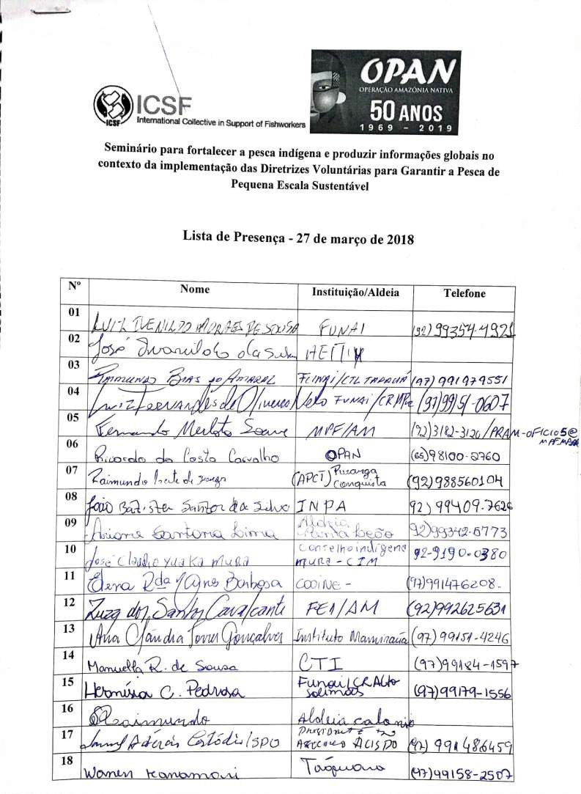

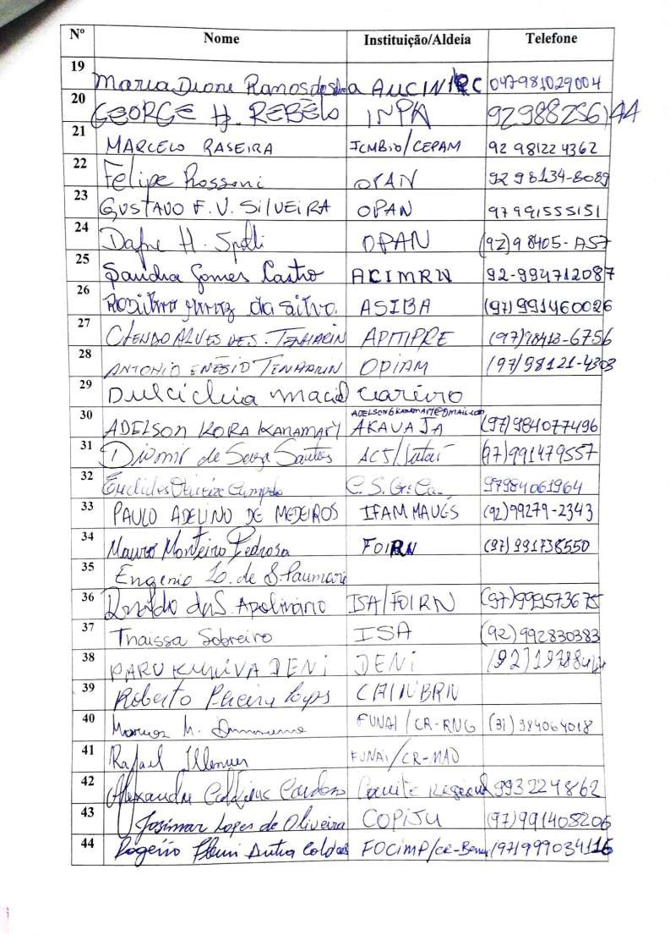

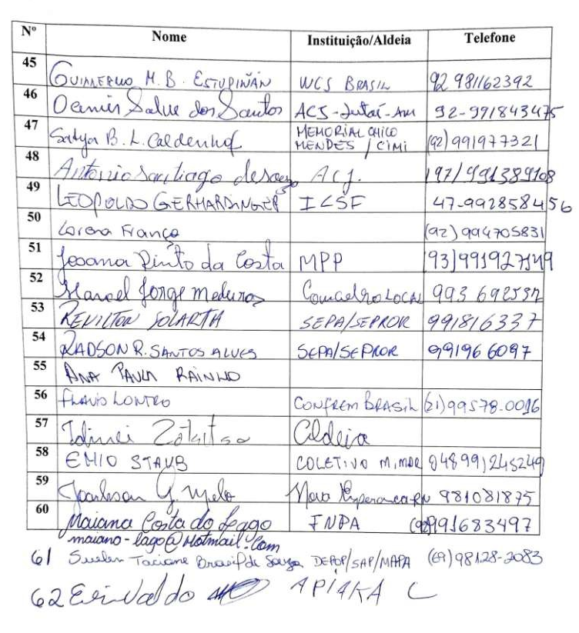

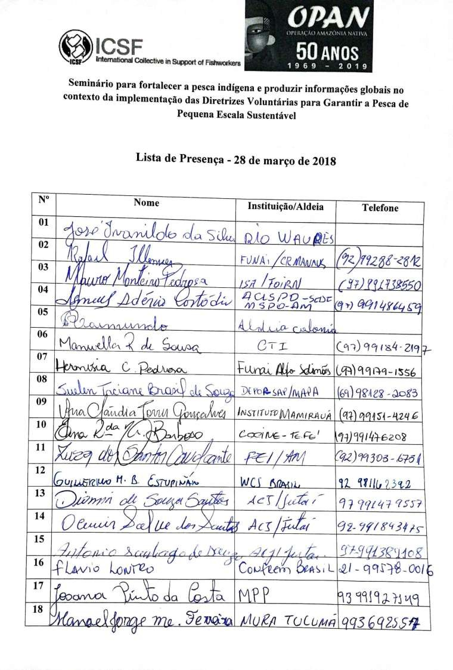

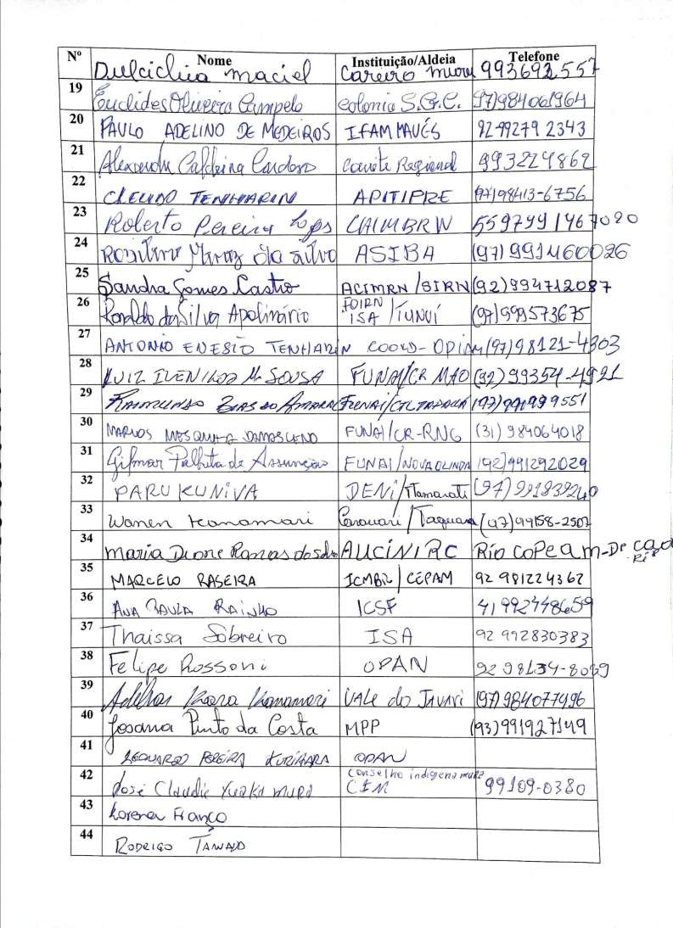

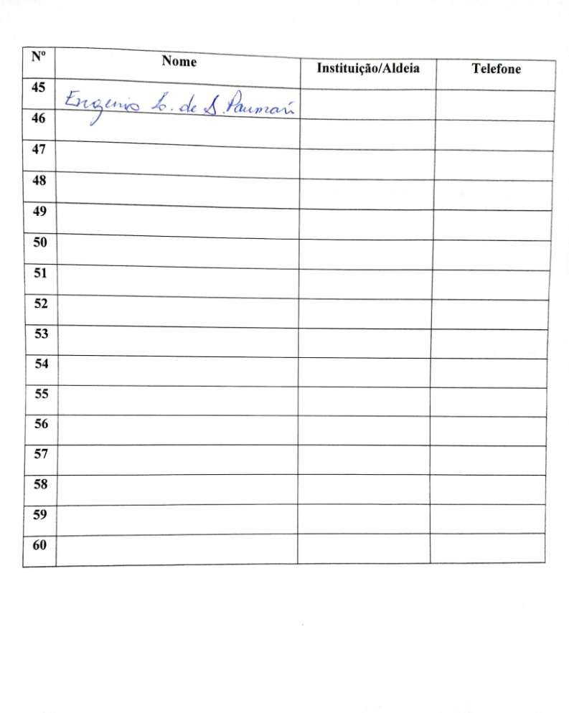

Due to the number of communities of coastal and riverine artisanal fishermen, the meeting did not have the participation of fishermen from all regions of the country, but was rather greatly focused on fishermen
Law 11,947/2009 states that at least 30 percent of the purchases of municipalities for school meals must be made directly from family farming (agricultural products and animal protein), where indigenous production is included. However, this law has not been implemented in the Amazon for several reasons, among them the specific logistics that make products too expensive.
Source: http://www.funai.gov.br/index.php/apresentacao-solimoes
They currently live within the Jutaí Extractive Reserve and there is a claim for the creation of an indigenous territory.
There is already a request for the demarcation of the indigenous territory.
Source: https://boletimisolados.trabalhoindigenista.org.br/2015/12/09/vale-do-javari-maior- concentracao-de-isolados-no-mundo/
Source: http://www.ciama.am.gov.br/pagina.php?cod=16
Renato Rodrigues Rocha, OPAN, contributed to the information contained in this section.
The Kanamari claim permanent ownership of the territory and have demanded demarcation of the land, but its title belongs to the former chief of the Kanamari people who, after having encouraged its change to that site, did not pass the title to them.
Information provided by Manoel Cunha, extractive and managerial leader of the Médio Juruá RESEX
Recent ethnological studies point out that the peoples of the middle Purus and the Purus-Juruá interfluvial region should be considered as a tangle of interconnected collective groups and subgroups, forming a kind of dégradée (Mendes dos Santos & Aparício, 2016). In the present analysis, for didactic purposes, we will use the ethnic names of each "people", but these names do not reflect the complex network of relationships existing among the small collective groups associated with the canals, beaching and lakes linked to the territory they occupy.
The migratory fish does not correspond to a single ichthyological species: there are large migratory fish, continental migratory fish, migratory fish between rivers, or migratory fish from lakes to rivers. In this case, considering the peculiarities of the region, the migratory fish probably refers to jaraqui (Semaprochilodus taeniurus). This information was provided by Guillemo Estupinan in 2019.
The territorial and environmental management plan, PGTA, is prepared in a participatory manner by each indigenous territory, within the National Policy for Territorial and Environmental Management of indigenous territories (PNGATI).
Lago Ayapoá indigenous territory, on the other hand, formally started management in 2013, but its community members did not implement lake surveillance in practice, although their resources are under even greater pressure. FUNAI nearly cancelled its financial support for surveillance.
They are: Upper Negro River, Cucué-Marabitanas, Balaio, Middle Negro River I, Middle Negro River II, Apapóris, Jurubaxi-Téa and Uneuixi
Information was provided by Euclides Campelo, president of the Association of Fishermen of São Gabriel da Cachoeira, in 2019
These techniques were studied and curated in the exhibition “Peixe-gente” at the Amazon Museum in Manaus, with a corresponding catalog (Cabalzar & Candotti, 2013)
The two major meetings held in 2008 were organised by ATRIART (Association of Indigenous tribes of the upper Tiquié River) and ACIMET (Association of Indigenous Communities of the Middle Tiquié), both as a part of a PDPI (Demonstration Project of Indigenous Peoples) project, of the Ministry of the Environment. The results can be found in the publication "Fish management in the Tiquié river basin", ISA, 2012.
From Manaus to São Gabriel da Cachoeira it takes between 75-90 hours by boat or a week by ferry. From the headquarters of São Gabriel da Cachoeira to Iauaretê district, it takes another 72 hours to transport food and goods.
Information in this section was provided by Thaisa Sobreiro, ISA.
Source: https://www.socioambiental.org/pt-br/noticias-socioambientais/projeto-de-turismo-comunitario-de-pesca-no-rio-marie-am-define-parceria-e-deve-comecar-este-ano
Source: https://www.socioambiental.org/pt-br/noticias-socioambientais/povos-indigenas-do-rio-negro-avancam-na-construcao-dos-planos-de-gestao-de-seus-territorios
Terra Diahui, 47,000 ha, Ipixuna, 215,000 ha and Nove de Janeiro, 229,000 ha
Information provided by Ane Alencar, Scientific Director, Institute of Environmental Research of the Amazon (IPAM). Source: https://www.oeco.org.br/noticias/arco-do-fogo-avanca-sobre-amazonas//
Information provided by Pedro Souza, Indigenous Missionary Council (CIMI)
Source: http://www.ibama.gov.br/noticias/58-2016/169-ibama-recebe-premio-hugo-werneck-por-projeto-de-manejo-do-pirarucu-no-amazonas
Source: https://www.mamiraua.org.br/manejo-pesca
Source: http://amazonianativa.org.br/Noticias/Coletivo-do-manejo-de-pirarucu-mais-forte,2,520.html
This figure, from the year 2013, may have changed over the years.
Source: https://foirn.wordpress.com/2017/03/03/comunidades-indigenas-iniciam-a-construcao-de-uma-proposta-de-turismo-de-pesca-esportiva-no-rio-jurubaxi-no-municipio-de-santa-isabel-do-rio-negro
In the painful and complex aftermath of colonisation in the Amazon, several tribes hid their indigenous identities. For example, one of the ethnicities represented in the Seminar – the Baré – was declared extinct until the mid-1980s, and its members considered "riverine", not “indigenous”.

