Implementing the Voluntary Guidelines for Securing Sustainable Small-scale Fisheries in the Context of Food Security and Poverty Eradication in Sri Lanka

Final Project Report

Sri Lanka Forum for Small-Scale Fisheries (SLFSSF) | International Collective in Support of Fishworkers (ICSF)

Support

Food and Agriculture Organization of the United Nations (FAO)

Oscar Amarasinghe Ph.D.
President, SLFSSF

February 2020

Contents

Acknowledgement………………………………………………………………………………………...1

Introduction……………………………………………………………………………………………….5

Plan of Activities………………………………………………………………………………………….7

Sensitizing workshop on the SSF Guidelines for State actors……………………………………………8

Preparation of communication tools………………………………………………………………………9

Stakeholder meetings on the SSF Guidelines …………………………………………………………...10

National workshop on the National Fisheries Policy……………………………………………………15

Conclusion………………………………………………………………………………………………17

Way forward…………………………………………………………………………………………….18

Annexures……………………………………………………………………………………………….19

Annexure 1: Changes proposed to the current National Fisheries Policy………………………19

Annexure 2: Finalized Policy Statements and draft Action Plan (18 June, 2019)………………27

Annexure 3: Posters……………………………………………………………………………..37

Annexure 4: Fact Sheets…………………………………………………………………………39

Annexure 5: List of Participants in Workshops and Meetings…………………………………..51

Acknowledgement

The process of implementing the Voluntary Guidelines for Securing Sustainable Small-scale Fisheries in the Context of Food Security and Poverty Eradication in collaboration between the Sri Lanka Forum for Small Scale Fisheries (SLFSSF) and the International Collective in Support of Fishworkers (ICSF) was a combined effort of an array of individuals and institutions, including the government.

First and foremost, the ardent support extended by the Executive Committee of the SLFSSF was key to the successful completion of the project, which is highly commendable. Senior Professor Upali Amarasinghe, Professor Ivan Silva, Senior Professor Ruchira Cumaranatunge, Mr. Herman Kumara, Professor M. G. Kularatne, Professor Sunil Jayakody and Mr. Jayantha Chandrasome participated in all technical and policy meetings, giving advice and guidance. Mr. Herman Kumara and Mr. Nalaka Rosairo of National Fisheries Solidarity Organization (NAFSO) played a very important role in preparing the translations of SSF Guidelines and communication tools. Their assistance is acknowledged with gratitude. Professor M. G. Kularatne and the Center for Social Science Research (CSSR) with its research staff at the University of Kelaniya provided a very productive and conducive working environment. We are thankful to the Vice Chancellor of the University of Kelaniya and the Dean of the Faculty of Social Sciences for providing facilities at the CSSR. The secretary of the Project, Miss. Hareesha Sandaruwani did a commendable job in taking care of all documentation and organisational work.

The study relied heavily on stakeholder workshops with fishing communities and state actors. Dr. Nilantha De Silva and her team of facilitators (Miss. Kaumi Piyasiri, Miss. Chamini Dinushika, Miss. Thushara Dharmawarden, Miss. Shanika Weralugolla, Miss. Shiwanthika Dharmasiri, Miss Hareesha Sandaruwani and Mr. Swarna Malitha Peramunegama) organised and conducted field work in the southern, eastern, northern and northwestern provinces. We thank them for their excellent and dedicated work.

The task of organizing field work in distant locations was quite challenging. The SLFSSF was fortunate to have received the assistance of a number of dedicated Assistant Directors of the Department of Fisheries and Aquatic Resources who organized workshops in Hambantota, Trincomalee, Jaffna, Negombo and Colombo. We salute the willing assistance provided by Mr. L. G. T. Chandana, Mr. E. M. C. Boyagoda, Mr. Anura Jayasekera, Mr. T. U. K. Marasinghe (Negombo) and Mr. Rahim of NAFSO and Dr. Ahilan Kadirgamar and his students of the Department of Sociology of the University of Jaffna. In orgnising policy workshops, the assistance provided by Mr. K. D. S. Ruwanchandra, the present Secretary to the Ministry of Fisheries is mentioned with deep gratitude. We thank Mr. Monty Ranatunga, Director/Technical to the Ministry of Fisheries and, Mr. Dinesh Peiris and Mr. Suraj Chandrakumara of the Fisheries Management Division of the Department of Fisheries and Aquatic Resources in ensuring the participation of fisheries officers at the workshops.

The whole process of SSF Guidelines implementation was conducted to the fullest satisfaction of the SLFSSF due to the very successful deliberations that were held in various parts of the country, with the active involvement of fishing communities, including women fisher folk and State actors representing an array of institutions, including departments of fisheries, agriculture, coastal conservation, wildlife, forestry, environment, the Coast Guard and others. We salute them for their active participation. Our thanks are also due to a number of former senior administrators in the Ministry of Fisheries and Aquatic Resources, such as Mr. A. Hettiarachchi, Mr. H. S. G. Fernando, Dr. Leslie Joseph and the former secretary of the Ministry of Fisheries, Mr. G. Piyasena, who assisted us in conducting policy workshops and preparing policy statements.

It is the International Collective in Support of Fishworkers (ICSF), with funding from the FAO which gave the SLFSSF this opportunity of initiating SSF Guidelines implementation in Sri Lanka, a process that was outlined as one of the prime objectives of the SLFSSF. In this respect SLFSSF feels that it has done its duty to the country, thanks to its dedicated membership. We say “Grand Merci” to ICSF for having the confidence in SLFSSF in performing this task.
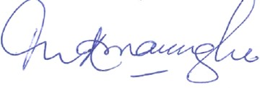

Oscar Amarasinghe, PhD

President, SLFSSF

Introduction

Context

Sri Lanka’s population consumes relatively large amounts of fish (10.8 kg per capita annually), while 570,000 people find direct or indirect employment in the fishing industry. The marine fisher folk population consists of 190,000 households and 221,000 active fishers spread out along the coastline, while another 48,900 fishing households and 54,450 active fishers are engaged in lagoons and inland water bodies. The total fisheries dependent population has been estimated as 2.7 million. Arguably, all of these fishers and workers in the post-harvest sectors are engaged in the small-scale sub-sector. Small-scale fishers in Sri Lanka are of many kinds. While some are beach-based, others use a variety of craft – orus, kattumarams or fibre-glass boats – to ply nearshore, offshore, lagoon or inland fishing grounds. Gears include a broad selection of gillnets, cast-nets, longlines, fixed nets and traps. While men generally dominate the harvesting process, women play an important part in processing, marketing and in support activities.

Sri Lanka’s ‘large scale’ fishery is confined to the off-shore and deep-sea areas, consisting of a fleet of 4,218 multi-day crafts, length varying from 32 ft to 45 ft, rather small in scale in comparison to fisheries of developed nations. Yet, a clear distinction exists between this fleet from the rest: Generally owned by non-fishing investors, they use hired labour, targeting expensive fish like tuna and producing for the export market.
Sri Lanka’s aquaculture industry is of fairly recent origin. Despite large freshwater and brackish-water resources, only marine shrimp aquaculture and ornamental fish culture have been developed to a certain extent. About 17,000 people are actively involved in the aquaculture sector. Nevertheless, shrimp and finfish production are growing. Today, the country’s main focus is to start small-scale aquaculture, aiming at supporting rural communities with income and food security.
In Sri Lanka, as well as globally, small-scale fisheries are threatened more by anthropogenic pressures coming from both inside and outside the communities, and less by natural factors. High rates of resource exploitation, unregulated technological change and increasing fishing pressure threaten aquatic ecosystems, leading to resource degradation. The significant increase in fish production, as also the degradation of marine resources, as a result of the ‘Blue Revolution’ compelled the State, as the custodian of natural resources, to intervene in protecting and managing the resources. Thus, legislation mainly aimed at dealing effectively with the resource crisis and a focus on wellbeing of fishing communities lacking. For fishing communities vulnerable to poverty, with limited livelihood opportunities, one option is to use rely heavily on fishery resources to meet the needs of their families.
While fisheries cooperatives have played a very important role in the past as a bridge between the State and the fishing community, providing fishers with extension, credit and social welfare, many of them collapsed when successive governments introduced parallel structures to meet short-term political goals. Unfortunately, Sri Lankan fisheries research fisheries management and conservation, rather than on social and human development of the fishing communities. Very little is heard of the issues facing small-scale fisheries, although these are of tremendous importance.
To add to these challenges, climate change impacts now present an important variable in the development of fishing communities. These impacts are mostly felt in coastal areas, largely inhabited by fishing populations: Sea level rise has already led to the loss of landing centers, beach seining sites, fish drying sites and displaced fisher folk settlements. Redistribution and depletion of marine fish species, ocean acidification and the degradation of wetlands have had profound impacts. Here too, climate change research has little focus on social impacts and the strategies adopted by people to cope and adapt.
Small-scale fisheries deserve attention not just because of their vulnerabilities for their social, economic, environmental and cultural contributions. It is for these reasons that the Sri Lanka Forum for Small Scale Fisheries (SLFSSF) was established. It is a forum of academics, researchers, interest groups and individuals who have come together, aiming at establishing interactive platforms to share information and knowledge in the interests of sustaining small-scale fisheries.
The recently developed Voluntary Guidelines for Securing Sustainable Small-scale Fisheries in the Context of Food Security and Poverty Eradication (the SSF Guidelines) address the most compelling issues in SSF, especially the need to recognize the rights of fisher folk and to make the process of fisheries management participatory, inclusive, integrated and holistic, with special attention to women and marginalised populations. Yet, efforts to develop the SSG Guidelines would be futile unless they are incorporated into a country’s policy-making and planning process.
Sri Lanka’s Ministry of Fisheries and Aquatic Resources Development (MFARD), with assistance from the Government of Norway, recently prepared a White Paper on National Fisheries Policy in 2018, which was approved by the Cabinet and is expected to be presented to the Parliament. The 2018 Policy incorporates some elements of the SSG Guidelines, although it is still quite deficient in addressing a number of compelling needs of the small-scale fisheries sub-sector.
In the above context, the Sri Lanka Forum for Small Scale Fisheries (SLFSSF) embarked on a number of activities to implement the SSF Guidelines between July, 2018 to May, 2019, with assistance from International Collective in Support of Fishworkers (ICSF), supported by the FAO, enumerated below.

Plan of Activities:

- Sensitizing Workshop on the SSF Guidelines for State actors: The Guidelines were presented, discussed and major areas of concern were identified. Participants included key officials of the Ministry of Fisheries and Aquatic Resources, Department of Fisheries and Aquatic Resources, Ceylon Fisheries Corporation, Ceylon Fisheries Harbour Corporation, National Aquatic Resources Research and Development Agency (NARA), National Aquaculture Development Authority, Coast Conservation Department, Coast Guard, Department of Forest Conservation, Department of Wildlife, Department of Agriculture, Central Environmental Authority and the Tourism Development Authority.
- Communication tools for community stakeholders: A number of documents were prepared in local languages (Sinhalese and Tamil) to be distributed among fishing communities, including translations of the SSF Guidelines; the Guidelines summarized in the two languages; 12 Fact Sheets with the key messages of Guidelines; and Posters on the Guidelines, to be displayed in community programmes and meetings.
- Stakeholder meetings held in various parts of the country: Fishing community members and State actors from 12 coastal districts of the country participated in these meetings: Galle, Matara, Hambantota, Batticaloa, Trincomalee, Mullativu, Jaffna, Kilinochchi, Mannar, Puttlam, Chilaw and Negombo. Participants discussed the relevance of the SSF Guidelines in Sri Lanka, identified priority areas and opportunities and challenges in implementation.
- Assessment of the National Fisheries Policy, 2018 to identify opportunities for implementing the SSF Guidelines: Carried out with a group of policy experts, the policy implications emerging from stakeholder meetings (Item 3) were discussed and the current Policy was revised by incorporating relevant sections of the SSF Guidelines.
- National Workshop on the National Fisheries Policy: To draft policy statements and to propose changes to the Policy

1. Sensitizing workshop on the SSF Guidelines for State actors

Although the SSF Guidelines were adopted in 2014, it was realized that the awareness of government officials, especially those engaged in fisheries governance, was quite low. Thus, the SLFSSF proposed a ‘State actors sensitizing workshop’ as the first step in implementing the SSF Guidelines, aimed at generating awareness among government agencies about the Guidelines; identifying priority areas in Sri Lanka’s fisheries; and to obtain the support of the government in the activities organised under the project. This workshop was held on 28 September, 2018 at the National Science Foundation in Colombo, Sri Lanka.

Forty-five representatives from the Ministry of Fisheries and Aquatic Resources Development (MFARD), Department of Fisheries and Aquatic Resources Development (DFARD), National Aquatic Resources Research and Development Agency (NARA), National Aquaculture Development Authority (NAQDA), Ceylon Fisheries Corporation (CFC) and 15 officers from Coast Conservation Department (CCD), Agriculture Department, Ministry of Tourism, Wild life department, Coast Guard (Navy),Marine Environmental Protection Agency (MEPA) and others participated in the workshop. FAO Representative in Sri Lanka, Nina Brandstrup, was the Chief Guest at the event.
Ivan Silva, Joint Secretary of SLFSSF, delivered the welcome address. Nina Brandstrup explained the FAO’s role in drafting and facilitating the negotiations for the SSF Guidelines, and the long process of consultation with the global community. She also mentioned the importance of incorporating the Guidelines into national fisheries policies and plans of action.
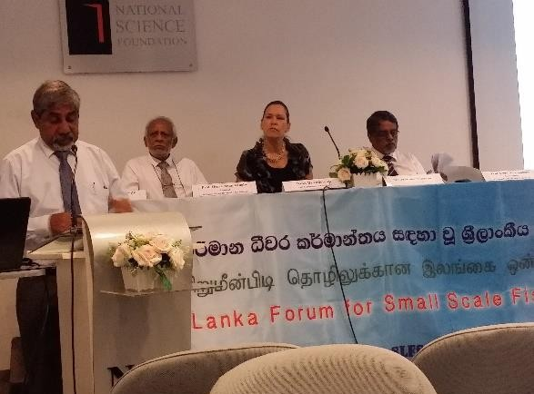

Photo 1: Prof. Ivan Silva, Joint Secretary of SLFSSF at the State Actors’ Workshop (September,2018)
Oscar Amarasinghe, President of SLFSSF and Upali Amarasinghe, Joint Secretary of the SLFSSF, presented the SSF Guidelines. Upali Amarasinghe dealt extensively with governance of tenure and gender issues, particularly on the need for equality and gender mainstreaming in fisheries. Moreover, the need to identify and respect the rights of fishers to fish resources, land (beaches) and adjacent areas were also highlighted in this presentation. Oscar Amarasinghe dealt extensively with sustainable resource management, co-management, fisheries value chains and post-harvest practices, including fish processing by women, social development and the need to empower fisher community organisations. The need for management to be integrated, inclusive, participatory and holistic was highlighted. After the technical sessions the participants were divided into the groups based on the thematic areas in the SSF Guidelines.

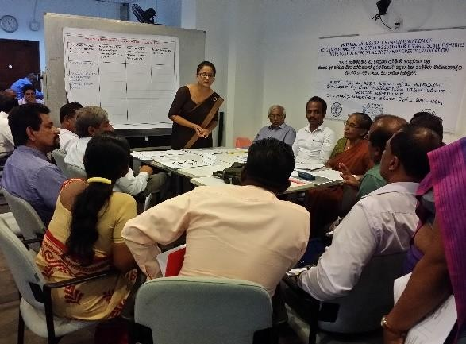

Photo 2: Group discussions at the State Actor Sensitizing Workshop: 28 September 2018

2. Preparation of communication tools

The National Fisheries Solidarity Organization (NAFSO), a civil society organisation (CSO) affiliated to SLFSSF had previously translated the SSF Guidelines into the two local languages, Sinhala and Tamil. In order to simplify its messages for a wider audience in fishing communities and organizations, NAFSO and SLFSSF jointly prepared a number of communication tools which succinctly summarize and disseminate these messages in a form that attracts the public eye. The organization is now working on distributing this material among fishing communities across Sri Lanka, especially among community organisations.

The communication tools prepared were the following (reproduced in Annexure):

- The SSF Guidelines in translation (500 copies in Sinhala, 250 in Tamil)
- SS Guidelines summary in translation (500 copies in Sinhala, 250 in Tamil)
- Fact sheets on the SSF Guidelines: Thirteen key messages contained in the document (500 copies in Sinhala, 250 in Tamil)
- Posters: Two posters, one on the role of women in fisheries; another on co-management (500 copies in Sinhala, 500 in Tamil)
- SLFSSF webpage and social media channels: Special page on the SSF Guidelines implementation process, constantly updated and open access for sharing.
3. Stakeholder meetings on the SSF Guidelines

This was the key component of the SSF Guidelines implementation process, which formed the means by which information was obtained at the local level. Stakeholder workshops were held in the Southern, Northern, Eastern and North-Western Provinces with the participation of all relevant stakeholders.

The first stakeholder workshop was held on 24 November, 2018 at NARA regional Center, Rekawa. Hambantota, with participants from all three districts of the Southern Province – Galle, Matara and Hambantota. Another stakeholder workshop was held on 15 December, 2018 in Trincomalee, with participants from three districts of the Eastern Province - Mullativu, Trincomalee and Batticaloa. The third workshop was held on 5 January, 2019 at the District Secretariat, Jaffna town, with participants from all three districts of the Northern Province – Mannar, Kilinochchi and Jaffna. The fourth and final stakeholder meeting was held in Negombo on 9 February, 2019.
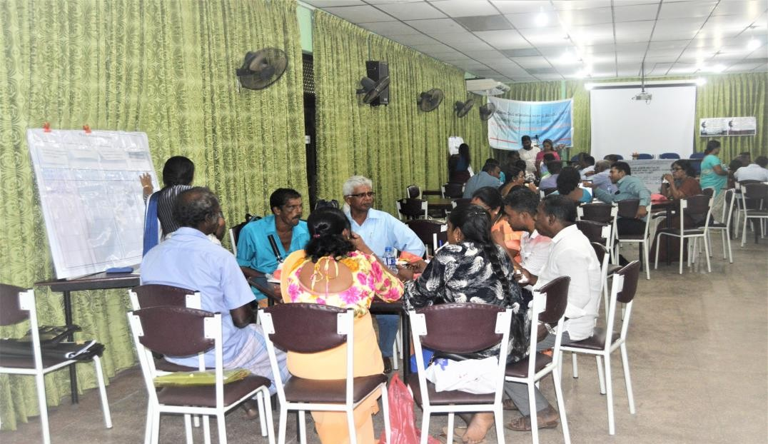

Photo 3: Stakeholder meeting in Trincomalee, Eastern Province (December, 2018)
Fishery stakeholders (both men and women) were selected with the help of SLFSSF’s partner, NAFSO, and district-level fisheries officials. These participants represent fisheries cooperative societies or local fisher associations. Women fish processors and cooperative members also participated. The meetings were also attended by government agencies operating in the coastal zone of key districts – Hanbamtota, Trincomalee and Jafna.
Several key issues in small-scale fisheries and the SSF Guidelines were selected for discussions, based on a number of past studies and the discussions during the State actors’ workshop held in September, 2018: Tenure rights and sustainable resources management; conflicts among stakeholder groups; institutional collaboration; gender equality and mainstreaming; post-harvest sector, marketing and trade; social development, occupational health, and safety and decent work; disaster risk and climate change, fisheries insurance; and capacity development and empowerment of community organisations.
The stakeholder consultations revealed a number of important areas that had not received adequate attention of policy makers in preparing the National Fisheries Policy, 2018. A summary of these ‘missing’ links in the policy, which are proposed to be incorporated, is presented below (Detailed recommendations in Annexure).

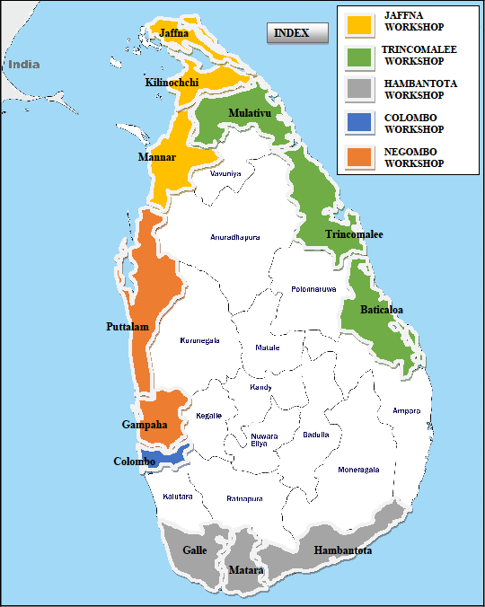

Figure 1: Coastal districts covered in the meetings
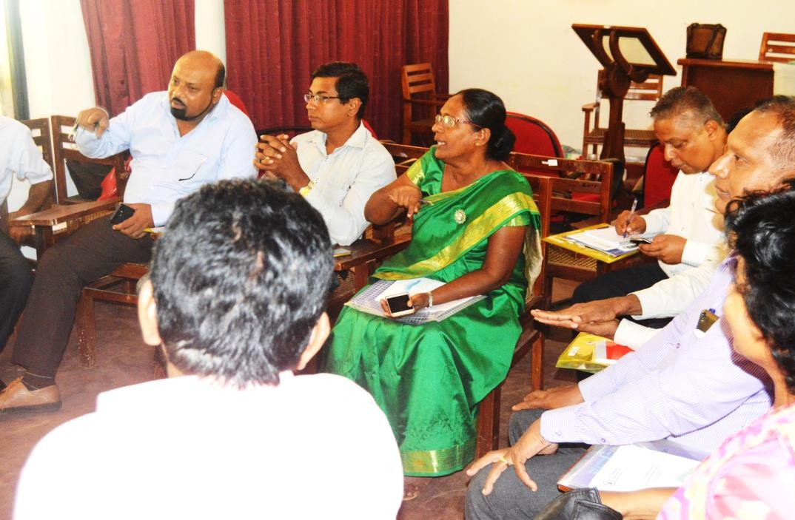

Photo 4: Stakeholder meeting in Rekawa, Southern Province (November, 2018)

Tenure Rights

Tenure rights of small-scale fishers is addressed in the National Fisheries Policy (NFP), which states, “Respect the tenure rights of the traditional, migrant, subsistence and artisanal fishing communities to land, water and fish resources.” While this is in line with the SSF guidelines, it was revealed in the discussions that there is a diversity of tenure ‘rights’ as perceived by fishers: Rights that they possess and enjoy; rights that they think they possess, but do not enjoy; and rights that they do not have and want to have and enjoy. Of the three, the former two were of importance because they were the rights the fishers thought that they had and were quite clear about them. While fishers were of the view that they enjoyed the rights to the beach, the waters (inland and marine) and the fish resources, they complained that these rights are violated by other resource users, especially powerful tourism interests. The acquisition of beach areas by tourism stakeholders, have resulted in loss of anchorage and beach seining sites, space available for craft and gear repair and fish processing and other effects. It was also revealed that the rights of small-scale fishers to coastal fish resources have also been violated by large-scale mechanized crafts and gear which took away resources which were traditionally exploited by the small-scale artisanal fleets.

There were also concerns about rights that fishers do not possess at present, but want to possess and enjoy. These included rights to access to the land adjoining beaches, for craft anchorage and to construct permanent structures on the beach to store fishing gear. These areas are under the control of institutions such as the Department of Forest Conservation and the Department of Wildlife, which hardly ever coordinated with the Department of Fisheries and Aquatic Resources. It was, however, pointed out that rights cannot be defined unless boundaries of beaches, lagoons and coastal land are not known. Thus, the need for zonation of the coastal areas was also noted.

Sustainable resource management

A number of important provisions for resource management are laid down in the NFP, with emphasis on the adoption of precautionary and ecosystem approaches to fisheries management, prevention of overcapacity and illegal, unregulated and unreported (IUU) fishing, promotion of co-management and compliance with international legal instruments.

The group discussions revealed that although an array of laws and regulations govern coastal zone management, an effective monitoring, control and surveillance (MCS) mechanism was absent. The need to decentralise management decisions to district level, with the involvement of local government institutions, was also highlighted. Another interesting point that emerged from the discussions was the need to treat the coastal zone as one ecosystem used by multiple users and to ensure that all relevant stakeholders are involved in decision making at all levels, including youth, women, differently abled and marginalised groups. The need for cross sectoral collaboration and institutional coordination in managing the coastal zone resource use was also an important concern in this regard. It was agreed that management approaches will have to be holistic, integrated, inclusive, and participatory. However, for such efforts to succeed it was agreed that discrepancies in the mandates of different institutions needs to be minimized. Therefore, it was proposed that there should be no overlapping policies and mandates among institutions responsible for coastal resource management and conservation.

Value chains, post-harvest and trade

The NFP takes into consideration several aspects of the fisheries post-harvest sector, but an important missing link is the absence of provisions for allocating space for fisheries activities on the coast – craft anchorage, fish drying – and the infrastructure and facilities for such activities. There were discussions on post-harvest losses and the need for scientific fish handling and storage at landing sites. Moreover, promotion of value addition technology was also proposed to be incorporated into the policy.

Economic and political power wielded by fish merchants and exploitative fish buying practices was highlighted. Merchants collude to push down producer prices, denying small fisheries fair prices. Thus, intervention in fish marketing and the need for more competition among was proposed. Promotion of community organisations in fish marketing was also suggested. To profit from emerging opportunities in the export market, it was also proposed to provide fishing communities with access to information on markets and to establish market links.

It was pointed out that unregulated trade has resulted in the export of even small fish species, which are important for the nutrition of poor communities. Therefore, it was suggested to incorporate a statement that the government will regulate foreign trade to ensure that food and nutritional security of the people is not threatened.

Occupational health and safety

The focus of the NFP on occupational safety and health has mainly been on ensuring safe, healthy and fair working conditions at sea and on land, in accordance with international standards and on developing insurance schemes for fishworkers. Discussions revealed that fishers are often careless about safety at sea. It was agreed that there is a need to build awareness among fishers on sea safety measures. Concerns were also expressed about the high costs of purchasing safety equipment. The recommendations included government assistance to fishers in acquiring safety equipment.

Besides safety at sea, concerns were expressed on the need to make landing site and fishing harbours safe for navigation. A large number of landing sites in coastal areas with rocky beds provide only a narrow passage for fishing craft, which are unsafe especially during the rainy season. Some landing sites do not have electricity. Recommendations included a provision for safety measures at landing sites.

Although its provisions are more applicable to the deep-sea fishing vessels, the meetings recommended that the government ratify the ILO Work in Fishing Convention (C169).

Social Protection and fisheries insurance

The NFP makes only a general statement that the government will improve social safety nets and social protection for the fishers, including women. However, fisheries stakeholders expressed their displeasure at the functioning of the Fishermen’s Pension Scheme, which was considered the best social protection for fishers in the past. Interest in the scheme has been on the decline in recent years. Insurance, too, has been a failure due to informational asymmetries and a time-consuming, laborious claims process that mostly ends without payments to fishers. This issue was discussed in detail and the participants agreed that one of the efficient means of operating a fisheries insurance scheme was though community organisations, because they have the requisite knowledge of hazards and accidents at sea.

It was also pointed out that the insurance does not cover partial damages to fishing equipment, but only total losses of craft and gear at sea. Climate change-induced hazards such as storms also cause the loss of life, injury and the destruction of fishing craft, gear and other assets on the coast. Thus, it was recommended that the insurance schemes cover full and partial damages to fishing crafts, gear, coastal assets, ill-health and loss of life as a result of fishing accidents and climate related disasters.

Disaster risk and climate change:

Coastal populations are increasingly under serious threat due to climate change such as the high frequency and intensity of storms; sea level rise; coastal erosion; and changes in wind and weather patterns, causing losses of income and livelihood disruption. The NFP has made provisions that the government will adopt “strategies to deal with climate change impacts including the promotion of research, building the resilience capacity of the fishing populations and helping them to resettle and recommence livelihoods”. During discussions, changes in fish breeding and migratory patterns due to climate change were highlighted. Thus, it was proposed that the government promote research on fish stock redistribution, migration and other climate change effects.

The meetings acknowledged that Sri Lanka’s weather information system works quite well, especially for the deep-sea fishing sector, by effectively communicating warnings through High Frequency Radio. The participants recommended that the government establish early warning systems for small-scale fishers, possibly using mobile phones.

In the case of rehabilitation measures after disasters, it was noticed that the absence of an updated list of craft and fishing gear was a hurdle. Thus, a recommendation to register fishers, craft and fishing gear, with regular updates, was included. It was also recommended that the government involve community organizations in disaster management.

Gender equality

Due to the participation of a large number of women in the stakeholder meetings, gender issues received special attention. While fishing has remained a male-dominated activity, gender roles in fisheries varies according to religious and cultural practices across the country.

In line its guiding principle of gender equality, the NFP indicates that the government will ensure that men and women have equal opportunities to participate in the sector. However, the discussions revealed that in some communities, women’s employment is considered a reflection of the man’s inability to feed the family. Awareness raising was recommended to show the importance of women’s employment in improving family wellbeing. The important role played by women in fisheries cooperative societies was also discussed. The meetings resulted in the recommendation to reserve a minimum of 25 percent of positions in fisheries community organisations for women. Women fishworkers also complained that they are paid less than men for the same work. It was proposed that the government take steps to remove inequalities in wage rates.

Social development

It was agreed among workshop participants that fisheries management will not succeed if measures towards social development of fishing communities are not adopted at the same time. The NFP lays out a vision to improve education, health, poverty indicators, and achieve better standards of living. Group discussions dealt with the need to ensure access through affordable basic education, health, housing and household amenities.

The meetings also discussed the problem of the continuity of children’s education during the lean fishing season, which could last several months. Many children in fishing communities don’t find opportunities to study in good government schools, either due to the remoteness of their dwellings or due to the high costs of education. The recommendation was so accord priority to children of fishing communities in fisheries education, greater recruitment opportunities in the sector and financial assistance to fisher families.

Access to credit has always been a problem for fishing communities because fishing assets are not accepted as collateral by formal lending institutions. Participants proposed developing micro-credit schemes to encourage investment in fisheries and to make fishing activities more secure.

Capacity development

The NPC has provisions for training fishing communities to develop fish businesses, engage in aquaculture, to work as boat skippers and to participate in fisheries management. Small fishers need training in new fishing techniques, especially in deep-sea fishing technology, fish processing and alternative income generation activities. It was recommended that special priority be given to women and youth.

Discussions revealed that fisheries management needed to be more participatory and inclusive if true ‘co-management’ platforms were to be developed. One recommendation was to provide training to government officials and community leaders on the principles of co-management.

Empowering community organisations

The NFP specifies the recognition, empowerment and strengthening of fisheries cooperatives in addressing issues in fisheries and fisher wellbeing, and in representing fishing communities at decision making platforms. It also says that the government will liaise with fisheries cooperatives in integrated coastal zone management (ICZM). However, it was it was pointed out that fishing communities will not be in a position to make a significant contribution to management measures, unless their capacities are built. For this, fisheries legislation and policy need to be elucidated and communicated to the community. Participants were quite critical of coastal development projects that had been implemented without consulting fishing communities. Consultation and participation of fishing communities and their organisations was another important recommendation.

- National workshop on the National Fisheries Policy

After the completion of the stakeholder workshops and identification of policy recommendations, the next step was to prepare a policy statement that incorporates the relevant SSF Guidelines. This process consisted of the following:
- A review of the current NFP and identifying the gaps
- Preparation of a policy statement based on the policy implications of the outcome of the stakeholder workshops.
- Policy workshop with fisheries governance institutions to finalize the new policy statement incorporate it into the current NFP.

A review of the NFP was carried out by Oscar Amarasinghe, President of the SLFSSF. He played a key role in the preparation of the National Fisheries Policy, 2004 and also participated in the preparation of the current NFP. A meeting with a group of policy experts was then held on 15 March, 2019 at the Social Science Research Center of the University of Kelaniya. The policy implications emerging from the stakeholder workshops were compiled and arranged according to the major themes outlined above. These were then drafted as policy statements by SLFSSF.

The final ‘National workshop on the National Fisheries Policy, 2018’ was held on 18 June, 2019 at the University of Kelaniya. Secretary, Ministry of Fisheries and Aquatic Resources was the Chief Guest, and several government agencies operating in the coastal zone, academics and researchers were in attendance. The proposed changes to the current NFP, and policy recommendations and a draft action plan were discussed and finalized (see Annexure).
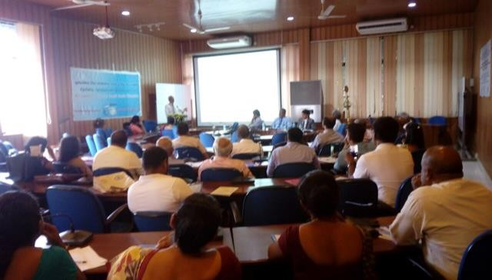

Photo 5: National Policy Workshop held at University of Kelaniya (18 June 2019)

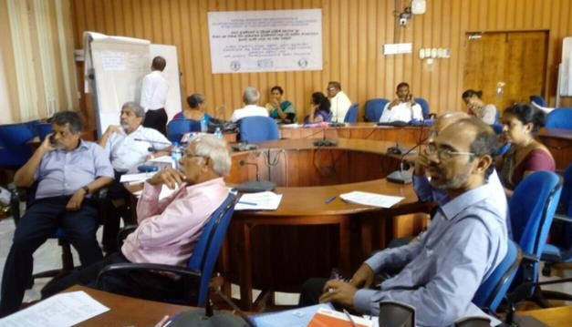

Photo 6: Workshop to prepare the SSF Policy Statement and Action Plan

Conclusion

The project to implement the SSF Guideline in Sri Lanka was conducted over a period of 10 months. A number of very important issues, which had not received much attention earlier, emerged from the activities and discussions. The need to look at the coastal ecosystem as a whole in fisheries management decision was an important theme in the deliberations. Connected to this is the need for cross sectoral collaboration and institutional coordination, by establishing co-management platforms at the local level, rising up to the national level.

Another very important outcome was a number of policy statements on fishers’ tenure rights. While the need to respect and protect legitimate tenure rights of fishers to land, water and fish resources was emphasized, it was also felt that boundaries should be demarcated in the coastal zone.

A number of policy statements on social development, working conditions and social protection schemes were also developed. The need to improve the fishers’ pension scheme, to adopt relevant ILO Conventions on work in fishing and to reduce discrimination in wages paid to men and women are important outcomes of the deliberation. Minimizing gender inequalities was also a high priority. Beyond awareness raising about the roles and rights of women in the sector, the project resulted in a proposal to allocate a minimum of 25 percent of positions in fisheries cooperatives for women, significant improvement on the earlier policy document.

Appreciably, the need for government intervention in marketing and trade was recognized in the deliberations and several policy statements were formulated to cope with unfair producer prices, unfair trade and nutrition issues. In this sphere, the promotion of community organisations to take up fish marketing, and regulation of international trade could be considered as very important policy measures indeed.

While the whole process of SSF Guideline implementation went on smoothly as expected, one of the setbacks was the insufficient time for community stakeholders to learn about the SSF Guidelines.
Way Forward
One major achievement of this project is the development of a new policy statement for small-scale fisheries, based on the SSF Guidelines. Although the National Fisheries Policy has already been approved by the Sri Lankan Cabinet and no amendments can be made, it was suggested that a new policy statement be prepared along with an action plan for small-scale fisheries. Such an initiative is likely to get the support of the Ministry of Fisheries, as was evident from the statement of the Secretary, Ministry of Fisheries at the final meeting in June, 2019:
“Implementation of the SSF Guidelines is an important step towards improving sustainable use of fisheries resources and the wellbeing of thousands of small-scale fishers and their families in this country”
SLFSSF proposes that the process of SSF Guidelines implementation should continue with six immediate priorities:
- Organize a workshop to prepare a National Plan of Action based on the new SSF policy statement
- Submit the policy statement and the action plan to the Sri Lankan Cabinet through the Ministry of Fisheries.
- Establish a proper monitoring mechanism to assess the implementation of the recommendations
- Establish district level co-management platforms that rise up to the national level, with cross sectoral participation and collaboration
- Build capacities of State actors and of fishing communities with targeted training and skill development programmes
- Empower women to effectively participate in fisheries management.
Annexure 1: Changes proposed to the current National Fisheries Policy

A. National Fisheries Policy (existing) |  |  | B. Proposed Strategies (emerging from SSF  Guidelines)
1. TENURE RIGHTS
1.1A Recognition and protection of the tenure rights of the fishing communities to land, water and fish resources |  |  | 1.1B Identification, recording and protection of traditional and customary rights of fishers to the fish resources, the beach and adjoining lands
 |  |  | 1.2B Identification and demarcation of the coastal zone to ensure sustainability of major economic activities including fisheries and tourism development
2. SUSTAINABLE RESOURCE MANAGEMENT
2.1 General
2.1.1A Ensure sustainable management of the living marine resources based on the best available evidence from social, economic and ecological sciences. |  |  | 2.1.1BA strong MCS process in all waters for fisheries and aquaculture in collaboration with other appropriate agencies
2.1.2A Application of ecosystem-based management and precautionary approaches for responsible  fisheries management. |  |  | 2.1.2B Promotion of area-specific co- management platforms with cross  sectoral collaboration.
2.1.3. An Enhancement of stocks of endangered, threatened and protected species |  |  | 2.1.3B Establishment of rules and guidelines for fisheries management through integrated, inclusive, participatory  and holistic approaches
2.1.4A Protection of resources in Sri Lankan water from IUU fishing |  |  | 2.1.4B Intervention to minimize overlapping policies and mandates among institutions responsible for coastal
 |  | resources development, management and conservation.
 |  | 2.1.5B Effective participation of the disadvantaged and the poorer sections of the community, particularly the youth, women and differently abled persons in the planning processes at all levels.
2.1.5A Application of temporal and spatial planning
2.1.6A Use management information systems for
planning, development, management and reporting
2.1.7A Application of co-governance and management processes where appropriate
2.1.8A Promotion fishing for under-exploited and unexploited fish resources
2.2 Marine & Coastal
2.2.1A fish stocks enhancement in the territorial sea and the exclusive economic zone (EEZ) by ranching and habitat improvement |  | 2.2.1B Promotion of Integrated Coastal Zone Management through cross sectoral collaboration and institutional  coordination
2.2.2A Prevention of overcapacity of the fishing fleet. |  | 2.2.2B Promote demarcation of boundaries of ecosystems in the Coastal zone critical for fisheries and  aquaculture.
2.2.3A Diversion of marine and coastal fishing efforts from over-exploited areas to unexploited or under-exploited areas. |  | 2.2.3B Prevention of fisheries and aquaculture based environmental pollution
2.2.4A Promotion of fishing practices that cause the least impact on resources and the environment.
2.2.5A Strengthen prevention of fishing by foreign
fishing vessels in Sri Lankan waters.
2.2.6A Compliance with international treaties concerning responsible fisheries management.
2.2.7A Conditions to limit entry of new national high- seas fishing boats based on internationally accepted protocols in navigation, fish detection, harvesting, preservation, postharvest technology etc.
2.2.8A Royalty for exploitation of fish stocks in the EEZ of Sri Lanka by local fishing boats
2.2.9A Fee for allocation of fish catch quotas to local fishing vessels fishing in high seas
2.3 Inland and Aquaculture
2.3.1A Conservation of aquatic biodiversity in inland waters.
2.3.2A Regulation of fishing fleet characteristics for lagoons and estuaries.
2.3.3A Prohibition of motorized boats fishing in reservoirs.
2.3.4A Environmental and socio-economic impact assessments for allocation of land and water
resources for aquaculture projects
2.3.5A Use of bio-safety and best management practices in aquaculture
3. FISHERIES VALUE CHAIN
3.1 Pre-Harvest Sector
3.1.1AManagement of the possible overcapacity of the fishing fleet.
3.1.2A Improvement of quality assurance of fishing
vessels.
3.1.3A Improvement of the fisheries forecasting
system for fishers to obtain information on locations for productive fishing.
3.1.4A Improvement of quality infrastructure facilities in the production and supply chain. | 3.1.1B Promoting the provision of suitable space and facilities for craft anchorage, fish drying and fishing  equipment storage etc.
3.1.5A Private sector involvement in the investment
and operation of fisheries infrastructure facilities.
3.1.6A Promotion of communities in the operation
and maintenance of anchorages and minor fish landing sites.
3.1.7A Promotion of managing fishery harbours by the CHFC under the “green fishery harbour” concept.
3.2 Harvest Sector
3.2.1 General
3.2.1.1A Promotion of investments in export-oriented fisheries and aquaculture projects.
3.2.1.2A Promotion of the production of fish and fishery products in compliance with
international standards through supply chain management.
3.2.1.3 A Promotion of fisheries and aquaculture as
appropriate.
3.2.1.4A Promotion of the import and culture of new exotic species that have the potential for export.
3.2.15A Promotion of the production and export of
ornamental fish and aquatic ornamental plants.
3.2.1.6A Promotion of a market driven production of fisheries and aquaculture products including
innovative products.
3.2.1.7A Promotion of the production of high valued eco-friendly fishery products.
3.2.1.8A Provision of assistance for branding of Sri
Lankan fishery products.
3.2.2Marine
3.2.2.1A Promotion of fishing for un-exploited or under-exploited fish stocks in EEZ.
3.2.2.2A Promote the use of locally produced bait
including live bait.
3.2.2.3A Promotion of foreign fish landings in a responsible manner in accordance with the relevant international treaties.
3.2.3 Inland and Aquaculture
3.2.3.1A Development of aquaculture eco-friendly approaches
3.2.3.2A Promotion of the culture of indigenous species, and new exotic species in compliance with the Food and Agriculture Organization (FAO) Code of Practice for the Introduction of
Aquatic Species.
3.2.3.3A Genetic improvement of the performance of fish species used for aquaculture with the application of the precautionary principle
3.3 Post-Harvest Sector
3.3.1A Development of awareness on best fish handling practices | 3.3.1B Provision of facilities for scientific fish handling and storage at landing sites
3.3.2A Working towards trade agreements that will improve the access to all export products including fisheries and aquaculture products in identified or prioritized international markets | 3.3.2B Intervention in fish marketing and increase competition in fish buying towards ensuring a fair price to fish  producers.
3.3.3B Provision of fishing communities with access to information on fish
export market
 | 3.3.4B Promotion of entry of community organisations into fish marketing and establish export market links
4. FOOD SECURITY, FOOD SAFETY AND NUTRITION
4.1A Creation of employment with adequate income levels in the sector to ensure food security of more people. | 4.1B Regulation of foreign trade to ensure that food and nutritional security of the people is not threatened by international trade in fish and fish products.
4.2A Ensuring the quality and food safety of locally marketed fish and fishery products.
4.3A Promotion of the consumption of sufficient fish
for meeting nutritional requirements.
4,4A Stocking fish as buffer stocks during gluts to ensure the availability of fish at reasonable
prices during lean periods.
4.5A Ensuring the traceability and transparency at all stages of the value chain process.
5. SOCIAL DEVELOPMENT
5.1A Adopting measures to prevent alcoholism in fishing communities | 5.1B Ensuring that small scale fishers have affordable access to basic  education, health, housing and household amenities
5.2A Ensuring that adequate compensation is  provided to fisher communities who will be | 5.2B According priority to children of fisher  communities to enter higher
affected by development activities in the respective areas |  | education in fisheries, and giving priority with their excellence, during recruitment for employment  in the fishery related institutions.
5.3A Promotion of investment in human resource development such as health, education, literacy and digital inclusion in fishing communities |  | 5.3B Provision of financial assistance to needy children from fisher families to continue education during off season.
5.4A Progressive realization of rights of the small-scale fishers and fishworkers to an adequate standard of living in accordance with the national and international human right standards. |  | 5.4B Promotion of the development of credit and micro-credit schemes to encourage investment in fisheries and to enable the poor and vulnerable to access credit.
5.5A Working towards the generation of more employment opportunities in the sector where possible. |  | 5.5B Building awareness among people of Sri Lanka of the importance of the SSF sector and recognition of fishing as respectable vocation.
5.6A Continuing to implement poverty alleviation programs that provides sustainable livelihoods.
6. OCCUPATIONAL HEALTH AND SAFETY
6.1A Ensuring safe, healthy and fair working conditions at sea and on land in accordance  with international standards. |  | 6.1B Ensuring safe, healthy and fair working conditions at sea, inland  waters and on land
6.2A Promotion of the establishment of insurance schemes concerning safety at sea and occupational safety |  | 6.2B Building awareness among fishers on the importance of adopting sea safety measures and assisting them  in acquiring safety equipment.
 |  | 6.3B Provision of land-based equipment and facilities for easy navigation of fishing crafts.
6.4B Investment in the construction/ development of proper anchorages and landing sites with basic
infrastructure facilities for marine and inland fishing villages.
6.5B Ratification of ILO Conventions on Safety and Work in the fishing sector and, incorporation of the relevant provisions to ensure safety and fair working conditions in the
fisheries sector.
7. SOCIAL PROTECTION AND FISHERIES INSURANCE
7.1A Improvement of the social safety net and social security protection for the fishers and fish workers including women |  | 7.1B Provision of social protection through effective fisheries pension schemes and fisheries insurance schemes
 |  | 7.2B Establishment of Fisheries Insurance Schemes jointly with Fisheries Community Organisations to
 |  | minimize informational asymmetries.
7.3B Promotion of fisheries insurance schemes that cover fishing and climate related risks causing full and partial damages to fishing
crafts and gear, coastal assets, ill- health and loss of life
8. DISASTER RISK AND CLIMATE CHANGE
8.1A Development of a strategy to address the environmental and climatic-change challenges, and impacts of natural disasters |  | 8.1B Promotion of research towards predicting the shifting of breeding, migration of fish stocks due to climatic change effects
8.2A Taking precautions to prevent marine pollution  given its direct adverse impacts on fish and other living marine aquatic resources. |  | 8.2B Establishment of early warning  systems for small scale fishers based on coastal district.
8.3A Provision of assistance to the communities  affected by disasters to resettle and recommence livelihoods. |  | 8.3B Provision of fishers with access to  weather data through mobile phone-based weather information system
8.4A Provision of assistance to the communities affected by disasters to resettle and recommence livelihoods |  | 8.4B Registration of fishers, crafts and fishing equipment with regular update of information on annual basis.
8.5A Development of peoples’ resilience capacity to cope with climatic change impacts. |  | 8.5B Involvement of community organizations on disaster management.
8.6A Improvement of research work and institutional involvement to fill the information gaps and developing a database on climate change
related issues.
9. CAPACITY DEVELOPMENT
9.1A Building the capacity of fishers and ensuring them  effective participation in fisheries management. |  | 9.1B Designing and conducting training courses in fish farming
9.2A Provision of training and capacity building programmed |  | 9.2B Building capacities of members of fishing communities, including women and school drop outs in new technology related to fish processing, deep sea fishing, fish farming, alternative livelihoods and, on resource conservation and  management.
9.3A Encouraging communities to commence business activities including integrated sustainable tourism |  | 9.3B Training of women & school drop outs in fishing communities in post- harvest processing and other ancillary activities related to fisheries
9.4A Motivation of communities to commence
aquaculture or culture-based fisheries as
income activities in wetland areas associated with their villages. |  | 9.4B Training of government officials and community leaders on the principles of co-management
9.5A Train school leavers in advanced technology
related to fisheries, aquaculture and new marine industries targeting employment.
9.6A Train skippers and crew members for foreign
employment.
10. GENDER IN FISHERIES
10.1A Promotion of equal opportunities for women’s participation in the activities of the sector |  | 10.1B Building awareness among fishing communities on the right of women to take up employment either directly or indirectly in small scale  fisheries.
10.2A Making gender mainstreaming an integral part of small-scale fisheries development strategies |  | 10.2B Ensuring a minimum of 25 percent representation of women in the ‘committee of office bearers’ of  fisheries community organisations.
10.3A Creation of conditions for both men and women to have equal access to resources and benefits. |  | 10.3B Removal of discrepancies in wages paid to men and women in the fisheries sector.
10.5A Assisting women in fisher communities to set up
micro-business enterprises with special attention to widows.
11. EMPOWERING COMMUNITY ORGANISATIONS
11.1A Recognition, empowerment and strengthening of fisheries cooperatives in addressing issues in fisheries and fisher wellbeing, and in  representing fishing communities at decision making platforms. |  | 11.1B Provision of training for officials of fisheries cooperatives in resource conservation and management,  financial management and principles of cooperation.
11.2A Liaising with fisheries cooperatives in integrated coastal zone management. |  | 11.2B Channeling of all public assistance to fishing communities through fisheries cooperatives ensuring the  benefits to the end users.
11.3B Consultation of Fisheries Cooperatives in the design, planning and implementation of fisheries and other development
projects
11.4B Dissemination of Policy documents, laws, rules and regulations in a manner fisheries community
understand easily.

Annexure 2: Finalized Policy Statements and draft Action Plan (18 June, 2019)

1. TENURE RIGHTS
No | Final Policy Statements |  |  |  |  |  |  | Strategies / Action Plan
1.1 | Identification, recording and protection of legitimate rights, including, where appropriate, traditional and customary rights of fishers, to the fish resources, the beach and adjoining lands. |  |  |  |  |  |  | Identification of key stakeholders  Identifying and mapping temporal and spatial changes related to tenure rights of fishers and other groups  Developing a legal framework to ensure access to fisheries and coastal resources  Consulting fishing communities for the decision-making process of fisheries management  Reviewing traditional practices in  the present fisheries management process
1.2 | Zonal plans to ensure sustainability of major economic activities including fisheries |  |  |  |  |  |  | Mapping major economic activities in the coastal zone  Prioritization of major economic activities in the coastal zone based on agreed parameters  Preparation of zonal plans through stakeholder consultation  Ensuring linkages with existing coastal zone management plans
2. SUSTAINABLE RESOURCE MANAGEMENT (General)
No |  |  |  |  | Final Policy Statements |  |  |  |  |  |  | Strategies / Action Plan
.1.1 |  |  |  |  | A strong MCS process in all waters for fisheries and aquaculture in collaboration with other appropriate agencies. |  |  |  |  |  |  | Developing a systematic management- oriented data collection system  Integration of socio-economic data in small scale fisheries management  Conducting research on SSF management through socio- economic approaches  Promoting integrated approaches for resource management through  collaboration with relevant agencies
2.1.2 |  |  |  |  | Promotion of area-specific or local level co-management platforms rising up to the national level, with cross sectoral collaboration, ensuring that they are participatory, integrated, inclusive and holistic. |  |  |  |  |  |  | Identification of the role of different stakeholders in resource utilization and management  Ensuring consultation and participation of key stakeholders in the management decision making process of Small-Scale Fisheries  Budget allocation for the implementation of a collaborative  management decision making system at field/local level
2.1.3 |  |  |  |  | Intervention to minimize overlapping policies and mandates among institutions responsible for coastal resources development conservation and management. |  |  |  |  |  |  | Preparation of site-specific integrated coastal management plan (such as CRMP)  Identifying the overlapping policies and mandates related to coastal resource development, conservation and management  Policy harmonisation and legalisation of the integrated plans
2.1.4 |  |  |  |  | Effective participation of the disadvantaged and the poorer sections of the community, particularly the youth, women and differently abled persons in the planning processes at all levels. |  |  |  |  |  |  | Identification and profiling of vulnerable groups in the SSF sector  Empowering and incorporating vulnerable groups in decision making process  Strengthening vulnerable groups through the provision of social-welfare facilities
2.2. SUSTAINABLE RESOURCE MANAGEMENT (Marine and Coastal)
No |  |  |  |  |  | Final Policy Statements |  |  |  |  |  |  | Strategies / Action Plan
2.2.1 |  |  |  |  |  | Promotion of cross sectoral collaboration towards Integrated Coastal Zone Management |  |  |  |  |  |  | Recognizing the importance of Small-scale Fisheries in Integrated Coastal Zone Management (ICZM) process  Promoting institutional collaboration and coordination towards coastal zone management
2.2.2 |  |  |  |  |  | Demarcation of boundaries of ecosystems in the Coastal zone critical for fisheries and aquaculture |  |  |  |  |  |  | Conducting research towards identification of physical, geographical and ecological boundaries critical for fisheries and aquaculture
2.2.3 |  |  |  |  |  | Prevention of fisheries and aquaculture-based environment pollution |  |  |  |  |  |  | Identification of sources and levels of pollution  Identification and implementation of mitigatory measures
3. FISH VALUE CHAIN: Pre-Harvest Sector
No |  |  |  |  |  | Final Policy Statements |  |  |  |  |  |  | Strategies / Action Plan
3.1.1 |  |  |  |  |  | Promoting the provision of suitable space and facilities for craft anchorage, fish drying and fishing equipment storage etc. |  |  |  |  |  |  | Demarcation of landing sites  Development of infrastructure facilities for different activities (e.g.: sorting, unloading, cleaning and waste management)
3. FISH VALUE CHAIN: Post Harvest Sector
No |  |  |  |  |  | Final Policy Statements |  |  |  |  |  |  | Strategies / Action Plan
.3.1 |  |  |  |  |  | Provision of facilities for scientific fish handling and storage at landing sites |  |  |  |  |  |  | Provision of proper fish handling facilities  Provision of proper and regular water supply to the storage centers  Provision of facilities to crush ice  Provision of training for fishers on proper fish handling and storage  Undertaking comprehensive studies/research to identify the factors affecting storage quality of fish
3.3.2 |  |  |  |  |  | Intervention in fish marketing and increase competition in fish buying towards ensuring a fair price to fish producers |  |  |  |  |  |  | Undertaking market research for different species  Promoting ‘producer organisations’ Utilising the excess quantities of low  -fish species for value added products  Providing facilities to fishers to access updated market information
3.3.3 |  |  |  |  |  | Provision of fishing communities with access to information on fish export  market |  |  |  |  |  |  | Conducting awareness programmes for fishers on the requirements of fish  export market
3.3.4 |  |  |  |  |  | Promotion of community organisations into fish marketing and establish local and foreign market links. |  |  |  |  |  |  | Conducting awareness programmes to increase knowledge on export market requirements  Expansion of information networks  Empowering community organizations financially
3.3.5 |  |  |  |  |  | Promotion of the development of technology for post-harvest value addition and minimizing post-harvest losses. |  |  |  |  |  |  | Increase funding for research on cost effective post-harvest technologies  Promoting institutional  collaboration to share and make available the research findings
4. FOOD SECURITY, FOOD SAFETY AND NUTRITION
No | Final Policy Statements |  |  |  |  |  |  | Strategies / Action Plan
4.1 | Regulation of foreign trade to ensure that food and nutritional security of the people is not threatened by international trade in fish and fish products. |  |  |  |  |  |  | Improving the quality of fish and fish related products available in the market.  Regulate international trade in fish and fish products.
5. SOCIAL DEVELOPMENT
No | Final Policy Statements |  |  |  |  |  |  | Strategies / Action Plan
5.1 | Ensuring that small scale fishers have affordable access to basic education, health, housing and household amenities |  |  |  |  |  |  | Empowering the fishing families to acquire basic facilities within the community  Updating information and data on the mentioned sectors  Provision of infrastructure facilities (human and physical)
5.2 | According priority to children of fisher communities to enter higher education in fisheries, and in recruitment for employment in the fishery related institutions.
5.3 | Provision of financial assistance to needy children from fisher families to continue education during off season |  |  |  |  |  |  | Introduction of an insurance scheme related to education
5.4 | Promotion of the development of credit and micro-credit schemes to encourage investment in fisheries and to enable the poor and vulnerable to access credit. |  |  |  |  |  |  | Revisiting available credit schemes to identify required amendments
5.5 | Building awareness among people of Sri Lanka of the importance of the SSF sector and recognition of fishing as a respectable vocation. |  |  |  |  |  |  | Conducting awareness programmes
6. OCCUPATIONAL HEALTH AND SAFETY
No | Final Policy Statements |  |  |  |  |  |  | Strategies / Action Plan
6.1 | Ensuring safe, healthy and fair working conditions at sea, inland waters and on land |  |  |  |  |  |  | Strategies  Standardization of fishing vessels in accordance with their seaworthiness  Activities  Identification, establishment and updating of standards for boats  Proper enforcement of the existing rules and regulations  Acting in accordance with the  international instruments related to fisheries (e.g.: ILO)
6.2 | Building awareness among fishers on the importance of adopting sea safety measures |  |  |  |  |  |  | Improving awareness of fishers on safety at sea  Conducting training and awareness programmes for fishing related community organizations
6.3 | Assisting fishers in acquiring safety equipment |  |  |  |  |  |  | Introducing subsidy schemes and provision of subsidies for community organisations
6.4 | Provision of land-based equipment and facilities for easy navigation of fishing crafts |  |  |  |  |  |  | Strategies  Development of infrastructure facilities at landing sites  Activities  Installation of beacon lamps in landing sites  Development of navigation pathways  Provision of proper anchorage facilities for fishing crafts
6.5 | Investment in the construction / development of proper anchorages and landing sites with basic infrastructure facilities for marine and inland fishing villages. |  |  |  |  |  |  | Strategies  State investment on the development of basic infrastructure facilities of fishing villages  Encouraging and empowering community organisations to undertake development and management of anchorage sites  Activities  Identification of proper anchorage and landing sites with the assistance  of community oraganisations
6.6 | Ratification of ILO Conventions on Safety and Work in the fishing sector and, incorporation of the relevant provisions to ensure safety and fair working conditions in the fisheries sector
7. SOCIAL PROTECTION AND FISHERIES INSURANCE
No |  |  | Final Policy Statements |  |  |  |  |  |  | Strategies / Action Plan
7.1 |  |  | Provision of social protection through effective fisheries pension schemes and fisheries insurance schemes
*7.2 |  |  | Establishment of Fisheries Insurance Schemes jointly with Fisheries Community Organisations to minimize informational asymmetries |  |  |  |  |  |  | State insurance agencies to work jointly with fisheries cooperatives to design a new insurance scheme  Empower Coops to collect premiums and involve in damage assessment for a certain percentage of the  premiums.
7.3 |  |  | Promotion of fisheries insurance schemes that cover fishing and climate related risks causing full and partial damages to fishing crafts and gear, coastal assets, ill health and loss of life |  |  |  |  |  |  | To study the possibility of offering insurance cover to full and partial damages to fishing crafts and gear, coastal assets, ill health, etc.
8. DISASTER RISK AND CLIMATE CHANGE
No | Final Policy Statements |  |  |  |  |  |  | Strategies / Action Plan
8.1 | Promotion of research towards predicting the shifting of breeding, migration of fish stocks due to climatic change effects |  |  |  |  |  |  | Conducting research on climate change and the impacts of climate change on small scale fisheries  e.g.  Changes of fish breeding spawning grounds  Climate change impacts on fish migratory patterns
8.2 | Establishment of early warning systems for small scale fishers based on coastal district and the provision of easy access to weather data. |  |  |  |  |  |  | Decentralizing early warning systems based on coastal district/ provinces  Development of mobile based disaster warning systems  Development of early warning systems with the involvement of  community organisations
8.3 | Registration of fishers, crafts and fishing equipment with regular update of information on annual basis |  |  |  |  |  |  | Registration of fishing crafts and equipment through community organisations  (The list of fishers who have registered their crafts has to be updated annually with the assistance of community organisations)  Updating data and information on crafts and equipment annually through ADs of fisheries
8.4 | Involvement of community organizations on disaster management. |  |  |  |  |  |  | Development of a direct coordination system between the Community based organisations and Disaster Management Centre  Development of a contingency plan based on the area of community organisations  Identifying social issues through the community organisations
8.5 | Cross sectoral collaboration and institutional coordination to deal with disasters and climate change impacts in the coastal zone |  |  |  |  |  |  | FMCC (Existing)
9. CAPCIY DEVELOPMENT
No | Final Policy Statements |  |  |  |  |  | Strategies / Action Plan
9.1 | Designing and conducting training courses in fish farming |  |  |  |  |  | Need Assignment – knowledge gap curriculum development  Training tools/responsible training institute  Identify resource persons/resources Funding agencies
9.2 | Building capacities of members of fishing communities in new fishing techniques, deep sea fishing technology, post-harvest processing, alternative livelihoods and, resource conservation and management. |  |  |  |  |  | Assess existing capacities Awareness building of new technologies  Selected / identify suitable technologies, resources Pilot level demonstration Train fishing community by  identified fishing technology
9.3 | Training of women & school drop outs in fishing communities in post-harvest processing and other ancillary activities related to fisheries |  |  |  |  |  | Identify the interested group Identify existing Post harvesting technology  Selecting suitable technologies Skill development/training
9.4 | Training of government officials and community leaders on the principles of co-management |  |  |  |  |  | Identify key stakeholder (relevant government officers and fishing community leaders of CBOs)  Training
10. GENDER IN FISHERIES
No |  |  |  | Final Policy Statements |  |  |  |  |  |  | Strategies / Action Plan
10.1 |  |  |  | Building awareness among fishing communities on the right of women to take up employment either directly or indirectly in small scale fisheries |  |  |  |  |  |  | Building awareness among fishing communities (both men & women)  Identify the role of fisher women in small scale fisheries
10.2 |  |  |  | Ensuring a minimum of 25 percent representation of women in the ‘committee of office bearers’ of fisheries community organizations. |  |  |  |  |  |  | Regulate 25% representation of women in fisher CBOs
10.3 |  |  |  | Removal of discrepancies in wages paid to men and women in the fisheries sector |  |  |  |  |  |  | If the discrepancies of wages paid for the fishers’ men and women  If there are any discrepancies identify the factors on discrepancies  Take necessary action the remove the discrepancies with consultation of relevant authority
11. EMPOWERING COMMUNITY ORGANISATIONS
No |  | Final Policy Statements |  |  |  |  |  |  | Strategies / Action Plan
11.1 |  | Provision of training for officials of fisheries cooperatives in resource conservation and management, financial management and principles of cooperation. |  |  |  |  |  |  | Need Assignment – knowledge gap curriculum and training tools development  Responsible training institute Identify resource persons/resources Funding agencies
11.2 |  | Channeling of all public assistance to fishing communities through fisheries cooperatives ensuring the benefits to the end users. |  |  |  |  |  |  | Formulate procedures to channeling the public assistance through CBOs
11.3 |  | Consultation of Fisheries Cooperatives in the design, planning and implementation of fisheries and other development projects |  |  |  |  |  |  | Formulate /implementation procedures to ensure consultation process  Introducing community monitoring system in implementation of  projects
11.4 |  | Dissemination of Policy documents, laws, rules and regulations in a manner fisheries community understand easily. |  |  |  |  |  |  | Develop communication tools in local language and user friendly  Conducting awareness programme using simplified communication tools

Annexure 3: Posters
Poster 1
Sihala

Tamil
Poster 2

Sinhala

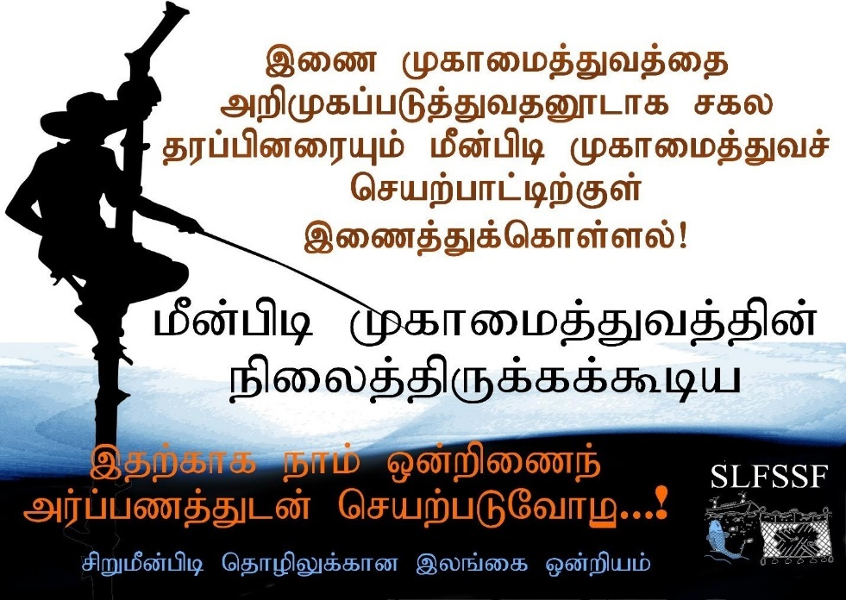
Tamil

Annexure 4: Fact Sheets

Fact Sheet 1

Fact Sheet 2
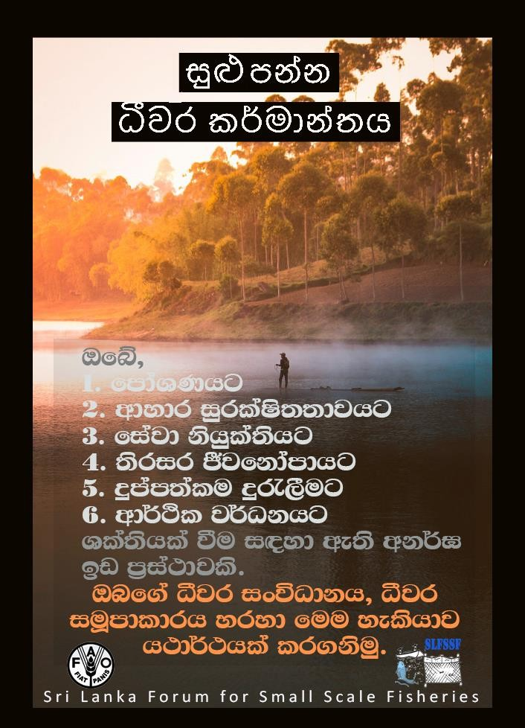
Fact Sheet 3
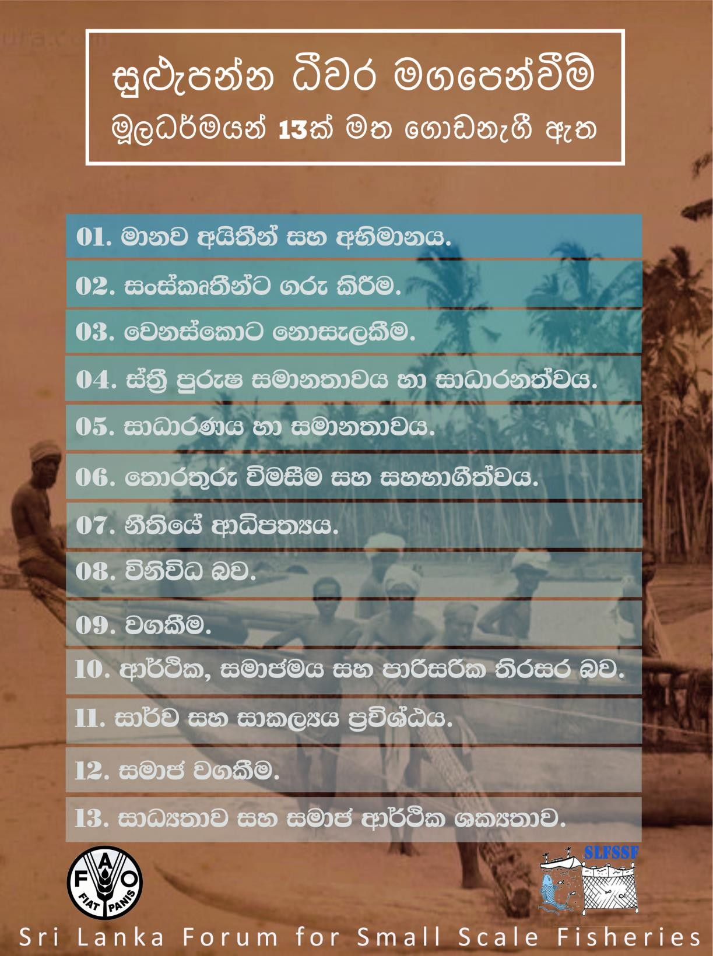

Fact Sheet 4
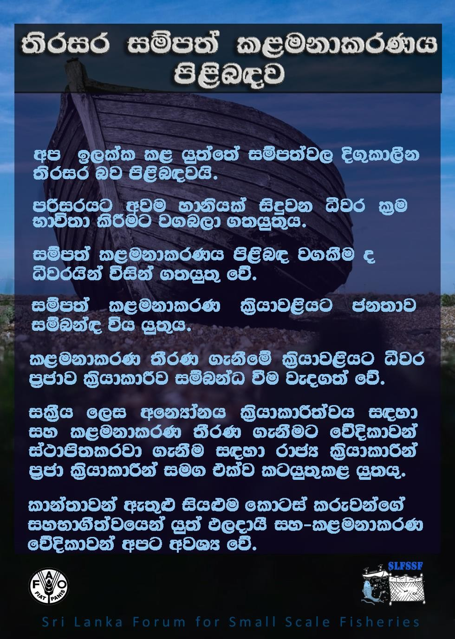

Fact Sheet 5

Fact Sheet 6
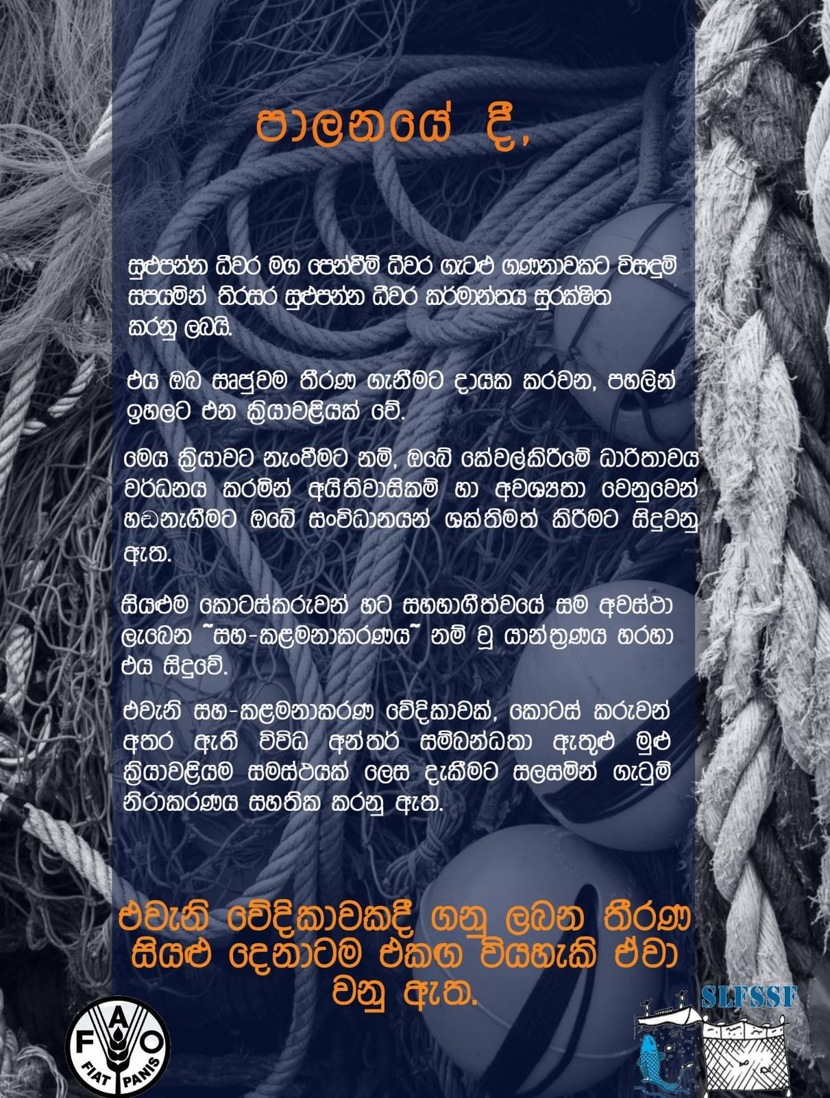

Fact Sheet 7
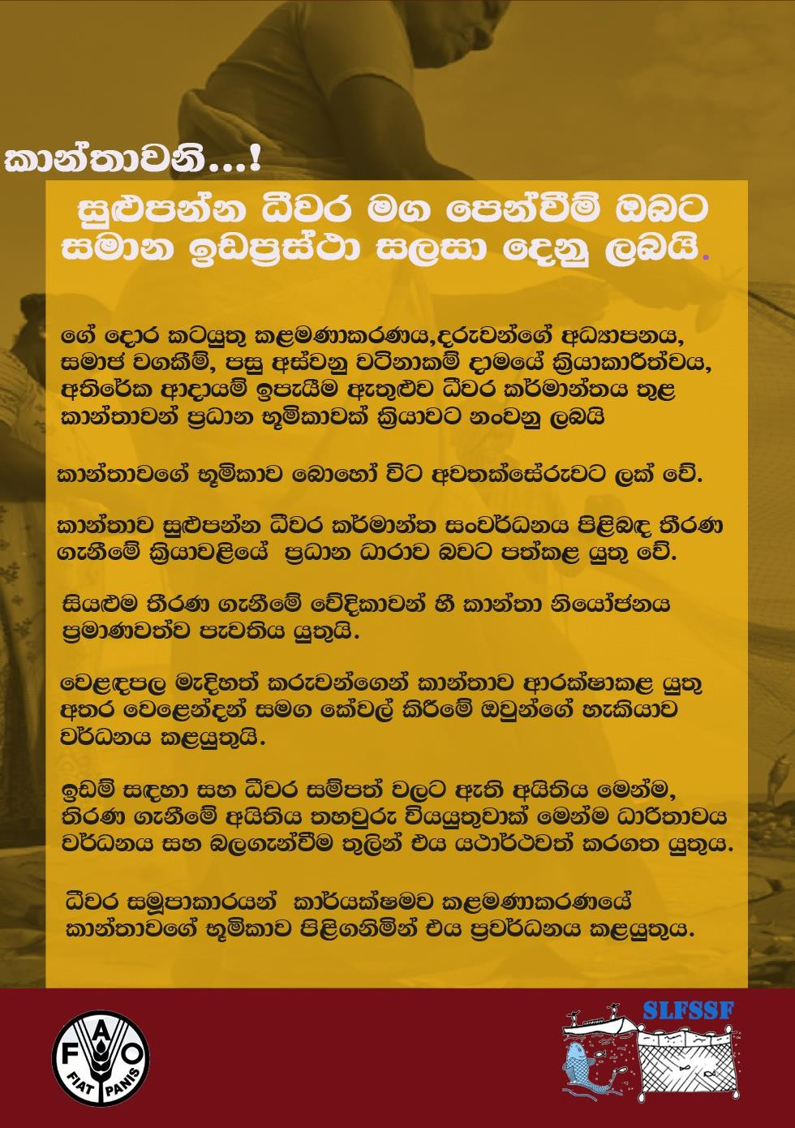

Fact Sheet 8
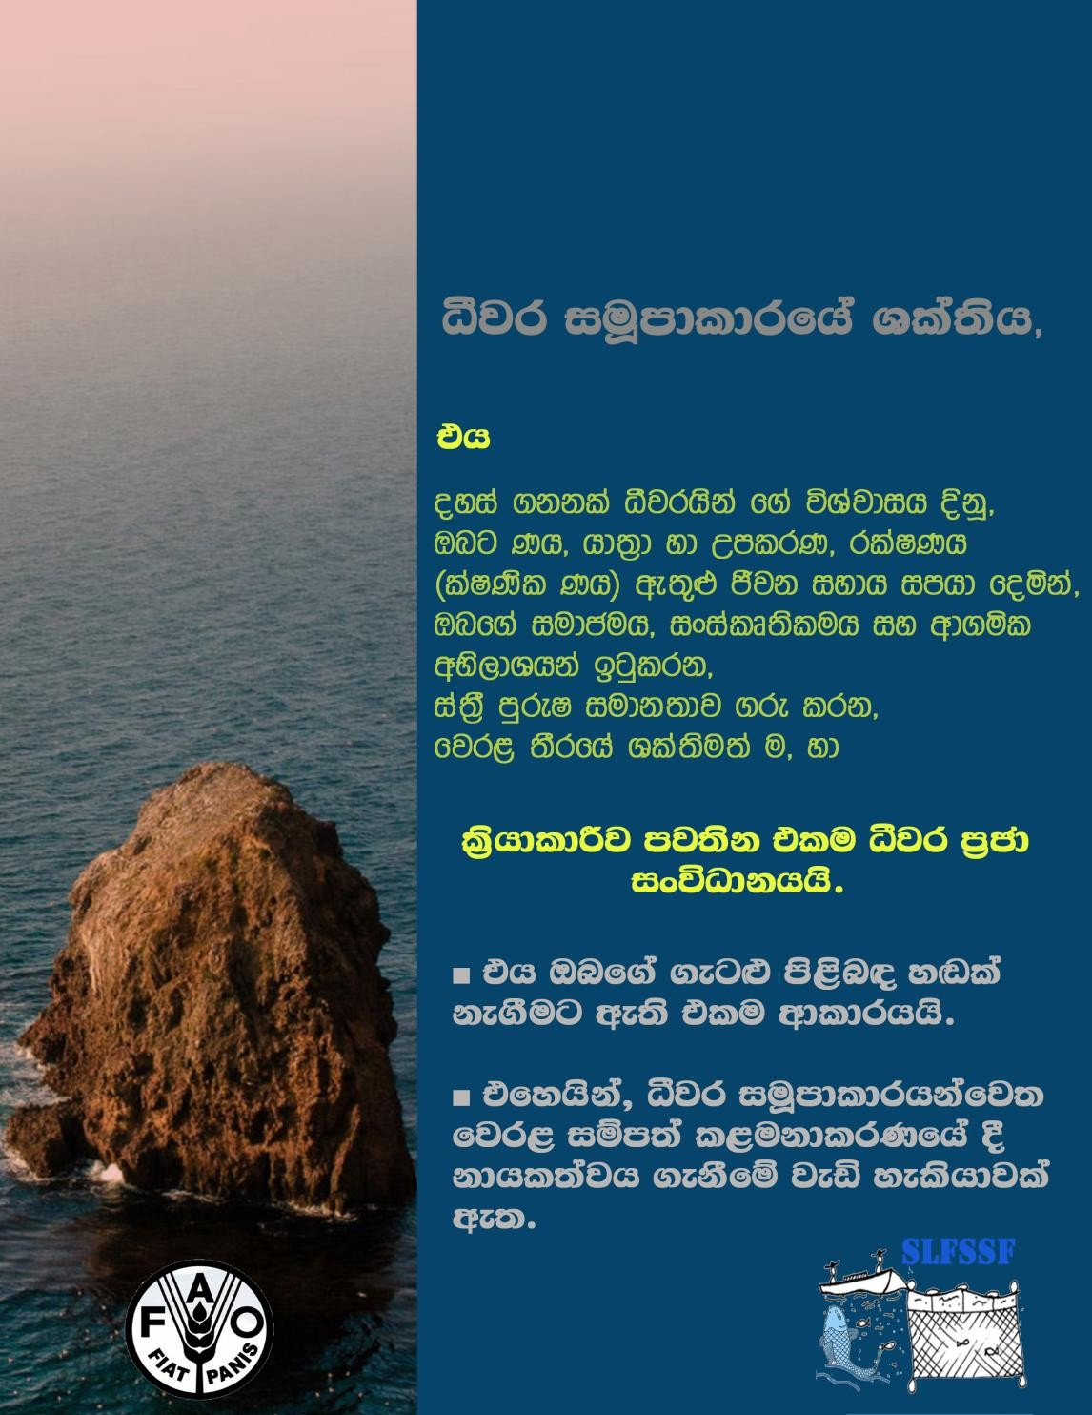

Fact Sheet 9
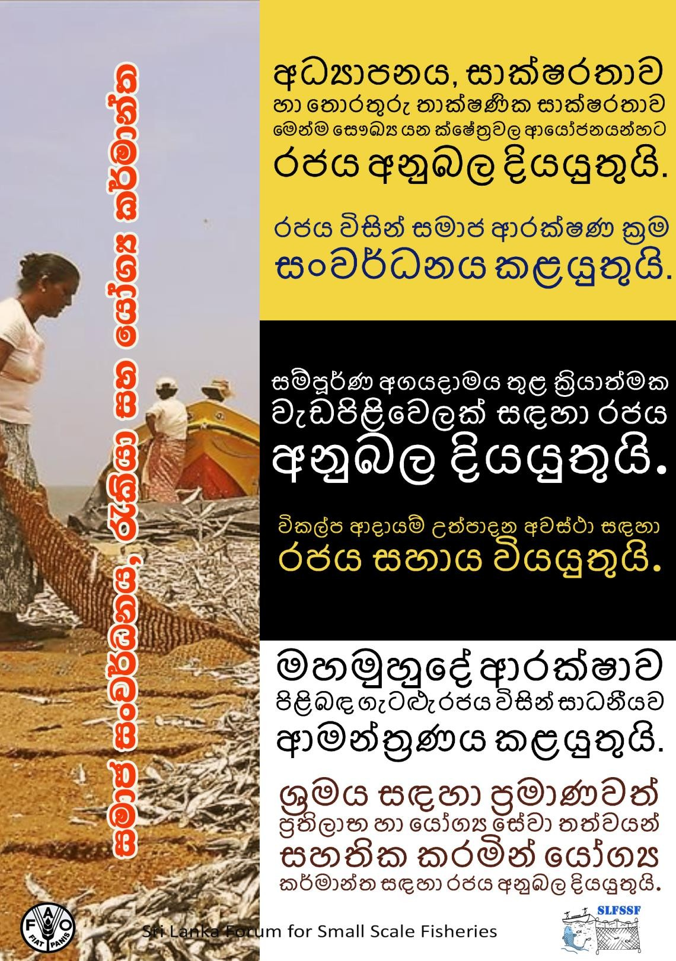

Fact Sheet 10
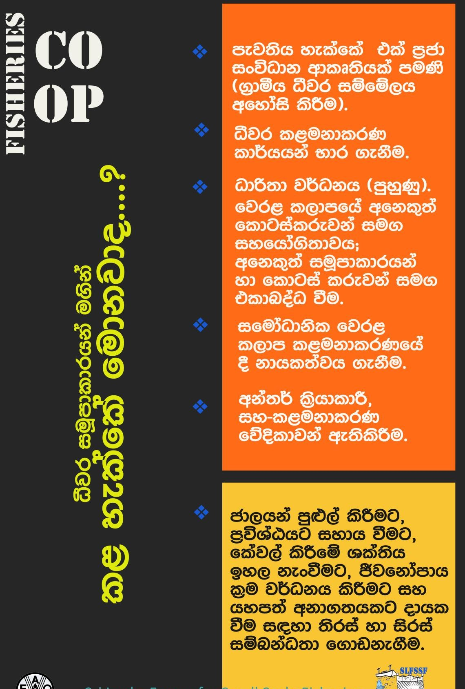

Fact Sheet 11

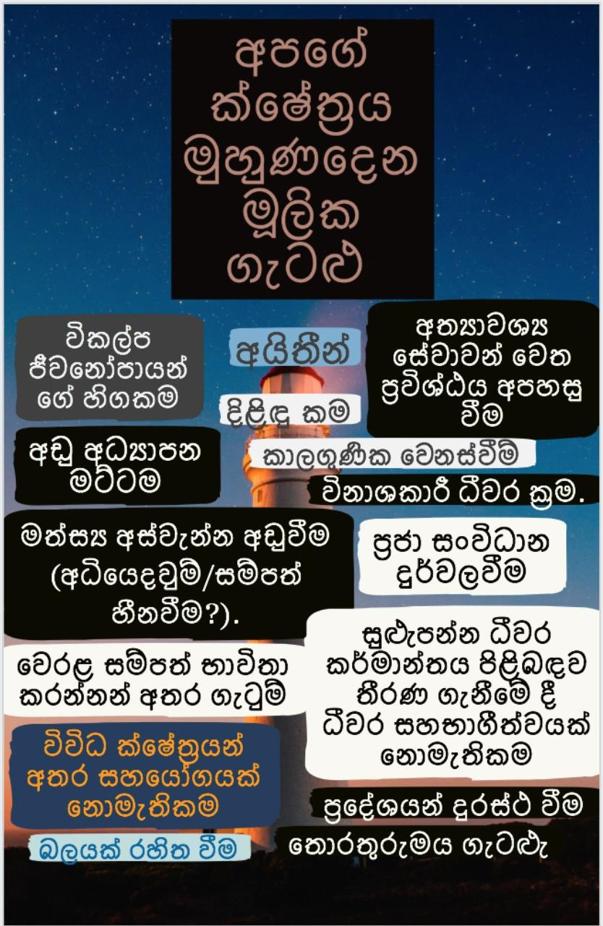

Fact Sheet 12
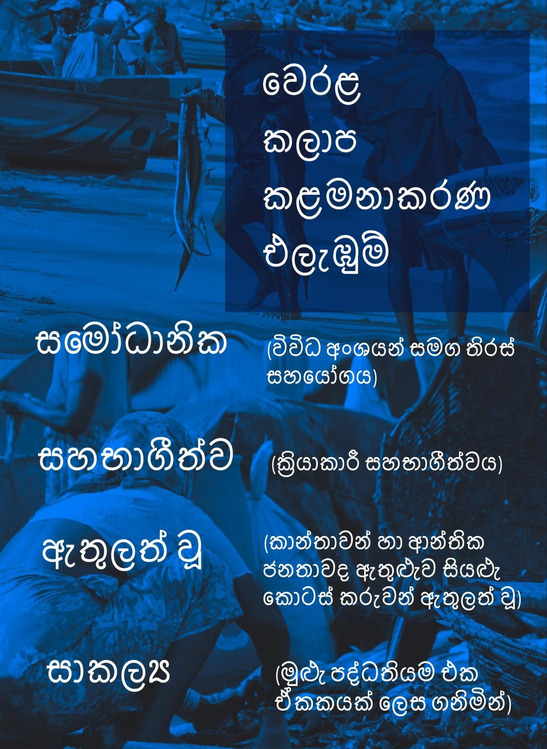

Annexure 5: List of Participants in Workshops and Meetings

State Actors Sensitizing Workshop
Date: 28 September, 2018

No | Name | Institution &  Designation | E- mail | Mobile
1 | E.I.L. Silva | WRST/CEO | eils.mecamp@gmail.com | +94719573809
2 | D.S. Jayakody | Professor (retired) | jayakodysunil@yahoo.com | +94778129802
3 | S.P.W. Curamachchi | DFAR (AD) | saminprabath@gmail.com | +94777980059
4 | M.A.A.D. Sepala | Sri Lanka Coast Guard | asinthasepala@gmail.com | +94777725155
5 | J.H.A.A. Jayasekara | AD, DFAR, Chillaw | jayasekaraanura@yahoo.com | +94718259059
6 | S.H. Sarath  Samarathunga | I.O., DFAR, Matara | samarathunga@gmail.com | +94716411185
7 | Nina Brandstrup | FAO | Nina.Brandstrup@gmail.com | +94777686880
8 | R.M.G. Sarath  Chandranayaka | AD, Puttalam | sarth3622@gmail.com | +94714247881
9 | S. Nesha Dushani | Ocean University of  Srilanka, Lecturer | sndushani@gmail.com | +94715895687
10 | M.K.W.Sanjeewa  Kumara | AD, QCU, DFAR | sanjeewak@gmail.com | +94757324937
11 | U.L.D.Nandalal | GM | gm@ceynow.gov.lk | +94710700044
12 | S.A.Nadeesha Darshani | AD (Development), Ministry of Agriculture | darshani.nadeesha2460@gmail.com | +94717696636
13 | A.Hettiarachchi | Consultant, Ministry of  Fisheries | hetti-a@sltnet.lk | +94718278062
14 | Upali S.  Amarasinghe | Senior Professor,  University of Kelaniya | zoousa@kln.a.lk | +94779446045
15 | B.A.P. Kapila | Ministry of Fisheries | bapkapila@gmail.com | +94715606829
16 | E.M.C.Boyagoda | AD, Trincomalee |  | +94718229622
17 | Terney Praddeep | GM |  | +94715169820
18 | H.D.R.Anselam | AD,DFAR (Colombo) |  | +94718229316
19 | V.Kaliston | AD, Mulative |  | +94779037237
20 | J.Suthagan | AD,Jaffna | sutha75@yahoo.com | +94779072967
21 | Daham Pussella | AGM ,Ceylon Fisheries | gdgmfinance@ck.gov.lk | +94718736912
22 | Dumintha  Munaweera | DGM(CFC) | dgmunaweera@cfc.gov.lk | +94719739870
23 | S.S.Chandrakeerthi | NAQDA, AD (ext) | sriyanc@gmail.com | +94718034866
24 | Rukshan | AD | rukshan.@yahoo.com | +94777947191
25 | M. Mercy | Director, DFAR | mmolligo67@gmail.com | +94774652278
26 | W.D.P.Gunawardana | Director, DFAR | nuwan54@gmail.com | +94773703885
27 | H.W.G.C.Geethamai Chandrasiri | Assistant Director | c.geethamali@gmail.com | +94713521474
28 | W.A.M. Pathmandra | Assistant Director | mpathmanadra@yahoo.com | +94775993285
29 | S.A.T. Namal | C.F.H.C. | satnamal1212@gmail.com | +94715357010
30 | Jayantha  Chandrasoma |  | jayanthachandrasoma@gmail.com | +94777572386
31 | A.S.L.E.Corea | NARA | scorea@nara.ac.lk | +94719353621
32 | L.H.A. Thilakantha | CFHC Beruwala | Beruwala.CFHC.gmail.com | +94718059217
33 | R.P.P.K. Jayasinghe | NARA | Prabath_jayasinghe @yahoo.com | +94714415788
34 | H.D.S.L. Abesekara | Sri Lanka Coast Guard | sachi45@yahoo.com | +94772996980
35 | L.G.T. Chandana | AD, DFAR,Hambantota | lgt.chandana@gmail.com | +94716840840
36 | K.L. Gamini | Assistant Director,  DFAR, Galle | gaminiliyanage89@gmail.com | +94725693644
37 | Damith Udayanga | Workshop Manager |  | +94718015865
38 | Nilantha De Silva | University of Ruhuna | nilanthadz@gmail.com | +94718407545
39 | U.P.I.G.Uggoldeniya | MFARD,ADP | imayagangeesha@yahoo.com | +94718123383
40 | G.R.H.S. Kularathna | AD(Social  Development),MFARD | hariniseu@yahoo.com | +94718249298
41 | H.S.Hathurusinghe | DFAR, QCU | hathurusinghehs@gmail.com | +94712330191
42 | A.T.R. Ravin | Wildlife | Ravintrawildlife@gmail.com | +94711391234
43 | D.W.L.U. De Silva | NARA | lasamiupsala@gmail.com | +94716572154
44 | N.Sriranjan | DFAR & AD  Kilinochchi | ranjan.uor@gmail.com | +94775076197
45 | R.H. Pothuwila | AD(Trainning),  NAQDA | ruwanpothuwila@gmail.com | +94714468201
46 | M.Rajitha daka | Engineer | ccd.rajith@yahoo.com | +9477352424
47 | A.H.S.Ediriweera | D, DFAR | ahsediriweera@gmail.com | +94719863872
48 | T.M.D.T.Peris | AD, DFAR | dineshdfar@gmail.com | +94771245908
49 | Buddhika Aberatne | AD, DFAR | buddhika.dfar@yahoo.com | +94714969572
50 | M.M.Ariyarathne | AD, DFAR | mma_fi@yahoo.com | +94776346306
51 | M.D.S.Wass | Fishery Habour | dwlalwass77@gmail.com | +94718224458
52 | Asanka  Gunawardane | Wildl Department | mtasankagunawargana@gmail.com | +94714482249
53 | Ruchira  Cumarathunga | University of Ruhuna | ruchiracum@gmail.com | +94777285960
54 | T.U.K.Marasinghe | DFAR, Negambo | mmtmarasinghe@gmail.com | +94718060910
55 | O.Amarasinghe | President, SLFSSF | oamarasinghe@gmail.com | +94718527327
56 | K.C. Dinushika | University of Ruhuna | chaminidinushika88@gmail.com | +94775364343
57 | M.G.Kularatne | Vise President, SLFSSF | kuleecon@gmail.com | +94718522540
58 | Hareesha  Sandaruwani | Project Assistant,  SLFSSF | hareeshasandaruwani186@gmail.com | +94713976535

Rekawa Stakeholder Workshop
Date: 24 November, 2018

No | Name | Institution & Designation | Mobile
1 | Muditha Sudusinghe | EO, NAQDA | 94718210933
2 | M.A.Sanath Manasinghe | (D. F.O. ), Forest Deparment | 94712267783
3 | R. Samiel Surmis | R.F.O | 94714489833
4 | A.G.L.A.S. Kumara | Assistant Director, Matara | 94714395696
5 | L.G.T. Chandana | AD, DFAR, Tangalle | 94716840840
6 | Uthpala Adaranga | Department of Wildlife | 94714467131
7 | Prasantha L. Wimaladasa | AD, Department of Wildlife | 94718215581
8 | G.C.A. Gunawardhana | District Director of Agriculture,  Hambantota | 94714486827
9 | R.G.R.S. Ranathunga | Department of Wildlife | 94718184729
10 | K.L. Gamini | AD, Galle | 94702569364
11 | G.M. Ravindra Kumara | Chairman, Galle, DFO | 94772328505
12 | J.L. Kumaranawaka | BFO | 94714868945
13 | B.P.P. Wasantha | coast conservation Department | 94714500907
14 | L.K. Wasantha | Fishery & Aquatic Department, DO | 94714815593
15 | S.H.P. Jayanthi | No.19/3 , marakolliya, Tangalle | +94772798174
16 | K.Sahama | No.126/311, Seepwakulama,  Hambantota | +94711752847
17 | T.R.Kaseer | No.31/1 , Seepwakulama, Hambantota | +94775993846
18 | K.R.T. Renuka Damayanthi | No. 24, Singha Fisheries Village, Koggala | +94770459731
19 | K.S.T. Jayathilaka | No.19, Palassa | +94774360123
20 | Hetti Arachchi Doli  Hemasalatha | Rannapaya, Telwatta | +94713857005
21 | W. H. benat | Morakola, Dodanduwa | +94776363775
22 | Darmasena Jayasekara | Thalpe, Unawatuna | +94912182803
23 | G.M. Raweendra Kumara | Chairman, Galle, DFO | +94772328505
24 | L.K. Wasantha | Fishery & Aquatic Department, DO | +94714815593
25 | J.M. Kumaranawaka | BFO | +94714868945
26 | B.P.P. Wasantha | CCD | +94714500907
27 | Kanani Koongalage | Bambaranda South, Fisheries Committee | +94718354655
28 | K.H. Chandrika De Silva | Bambaranda South, Fisheries Committee | +94716023907
29 | W.P.Sujani | Hena- North, Supipi , Devionuwara | +947143772353
30 | Woltan Wickrama |  | +94713558228
31 | Prasantha L. Wimaladasa | AD, Department of Wildlife | +94718215581
32 | R.G.R.S. Ranathunga | Department of Wildlife | +94718184729
33 | R.P. Dayasiri |  | +94715697340
34 | S.P. Upathissa | Rekawa-West | +94716213562
35 | S.P. Kamala | Rekawa-West | +94774234249
36 | A.A. Ajith Shantha | South-Bataatha Fisheries Committee | +94713101576
37 | M.O. Dulanthi Wasana | Godawaya Fisheries Committee | +94475601200
38 | S.R.G. Janaka | Godawaya Fisheries Committee | +94764731863
39 | Uthpala Adaranga | Department of Wildlife | +94714467131
40 | R. Samiel Suvaris |  | +94714489833
41 | Priyankara Wijeweera | Sarasavi Kadagodellsa | +94714611184
42 | E.K.A.Sumith Kumara |  | +94714890059
43 | Shiwanthika Dharmasiri | University of Ruhuna
44 | H.W.H. Sandaruwani
45 | Nilantha De Silva | University of Ruhuna | +94718407545
46 | K.H.K.L. Piyasiri | University of Ruhuna | +94766146716
47 | S.S.S. Weralugolla | University of Ruhuna
48 | O.Amarasinghe | President | +94718527327
49 | Rose Abesuriya | Godigamuwa, Tangalle
50 | B.Mahamure | Siribopura, Hambantota | +94728804401
51 | T.A. Doole | 60/1, Sippikulama, Hambantota
52 | K.L. Gamini | AD, Galle | +94702569364
53 | A.V.G. Nilanka Nilmini | G.L.E. 34, Thotawanagala Rural Fisheries  Coorparation | +94770785110
54 | A.G.L.A.S. Kumara | Assistant Director | +94714395696
55 | M.A.Sanath Manasinghe | D. F.O. | +94712267783
56 | G.C.A. Gunawardhana | District Director of Agriculture | +94714486827
57 | T.R. Liyanage | Dodanduwa Fisheries Committee | +94776180139
58 | L.G.T. Chandana | Ad, DFAR, Tangalle | +94716840840
59 | P.N. Mathagasinghe | Dewinuwara, Arunodaya | +94715830910
60 | M.M. Siriyawati | LunuKalapuwa Fisheries Committee | +94771625809
61 | H.W. Wickramapala | Matara Fisheries Committee | +94715375767
62 | M.S. Ranjith | Matara Fisheries Committee | +94713531028
63 | Mudiitha Sudusinghe | EO | +94718210933
64 | W.P. Sujee Priyantha |  | +94716953543
65 | S.S. Junudeera |  | +94711316869
66 | Samantha Weerathunga |  | +94775098321
67 | S.P. Martin |  | +94475683919
68 | S.K. Lalitha |  | +94716313561
69 | H.M. Ranjith |  | +94776075075
70 | L.H.M. Sumanapala |  | +94779705993
71 | R.S.R.G. Anoma | Godawaya Fisheries Committee | +94770295749
72 | K.L.C.P. Kumara | Vihara Road, Godawaya, Ambalanthota | +94717346565
73 | J.P. Mahindapala | Southern provincial Fisheries Committee | +94715635168
74 | Y.K.R.K. Kumari | Universsity of Ruhuna | +94775652651

Negombo Stakeholder Workshop
Date: 09 February, 2019

No | Name | Institution & Designation | Mobile
1 | E.I. Fernando | MEO,MEPA | +94718325678
2 | Thakshila Yasarathne | AMEO,MEPA | +94776148141
3 | H.A.S.D.Perera | AMEO,MEPA | +94710533948
4 | M. Gammanpila | Senior Scientist ,NARA | +94714436144
5 | B. devanee Jayathilaka | DFO, Forest Department, Gampaha | +94717102111
6 | W.W.P. Chandana | CCD, | +94776648900
7 | J.H.A.A. Jayasekara | Assistant Director, DFAR, Chilaw | +94718259059
8 | T.U.K. Marasinghe | DFI,DFAR, Negombo | +94718068916
9 | K.S. Vincent Fernando | Sri Vimulathi Fisher Women  Organization, Negombo | +94779019484
10 | D.Wanach |  | +947722385211
11 | Nalaka Rasairo | NAFSO | +94777709085
12 | M.M.W.R. Bandara | DFAR, Negombo | +94718129650
13 | I.M.G. Sarath Chandranayake | DFAR, Puttalm | +94714247881
14 | Nelum | Negombo | +94779165101
15 | S. Dharmasiri | UOR | +94779609209
16 | W.N. De. Silva | UOR | +94718407545
17 | S.S.S. Weralugolla | UOR | +94714949640
18 | K.C. Dinushika | UOR | +94775364343
19 | D.T.P.S. Edharmawardhana | UOR | +94718362295
20 | A.H.B. Roshani | UOR | +94715692424
21 | Wijitha Mallika | Sri Mukthi Women Cooperative | +94771085616
22 | W.Chanaka Niroshan | Sri Jusewas Fisheries Cooperative | +94770845669
23 | W.Nimini Peris | Sri Jusewas Fisheries Cooperative | +94773634992
24 | M.Meri Brint Perera | Sri Jusewas Fisheries Cooperative | +94726509101
25 | W. Malani Fernando | Sri Jusewas Fisheries Cooperative | +94724304306
26 | R.S. Hilda Perera | Sri Jusewas Fisheries Cooperative
27 | M. Rita Pinthu | Sri Jusewas Fisheries Cooperative
28 | Roshan | Fisheries Cooperative | +9472582589
29 | Samadhi Thilanka | Fisheries Cooperative | +94789782897
30 | W.Leetas | Fisheries coperation | +94764303742
31 | Emmanuwel Leema | Fisheries cooperation | +94724556282
32 | K. N. Lenard Fernando | Fisheries cooperation | +94717386787
33 | W.T.P. Rosman Fernando | Fisheries cooperation | +94768088871
34 | W. Pudigantor | Dewadayawa Fisheries coperation | +94755150444
35 | C. Philip Mewal Fernando | Fisheries Cooperative | +94778148125
36 | A.Berty perera | Fisheries Cooperative | +94752998903
37 | S.H. Ruwan Sri Pathma kumara | Fisheries Cooperative | +94788971841
38 | M.Josap Peter | Fisheries Cooperative
39 | N.Edman Fernando | Fisheries Cooperative | +94711974908
40 | Meriyas Prema Hamine | Fisheries Cooperative | +94312228362
41 | G.Josap Nihal Fernando | Fisheries Cooperative | +94315610757
42 | T.M.m. Anton | Fisheries Cooperative | +94715054319
43 | W.A.P. Fernando | Fisheries Cooperative | +94777518791
44 | D.M.R. | Fisheries Cooperative | +94784553615
45 | Selwaraj Perera | Munnakkaraya Fisheries Cooperative | +94713190966
46 | Anna Ayoni | Munnakkaraya Fisheries Cooperative | +94778035478
47 | <eri Rita Maheshwari | Munnakkaraya Fisheries Cooperative | +94719392682
48 | T. Chandrika Priyangani | Fisheries Cooperative | +947229787595
49 | Suneetha Hettiarachchi |  | +94775137718
50 | Sakunthala
51 | b.Nimal Priyan |  | +94777496457
52 | Saduni
53 | W.T. Sanjeewa Fernando |  | +94775453559
54 | Jayanthi | Fisheries Cooperative
55 | P.K.P. Kansi Napkin | Fisheries Cooperative | +94322260098
56 | Sriyantha Swarnamalitha | Kalpitiya Fisheries Cooperative

Trincomalee Stakeholder Workshop
Date: 15 December, 2018

No |  | Name |  | Institution & Designation |  | Mobile
1 |  | Dr. Wasantha Liyanage |  | DFO/ Trincomalee |  | +94779985833
2 |  | T. Sujitha |  | AM/ MEPA |  | +94711635305
3 |  | J.M. Rasri |  |  |  | +94773526722
4 |  | Y.K.M.T.B. Senarath |  | DFAR, DFI/ Trincomalee |  | +94718175957
5 |  | E.M.C. Boyagoda |  | AD, DFAR, DFI/ Trincomalee |  | +94718229622
6 |  | K. Urmila |  | CCD Officer, District Secretariat |  | +94772346868
7 | M.G. Kularatne |  |  | SLFSSF | +94718522540
8 | R.A.G. Duminda Sampath |  |  | DAEO/ NAQDA | +94715758581
9 | W.A. Lalith Kumara |  |  | Assistant director/ Wild Life | +94714485251
10 | S. Mathana Rujah |  |  | AEO/ NAQDA | +94773489477
11 | R. Ragiharan |  |  | Fisheries Officer/ Department of Fisheries | +94703392522
12 | Edudayanadaran |  |  |  | +94771510787
13 | A.T. Wasanthi |  |  | Abimani Fisheries Coorparation | +94712080473
14 | N.M. Nair |  |  |  | +94717153616
15 | Anthola |  |  |  | +94771510787
16 | G.Soeoshi |  |  | Pavaneen Fisheries CO.Society | +94775373121
17 | M.Thavanyah |  |  | Palamoon madu CO.society | +94770652127
18 | K. Lamuskanthi |  |  |  | +94779995645
19 | Antholi |  |  |  | +94771510787
20 | Mathendan |  |  |  | +94779054884
21 | C. Punithi |  |  |  | +94776042787
22 | W. Pathmanadan |  |  |  | +94774437891
23 | M. Ashasmothan |  |  | kattanyu | +94776686133
24 | N.Parasoraman |  |  |  | +94775926861
25 | R. Rajiharan |  |  | Department of Fisheries | +94703392522
26 | Anandawetsumi |  |  |  | +94770498331
27 | R.M. Ahskar |  |  |  | +94779534401
28 | M.I. Saleem |  |  |  | +9477495595
29 | K.R. Sebasthiyan |  |  | Sinhapura Thotupala | +94712107948
30 | Champa Kumari Hettihewa |  |  | Kulsapura Fisheries coorparaton | +94715956278
31 | K.B. Sajeewani Pushpa Kanthi |  |  | Kulsapura Fisheries coorparaton | +94728714257
32 | D.G. Kuldan |  |  |  | +94769204602
33 | S. naseen |  |  |  | +94778293217
34 | H.A.M. Pasa |  |  |  | +94705824192
35 | H.P. Thushara Nikson |  |  |  | +94776101409
36 | S.A.Avamd |  |  |  | +94779007361
37 | A.G. Chithrani |  |  | No.37 Nelsapura
38 | E.Marian |  |  |  | +94773211988
39 | Stedan Cook |  |  | Journalist
40 | W.S.T. Punani |  |  | Madama | +94773604687
41 | M. Subalwa |  |  |  | +94766696910
42 | N.C. Piyal Hemasiri |  |  | Tincomalee Fisheries coorparation | +94774329352
43 | A.B. Anura |  |  | Vijithapura Fisheries coorparation | +94788670000
44 | S.Sutharan |  |  |  | +94779003528
45 | S.Senaraswathan |  |  |  | +94766085339
46 | E. Albulla |  |  |  | +94767097888
47 | O. Amarasinghe |  |  | SLFSSF | +94718527327
48 | H.W.H. Sandaruwani |  |  | SLFSSF | +94713976535
49 | K.C. Dinushika |  |  | UOR | +94775364343
50 | K.H. Kaumi Piyasiri |  |  | UOR
51 |  |  | Nilantha De Silva | UOR
52 |  |  | S.S.S. Werallugolla | UOR
53 |  |  | D.T.P.S. Darmawardhana | UOR
54 |  |  | S.S.M. Peremunagama | DOA

Jaffna Workshop
Date: 05th January 2019

3 | S. Ravanithy | +94771345955
4 | V. Malavan | +94717671392
5 | K. Akilan | +94777112186
6 | L.C. Aranth | +94777250965
7 | D. Nilochkumar | +94775978196
8 | A.Shirangan | +94773051363
9 | H.S.H. Weerasinghe | +94775734120
10 | S. Dilanan | +94770633103
11 | Y. Piyasath | +94779785707
12 | Ahilan Kadirgamar | +94775714534
13 | T. Nanthavathi | +94779449551
14 | S. Florida Yasmeena | +94212228595
15 | M. Logathevy | +94764148285
16 | V. Balasuresh | +94771883606
17 | y. Sagayarajah | +94764997762
18 | k. Shanmugarajah
19 | K.Kulasingam | +94771951014
20 | K. Kunesweary
21 | D. Marry Anne | +94771179438
22 | S. Sivarajah | +94771135691
23 | R. Chandramouleesan | +94771532424
24 | T. Vijayabalan | +94768878358
25 | S. Kuganesan
26 | S. Majilazakan | +94775631359
27 | A.Annarasa | +94771864113
28 | A.k. Aruljeevan | +94766370519
29 | S.Natkunam | +94772890474
30 | N.V. Subramanium
31 | P. Hanafdeen | +94779300722
32 | S. Rasenthiram | +94779237328
33 | m. Jeyamini | +94775780028
34 | N. Varnakulasinghe | +94773313103
35 | Dr. Nilantha De Silva | +94718407545
36 | Oscar Amarasinghe | +94718527327
37 | K.C. Dinushika
38 | K. Suren | +94779103565
39 | N. Sanotharan | +94752624364
40 | S.S.S. Weralugolla
41 | H.W.H. Sandaruwani
42 | R. Thusyanthiri | +94766869466
43 | SSM Peramunugama | +94717161970
44 | D.T.P.S. Dhaarmawardhena | +94718362295
45 | A. Theleepan | +94773934624
46 | Ajitha Krishnakumar | +94766773050
47 | Suganya Kandeepan | +94767851323

National Policy Workshop
Date: 13th March 2019

No | Name | Mobile
1 | U.S. Amarasinghe | +94779646045
2 | H.S.G.Fernando | +94777188083
3 | G.Piyasena | +94712767230
4 | J.Chandrasoma | +94777572386
5 | A.H.V.V.K.Abeygunarathna | +94710647643
6 | Shamon Vidauge | +94777753743
7 | O. Amarasinghe | +94718527327
8 | A.Hettiarachchi | +94718278062
9 | DileepaDe Cross | +94718129806
10 | K.D.S. Ruwanchandra
11 | Ivan Silva
12 | J.B.T. Wijerathna | +94777808210
13 | K. Suraj Chandrakumara | +94077405987
14 | Lesli Joseph | +94714690691
15 | D.S. Jayajkody | +94718129802
16 | I.W.M.A. Wijayawardhana | +94716888629
17 | U. Pahalewaththa | +94719353104
18 | P.R.T. Cumaranathunga | +94777285160
19 | M.G.Kularatne | +94071852280
20 | K.H.M.L. Amralal | +94778362158
21 | B.A.P. Kapila | +94715606011
22 | U.P.I.G. Uggaldeniya | +94718123383
23 | P.M. Liyanage | +94713981575
24 | D.C.I.H.K. Peiris | +94710930039
25 | K.A.C.P. Kodithuwakku | +94711038044
26 | M.K.W. Sandeepa | +94757324937
27 | Geethamali Chandrasiri | +94713521474
28 | U.L.S. Kumudini | +94779971267
29 | L.G.R. Isurani | +94714934261

Message: “Recognize the important role played by women in small scale fisheries/ Let us enforce the Voluntary Guidelines for Securing Sustainable Small-scale Fisheries”
Message: “Let us ensure participation of all stakeholders in a Co-management Platform/ Make the Fisheries Management Process Sustainable”
Message: “The Rights of Fishing Populations • Rights to coastal land: what rights? Violation of rights? • Rights to resources: who has rights to which resources? • Rights to adequate food, education, social welfare measures and a decent standard of living • However, Rights come with responsibilities! The SSF guidelines attempt at recognizing, recording and respecting your rights”
Message: “Small-scale Fisheries You have great potential to make contributions towards: 1. Nutrition 2. Food Security 3. Employment 4. Sustainable Livelihoods 5. Poverty Alleviation 6. Economic Growth Let us realize this potential, through your organisations – Fisheries Cooperatives”
Message: “The SSF Guidelines are based on 13 Principles: 1. Human rights and dignity 2. Respect of cultures 3. Non-discrimination 4. Gender equality and equity 5. Equity and equality 6. Consultation and participation 7. Rule of law 8. Transparency 9. Accountability 10. Economic, social and environmental sustainability 11. Holistic and integrated approaches 12. Social responsibility 13. Feasibility and social and economic viability”
Message: “On Sustainable Resource Management • We should aim at long term sustainability of resources • Use fishing practices doing least harm to the environment • Fishers should also take responsibility of resource management • Communities should be involved in the process of resource management • Active participation of fishing communities in management decision making is important • State actors should join hands with community actors in establishing platforms where they actively interact and make management decisions • We require effective co-management platforms with the participation of all stakeholders including women”
Message: “How can you raise your voice to realize your rights and meet your needs: • Understanding the status: yours and the system’s • Developing your knowledge and skills • Strengthening your organisations (cooperatives) • Actively participating in the decision-making process • Taking leadership in coastal resource management • Community organisations undertaking resource management functions • Cross-sectoral collaboration”
Message: “On Governance: • SSF guidelines will provide answers to major SSF issues and secure sustainable small-scale fisheries. • This will be a bottom up process, where you will actively participate in decision making • To do this, you may require to build up your capacities to negotiate and strengthen your organisations to voice your rights and needs • This is done through a mechanism called ‘co-management’, where all relevant stakeholders are provided with equal opportunity of participation. • Such a co-management platform, will ensure looking at the system as a whole, various interactions among stakeholders, a and resolving conflicts among them. • Decision taken at such a platform will be acceptable to all.”
Message: “The SSF Guidelines calls for equal opportunities for men and women: • Women play a major role in the fisheries post-harvest value chain, managing the household, education of children, social obligations and supplementing household incomes • Women’s roles are often underestimated • They should be involved in SSF development decision-making process • They should be adequately represented in all decision-making platforms • They should be protected from exploitative middlemen and their bargaining power increased vis-à-vis merchants • Their rights to land and fisheries resources and the right to make decisions should be recognized and realized through capacity building and empowerment • Women’s role in efficiently managing fisheries cooperatives should be recognized and promoted”
Message: The Strength of Fisheries Cooperatives: • The only functional fisheries community organizations • Have won the faith of thousands of fishers • The strongest community organizations along the coast • Provide you with life support: credit, crafts and gear, insurance, instant loans • Meet your social, cultural and religious aspirations • Mode of voicing your problems • Gender equal • Have a high Potential to take the lead in coastal resource management • Build links to expand networks, provide assistance, increase bargaining power, improve livelihoods and contribute to a better future”
Message: “Social development, employment and decent work: • States should promote investments in health, education, literacy and IT literacy • States should develop schemes on social security measures, including savings, credit and insurance schemes • State should promote social security measures along the entire value chain • States should effectively address safety-at-sea issues. • States should promote decent work, ensuring adequate wages and decent working conditions • States should support alternative income generating opportunities”
Message: “What Fisheries Cooperatives can do: • Assume fisheries management functions • Training and capacity buidling • Collaborate with other stakeholders in the coastal zone • Take the leadership in integrated coastal zone management • Form interactive co-management platforms • Build links to expand networks, provide assistance, increase bargaining power, improve livelihoods and contribute to a better future”
Message: “Some problems that our sector faces: • Low catches (high fishing pressure) • Destructive fishing • Poverty • Powerlessness • Remote areas • Poor access to essential services • Low levels of education • Lack of alternative livelihoods • Climate Change • Rights not recognised • No access to information • Conflicts with coastal resource users • Lack of cross-sectoral collaboration • Limited participation in SSF decision making • Weak community organisations”
Message: “Management of the coastal zone should be: • Integrated (Cross-sectoral collaboration) • Participatory (Actively participate) • Inclusive (All relevant stakeholders including women and marginalised groups) • Holistic (Looking at the system as a whole)”

